COMMUNITY HEALTH PROFILE

HIGHLANDS COUNTY, FLORIDA

OCTOBER 2012

Prepared by the Highlands County Health Department in conjunction with
The Health Council of West Central Florida

This Profile is the first in a series of Mobilizing for Action through Planning and Partnership (MAPP) assessments. The results of the assessments will be used to develop a Community Health Improvement Plan (CHIP) for Highlands County.

This document was prepared by Ingrid Utech, Community Outreach Worker, Highlands County Health Department. Teresa Kelly, Special Projects Coordinator, Health Council of West Central Florida, served as a consultant.

For further information, contact the Highlands County Health Department, 7205 S. George Boulevard, Sebring, FL 33875

(863) 386-6040

Table of Contents | i
Figures Index | iii
Tables Index | iv
EXECUTIVE SUMMARY | 1
I. POPULATION CHARACTERISTICS
Resident Population | 5
Visitor Population | 5
Migrant and Seasonal Farmworker Population | 5
Homeless Population | 6
Age Distribution | 6
Gender | 7
Race | 8
Ethnicity | 9
Language | 10
Density of Population | 10
II. SOCIO-ECONOMIC CHARACTERISTICS
Family & Non-Family Households | 11
Median Household Income | 12
Distribution of Household Income | 12
Poverty | 13
Major Employers | 14
Major Employment Sectors | 15
Labor Force | 15
Educational Attainment | 16
III. MAJOR CAUSE OF DEATH & PREMATURE DEATH
Leading Causes of Death | 17
Heart Disease | 18
Cancer | 20
Chronic Lower Respiratory Disease | 22
Stroke | 24
Unintentional Injuries | 26
IV. CHRONIC DISEASES
Chronic Disease Health Status, Adults | 28
Chronic Disease Risk Factors, Adults & School-Aged Children | 31
V. COMMUNICABLE DISEASES
Vaccine Preventable Diseases | 32
Tuberculosis | 33
HIV/AIDS | 34
Sexually Transmitted Diseases (STDs) | 35
Enteric Disease | 35

i

VI. MATERNAL, INFANT & YOUNG CHILD HEALTH
Birth Rates | 36
Birth Outcomes and Pregnancies | 37
Death Rates >0-1 Years of Age | 41
Health Issues, Children 1-5 Years of Age | 42
VII. MENTAL HEALTH
Mental Health Indicators for Adults and Children | 43
Suicide | 45
Domestic Violence | 45
VIII. ALCOHOL, DRUG, AND TOBACCO USE
Alcohol Use by Adults | 46
Alcohol Use by Students | 46
Drug Use by Students | 47
Tobacco Use by Adults | 48
Tobacco Use by Students | 48
IX. ORAL HEALTH
Community Water Supplies and Fluoridated Water | 49
Oral Health Indicators | 49
X. ENVIRONMENTAL HEALTH
Air Quality | 50
Lead Poisoning | 50
Access to Recreational Facilities | 51
Access to Healthy Foods | 51
Fast Food Restaurants | 52
XI. HEALTH CARE RESOURCES
Health Care Facilities | 53
Health Care Providers: Physicians, Dentists, Mental Health Professionals | 54
Manpower Shortage Designations | 55
XII. HEALTH CARE ACCESS
Financial Barriers | 56
Structural Barriers | 58
Personal Barriers | 61

ii

Figure 1 | Highlands County Population by Year | 5
Figure 2 | Population by Age, 2010 | 6
Figure 3 | Population by Age, 2020 | 7
Figure 4 | Highlands County Population, by Sex, 2010 | 7
Figure 5 | Population by Race, 2010 | 8
Figure 6 | Highlands County Population, by Race, by Year | 8
Figure 7 | Population by Ethnicity, 2010 | 9
Figure 8 | Highlands County Population, by Ethnicity, by Year | 9
Figure 9 | Density of Population | 10
Figure 10 | Highlands County Households, 2010 | 11
Figure 11 | Household Income Distribution, Highlands County, 2010 | 12
Figure 12 | Poverty, by Age Groups, 2010 | 13
Figure 13 | Families in Poverty, 2010 | 13
Figure 14 | Unemployment Rates, by Year | 15
Figure 15 | Highlands County Educational Attainment, 2010 | 16
Figure 16 | Heart Disease Age-Adjusted Dearth Rate, 3-Year Rolling Rates | 18
Figure 17 | Heart Disease Age-Adjusted Death Rate, 3-Year Rolling Rates, | 18
 | Race
Figure 18 | Heart Disease Age-Adjusted Rate, 3-Year Rolling Rates, Ethnicity | 19
Figure 19 | All Cancers Age-Adjusted Death Rate, 3-Year Rolling Rates | 20
Figure 20 | All Cancers Age-Adjusted Death Rate, by Race, | 20
 | 3-Year Rolling Rates
Figure 21 | All Cancers Age-Adjusted Death Rate, 3-Year Rolling Rates, | 21
 | Ethnicity
Figure 22 | Chronic Lower Respiratory Disease Age-Adjusted Death Rate, 22
 | 3-Year Rolling Rates
Figure 23 | Chronic Lower Respiratory Disease Age-Adjusted Death Rate, | 22
 | 3-Year Rolling Rates, Race
Figure 24 | Chronic Lower Respiratory Disease Age-Adjusted Death Rate, | 23
 | 3-Year Rolling Rates, Ethnicity
Figure 25 | Stroke Age-Adjusted Death Rate, 3-Year Rolling Rates | 24
Figure 26 | Stroke Age-Adjusted Death Rate, 3-Year Rolling Rates, Race | 24
Figure 27 | Stroke Age-Adjusted Death Rate, 3-Year Rolling Rates, Ethnicity | 25
Figure 28 | Unintentional Injuries Age-Adjusted Death Rate, | 26
 | 3-Year Rolling Rates
Figure 29 | Unintentional Injuries Age-Adjusted Death Rate, | 26
 | 3-Year Rolling Rates, Race
Figure 30 | Unintentional Injuries Age-Adjusted Death Rate, | 27
 | 3-Year Rolling Rates, Ethnicity
Figure 31 | Total Resident Live Births, 3-Year Rolling Rates | 36
Figure 32 | Total Resident Live Births by Race, 3-Year Rolling Rates | 36
Figure 33 | Total Resident Live Births, by Ethnicity, 3-year Rolling Rates | 37
Figure 34 | Suicide (All means), Age Adjusted Death Rate, | 45
 | 3-year Rolling Rate
Figure 35 | Total Domestic Violence Offenses, 3-Year Rolling Rates | 45
Figure 36 | Lead Poisoning, 3-Year Rolling Rates | 50
Figure 37 | Lead Poisoning, <6 years of Age, 3-Year Rolling Rates | 51

iii

Table 1: | Median Household Income, Highlands County and Florida, | 12
 | 2000 and 2010, and Percent of Change
Table 2: | Private and Public Sector Employment, Highlands County, 2011 | 14
Table 3: | Most Common Causes of Death from Cancer, Highlands County, | 21
 | 2008-2010
Table 4: | Highlands County Chronic Diseases, Health Status of Adults | 29
Table 5: | Highlands County Chronic Diseases, Risk Factors for Adults | 31
Table 6: | Highlands County Chronic Diseases, Risk Factors for Children | 31
Table 7: | Vaccine Preventable Disease Rate per 100,000 Population, 2008-2010 | 32
Table 8: | Vaccine Preventable Diseases, by Type | 33
Table 9: | Screenings for Vaccine Preventable Diseases | 33
Table 10: Tuberculosis Rate Per 100,000, 2008-2010 |  | 34
Table 11: HIV/AIDS Rates, Per 100,000, 2008-2010 |  | 34
Table 12: Sexually Transmitted Disease Rates, Per 100,000, 2008-2010 |  | 35
Table 13: Births and Pregnancies, 2008-2010 |  | 39
Table 14: Deaths > 0-1 Year of Age, 2008-2010 |  | 41
Table 15: Health-Related Issues, Children, Ages 1-5 |  | 42
Table 16: Mental Health Indicators for Adults |  | 43
Table 17: Mental Health Indicators for School-Aged Children/Adolescents |  | 44
Table 18: Adults Who Engage in Heavy or Binge Drinking |  | 46
Table 19: Alcohol Use, by Adolescents, by Grade |  | 46
Table 20: Illegal Drug Use, by Adolescents, by Grade |  | 47
Table 21: Tobacco Use, by Adults |  | 48
Table 22: Tobacco Use, by Adolescents |  | 48
Table 23: Adults Who Had Dental Work Performed |  | 49
Table 24: Air Quality Index Breakdown for Highlands County, 2010 |  | 50
Table 25: Selected Health Care Facilities, 2009 |  | 53
Table 26: Selected Licensed Facilities by Type and Capacity, 2010 |  | 53
Table 27: Licensed Physicians, 2009-2010 |  | 54
Table 28: Licensed Dentists, 2009-2010 |  | 54
Table 29: Licensed Mental Health Professionals, 2011 |  | 54
Table 30: Manpower Shortage Area Designations, 2010 |  | 55
Table 31: Estimated Number and Percent without Health Insurance, |  | 56
 | 2008-2010
Table 32: Percent of Population by Insurance Provider, 2010 |  | 57
Table 33: Adults Who Received Regular Medical Care, 2010 |  | 57
Table 34: Trips, by Population Served, Highlands County, |  | 59
 | July 1, 2011 – June 30, 2012
Table 35: Trips, by Mobility of Population, Highlands County |  | 59
 | July 1, 2011 – June 30, 2012
Table 36: Trips, by Type of Trip, Highlands County, |  | 59
 | July 1, 2011 – June 30, 2012
Table 37: Unmet Trip Requests, Highlands County, |  | 60
 | July 1, 2011 – June 30, 2012
Table 38: Reason Trip Was Denied, Highlands County, |  | 60
 | July 1, 2011 – June 30, 2012
Table 39: Revenue Sources, Veolia Transportation, Highlands County, |  | 60
 | July 1, 2011 – June 30, 2012

iv

EXECUTIVE SUMMARY

POPULATION

- Highlands County is the 34th most populous county in Florida. It has just under 100,000 population. It is a rural county.

- One-third of the population is 65 and older.

- In addition to full-time residents, the County has a seasonal population of snowbirds or winter visitors.

- The County also has a migrant population and a seasonal farmworker population.

- The population is primarily white (81%). African Americans are the next most populous racial group (9.4%).

- Hispanics are the main ethnic group. Hispanics comprise slightly more than 17% of the population.

SOCIO-ECONOMIC CHARACTERISTICS

- Family households make up approximately 2/3 of the population. Family households are comprised mostly of married couple families.

- Non-family households comprise 1/3 of the population. Most non-family households are people living alone.

- Median household income was just under $35,000 in 2010 in Highlands County. In Florida, it was close to $48,000.

- Highlands County has a higher percentage of residents living in poverty than Florida. In 2010, more than 19% were living in poverty. Of those, 33% were children under the age of 18; 20% were ages 18-64, and 11% were 65 and older.

- The unemployment rate in Highlands County averaged 11.3% in 2010, and 10.4% in 2011. In June 2012, it was 8.9%.

- The Highlands County School District had close to a 400 percent increase in the population of homeless children and families from 2010-2011 to 2011-2012.
- Local government is the largest employer.

MAJOR CAUSES OF DEATH

- Leading causes of death in Highlands County are heart disease, cancer, chronic lower respiratory disease (CLRD), stroke, and unintentional injuries.

- Heart disease is the leading cause of death for individuals 65 and older. Cancer is the leading cause of death for those aged 45-64.

- The leading causes of death for those aged 1-44 are unintentional injuries; and the leading causes of death for infants less than one year of age are complications in the perinatal period.

- Blacks have higher death rates than Whites from heart disease, cancer, and strokes. They have a lower death rate from CLRD.

- Hispanics have lower death rates than non-Hispanics from heart disease, cancer, and strokes, but a higher death rate from CLRD.

1

CHRONIC DISEASES

- Highlands County does not score well or compare well to the State and other Florida counties for several diseases, including CLRD, asthma, and diabetes.

- In 2008-2010, the age-adjusted hospitalization rates in Highlands County for CLRD, asthma, and diabetes were higher than in previous years. The rates were also higher than the State rates for these diseases. In addition, at least 75% of the other Florida counties had a lower hospitalization rate for CLRD and asthma, while 50% had a lower hospitalization rate for diabetes.

- The incidence rate for melanoma was higher in Highlands County in 2008-2010 than in previous years. Highlands County had a higher incidence rate for melanoma than the State.

- Risk factors for chronic diseases include not engaging in physical activity and being overweight or obese.

- More than one-third of the County’s adults do not engage in any leisure time physical activity. Thirty-three percent are overweight, and 30% are obese.

- Less than 40% of students engage in sufficient vigorous physical activity, and 14% of middle school students and 16% of high school students are overweight.

COMMUNICABLE AND INFECTIOUS DISEASES

- The incidence of communicable diseases in Highlands County is low.

- Highlands County has a lower rate of tuberculosis, influenza, hepatitis, HIV/AIDS cases, and STDs (gonorrhea and Chlamydia) than the State

- Highlands County ranked in the top 25% of Florida counties for administration of the influenza and the pneumococcal vaccines in 2008-2010.

MATERNAL, INFANT AND YOUNG CHILD HEALTH

- The rate of births in Highlands County declined from 2006-2008 to 2008-2010.

- The rate of births to Blacks also declined over that same time period. However, Blacks still have a higher birth rate than Whites.

- Highlands County ranks in the bottom quartile when compared to other Florida counties in terms of births to mothers aged 15-19, repeat births to mothers aged 15-19, births to unwed mothers, births to mothers with a high school education, births to women who had adequate prenatal care, and women who breastfed.

- Highlands County ranks n the 3rd quartile among Florida counties in terms of women who were overweight and obese at time of conception, women with a 1st Trimester prenatal care, and women with late or no prenatal care.
- Highlands County has a higher rate of hospitalizations and emergency room visits than the State for infants less than 1 year of age.

- Highlands County has a higher neonatal, post-neonatal, and infant death rate per 1,000 births than the State.

- Highlands County has a much higher rate of hospitalization for asthma in children ages 1-5 than the State. It also has a higher rate of hospitalizations for traumatic brain injuries and poisonings in children 1-5.

2

MENTAL HEALTH, SUICIDE, AND DOMESTIC VIOLENCE

- The percentage of adults reporting “good mental health” declined from 2007 to 2010, and the number reporting “poor mental health on 14 of the past 30 days” increased.

- The Highlands County School District has a higher rate of referrals to the Department of Juvenile Justice than the State. It also reports more violent acts in school than are reported for the State overall.

- The death rate from suicide in Highlands County is higher than the overall State rate, and it is increasing.

- Domestic violence rates are increasing in Highlands County while the overall State rate is declining.

ALCOHOL, DRUG, AND TOBACCO USE

- The percentage of adults who reported that they engage in heavy or binge drinking declined from 2007 to 2010 in Highlands County. Adults in Highlands County also engaged in less heavy or binge drinking than adults statewide.

- The percentage of adults who reported that they smoked increased from 2007 to 2010 in Highlands County. The percentage who tried to quit declined.

- In both 2008 and 2010, a greater percentage of students in Highlands County drank and engaged in binge drinking than statewide

- Middle school students in Highlands County reported smoking at almost twice the rate of all middle school students in Florida. High school students reported smoking at a rate almost a third higher than the rate statewide.

- The percent of middle school students in Highlands County who used one or more drugs declined from 2008 to 2010, while the percent of high school students who used one or more drugs increased. Marijuana and hashish were the most popular drugs.

ORAL HEALTH

- Only 61% of the population in Highlands County has fluoridated water.

- The percentage of Highlands County residents who visited a dentist and who had their teeth cleaned in 2010 was less than the percentage of Florida residents statewide who did so.

ENVIRONMENTAL HEALTH

- The Air Quality Index (AQI) in Highlands County is measured for ozone. In 2010, Highlands County had an AQI of Good on 351 days and an AQI of Moderate on 14 days.

- Lead poisoning rates in Highlands County are more than twice those for Florida overall in 2008-2010.

- Lead poisoning rates for children under the age of 6 in Highlands County were almost three times higher than the State rate in 2008-2010.

3

HEALTH CARE RESOURCES

- The County compares favorably with the State in terms of number of hospital beds, acute care beds, and nursing home beds. It does not compare favorably with the State in terms of specialty care beds for adult psychiatric patients.

- Highlands County has close to 60% fewer physicians per 100,000 population than the State. That includes a lower rate of pediatricians, obstetricians and gynecologists, and internists. Only the rate of family practice physicians comes close to the State rate.

- Highlands County is also below the State rate for total licensed dentists. It has about 60% fewer dentists per 100,000 population than the State.

- The State also has twice the number of mental health professionals per 100,000 population as Highlands County.

- Highlands County has been designated a Health Professional Shortage Area and a Medically Underserved Population by the federal government due to the shortage of primary care, dental, and mental health practitioners to serve low income and migrant farm worker populations.

HEALTH CARE ACCESS

- Nearly 34% of those 18-64 years of age in Highlands County were uninsured in 2008-2010.
- A greater percentage of males than females were uninsured.

- Nearly 40% of Hispanics were uninsured.

- A total of 50% of those who were unemployed and 31% of those who were employed were without insurance.
- Nearly 25% of households with incomes under $25,000 were uninsured.

- Medicaid and to a lesser extent Medicare and private insurance patients are sometimes denied access to physicians because of the low reimbursement rates for services.

- Highlands County does not have a public transportation system. That creates barriers to accessing care.

- Highlands County has a Community Transportation Coordinator. The company transports low income, elderly, disabled and other eligible transportation disadvantaged Highlands County residents. However, the resources for the trips that the company provides are not sufficient to meet the needs.

4

I. POPULATION CHARACTERISTICS

Resident Population

According to recent updates to the 2010 U.S. Census, Highlands County has an estimated population of 99,825. This is an increase of 13.1 percent over the population in 2000. Highlands County is the 34th most populous county of the 67 Florida counties with 0.5% of Florida’s population. By 2016, the population is expected to be close to 106,770.

Figure 1

Highlands County Population by Year

120,000
100,000
80,000
60,000
40,000
20,000
0
2000 | 2010 | 2020
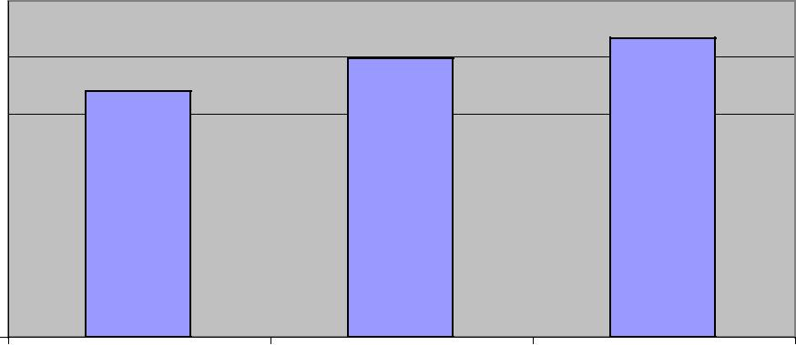
Source: Florida Legislative Office of Economic and Demographic Research

Visitor Population

Highlands County has a sizable seasonal population of “snowbirds”. The majority are retired and come to Florida in the winter to enjoy the warmer climate. Most arrive between October and Thanksgiving and leave after Easter.

The seasonal population is valued for its tremendous economic impact, yet very little is known about the number, timing, and characteristics of these residents; their origins and destinations, and the determinants and consequences of their movements.

Migrant and Seasonal Farmworker Population

Highlands County also has a migrant population and a seasonal farmworker population. The migrant population does not stay in Highlands County for the entire growing season. Seasonal farmworkers stay in the County, although they may travel to different employers over a wide geographical area. Statistics on the number, length of stay, and characteristics of migrants and seasonal farmworkers are not readily available.

5

Homeless Population

Highlands County also has a homeless population. Homeless is defined as living with relatives or friends, living in cars, living in the woods or on the streets.

In the 2011-2012 school year, the Highlands County School District reported 485 cases of homeless children and families. This represents close to a 400 percent increase over 2010-2011. The increase is likely due to both an expanded outreach program and to an actual increase in the number of homeless, primarily because of mortgage foreclosures on homes. These figures do not include adults who are homeless who have no children.

The Homeless Coalition of Highlands County counted 100 males and 31 females as homeless in 2011, but it is unknown how many had children and whether they also were included in the school district’s figures.

Age Distribution

Florida has one of the oldest populations in the United States, and Highlands County has one of the oldest populations in Florida.

According to the 2010 Census, 32.3% of the population is 65 years of age and older compared to 17.4% for Florida. The second largest percentage of the population is the 45-64 age group, which makes up 25.3% of the population. In 2010, the median age in the County was 51.5; in Florida, it was 40.7.

Figure 2

 |  |  | Population by Age, 2010
Population | 30.0
 | 25.0
 | 20.0 |  |  | Highlands County
 | 15.0
of |  |  |  | Florida
Percent | 10.0
 | 5.0
 | 0.0
 | 0-4 | 5-14 | 15-24 25-44 45-64 65-74 | > 74
 |  |  | Age Groups
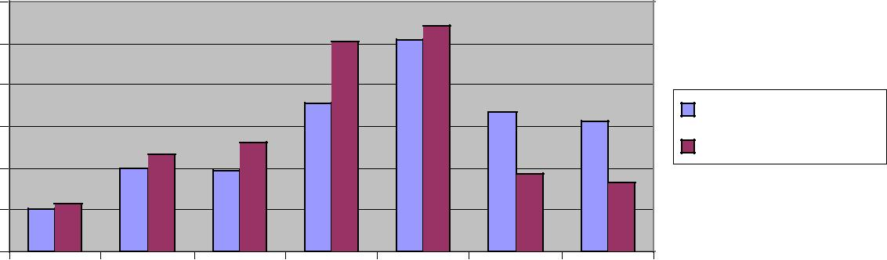
Source: Florida Legislative Office of Economic and Demographic Research

6

Based on population projections, Highlands County will continue to have an older population. In 2020, 34.4% of the population will be 65+, compared to 20.0% for Florida.

Figure 3

 |  |  | Population by Age, 2020
 | 30.0%
Population | 25.0%
 | 20.0% |  |  | Highlands County
 | 15.0%
of |  |  |  | Florida
Percent | 10.0%
 | 5.0%
 | 0.0%
 | 0-4 | 5-14 | 15-24 25-44 45-64 65-74 | >74
 |  |  | Age Groups
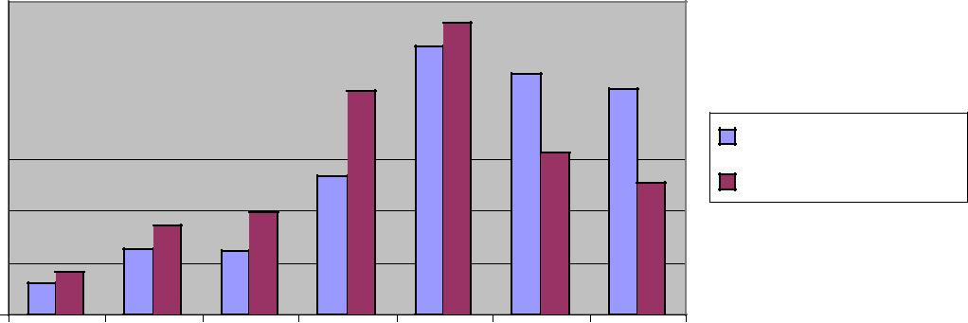
Source: Florida Legislative Office of Economic and Demographic Research

Gender

Highlands County’s 2010 population is 48.9% male and 51.1% female. These are the same percentages as in 2000. The percentage distribution of males and females for Florida is the same as for Highlands County. In 2020, the percentage of males and females also is projected to be the same for both Highlands County and Florida.

Figure 4

Highlands County Population,

by Sex, 2010

48.9%
51.1%

 |  | Male |  | Female

Source: Florida Legislative Office of Economic and Demographic Research

7

Race

According to the 2010 Census, Highlands County’s population is 81% white, 9.4% black or African-American, and 9.6% other. Florida’s population is 75% white; 16% black or African-American, and 9% other. Other includes respondents who answered either “Two or More Races” or “Other” on their census forms.

Figure 5

 |  | Population by Race, 2010
 | 90.0%
of Population | 80.0%
 | 70.0%
 | 60.0%
 | 50.0% |  | Highlands County
 | 40.0% |  | Florida
Percent
 | 30.0%
 | 20.0%
 | 10.0%
 | 0.0%
 | White | Black | Other
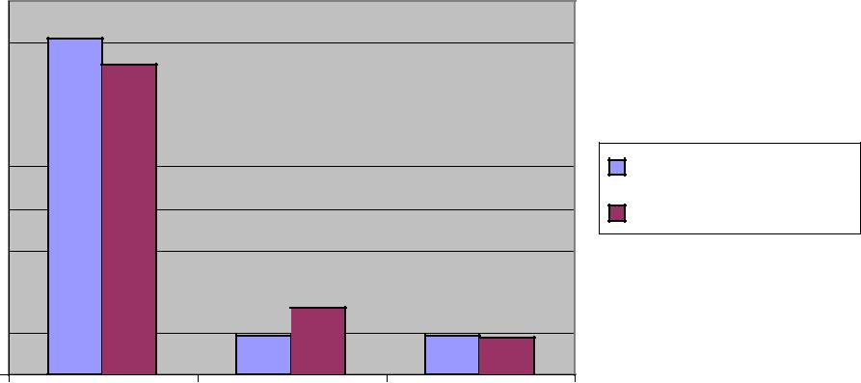
Source: Florida Legislative Office of Economic and Demographic Research

The racial make up of Highlands County has changed only slightly since 2000 and is projected to change only slightly by 2020.

Figure 6

 | Highlands County Population, by Race, by Year
 | 100.0%
Population | 90.0%
 | 80.0%
 | 70.0% |  | 2000
 | 60.0%
 | 50.0% |  | 2010
of
 | 40.0% |  | 2020
Percent
 | 30.0%
 | 20.0%
 | 10.0%
 | 0.0%
 | White | Black | Other
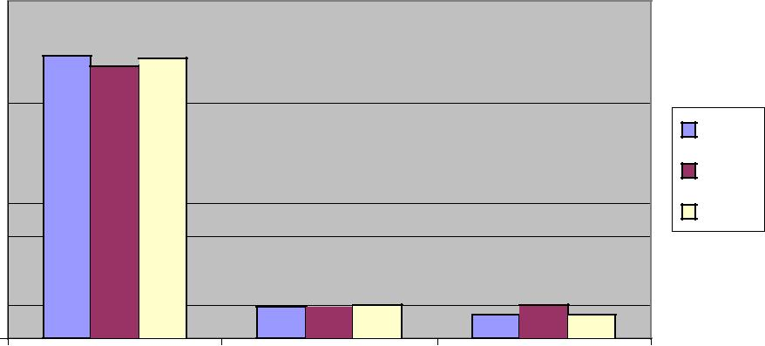
Source: Florida Legislative Office of Economic and Demographic Research

8

Ethnicity

Highlands County’s population is predominantly non-Hispanic. According to the 2010 Census, 82.8% of the population is non-Hispanic, and 17.4 percent is Hispanic. Florida’s 2010 population is 22.5% Hispanic and 77.5% non-Hispanic.

Figure 7

 |  | Population by Ethnicity, 2010
 | 90.0% |  | 82.6% _{77.5%}
 | 80.0%
Populaton
 | 70.0%
 | 60.0%
 | 50.0% |  | Highlands County
of | 40.0% |  | Florida
Percent |  | 22.5%
 | 30.0%
 |  | 17.4%
 | 20.0%
 | 10.0%
 | 0.0%
 |  | Hispanic | Non-Hispanic
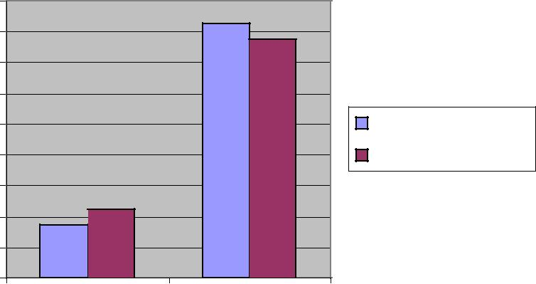
Source: Florida Legislative Office of Economic and Demographic Research

The Hispanic population in Highlands County has increased by 5.3% since 2000. In 2020, the Hispanic population is projected to represent 20.5% of the population.

Figure 8

 | Highlands County Population, by Ethnicity, by Year
 | 100.0%
Population | 90.0%
 | 80.0%
 | 70.0% | 2000
 | 60.0%
 | 50.0% | 2010
of
 | 40.0% | 2020
Percent
 | 30.0%
 | 20.0%
 | 10.0%
 | 0.0%
 | Hispanic | Non-Hispanic
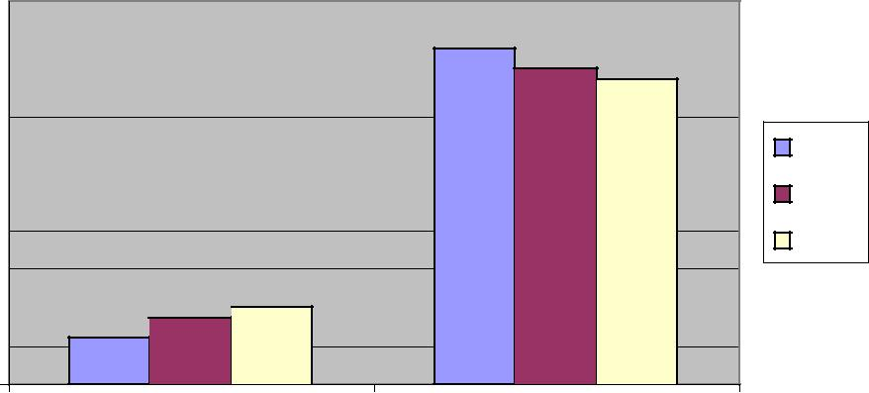
Source: Florida Legislative Office of Economic and Demographic Research

9

Language

A total of 17.9% of Highlands County residents 5 years of age and older who lived in the county from 2006-2010 speak a language other than English at home. A total of 7.8% say that they don’t speak English very well. The main language spoken in Highlands County besides English is Spanish.

Density of Population

Highlands County has a total land area of 1,106.28 square miles, of which 93% is land and 7% is water. It is a rural county, so there are fewer persons per square mile compared to Florida.

Figure 9

 | Density of Population
 | 400.0
Mile | 350.0
 | 300.0
Square
 | 250.0 | 2000
 | 200.0
per |  | 2010
 | 150.0
Persons
 | 100.0
 | 50.0
 | 0.0
 | Highlands County | Florida
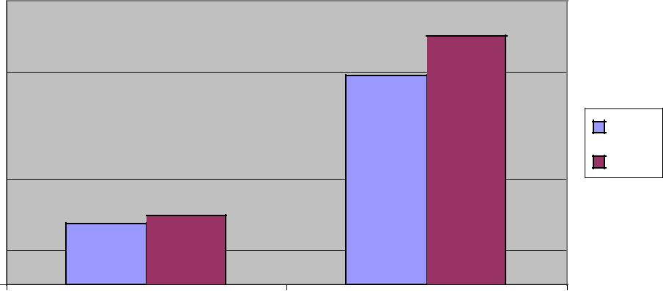
Source: Florida Legislative Office of Economic and Demographic Research

10

II. SOCIO-ECONOMIC CHARACTERISTICS

Family and Non-Family Households

According to the U.S. Census, there were 42,604 family and non-family households in Highlands County in 2010. Family households consist of a householder and one or more people related the householder by birth, marriage or adoption. Non-family households consist of people living alone and households which do not have a member related to the householder.

Family households made up 65.8% of all households in 2010. Most were married couple families. Non-family households made up 34.2 percent. Most were people living alone.

The average household size was 2.46 people.

Figure 10

Highlands County Households, 2010
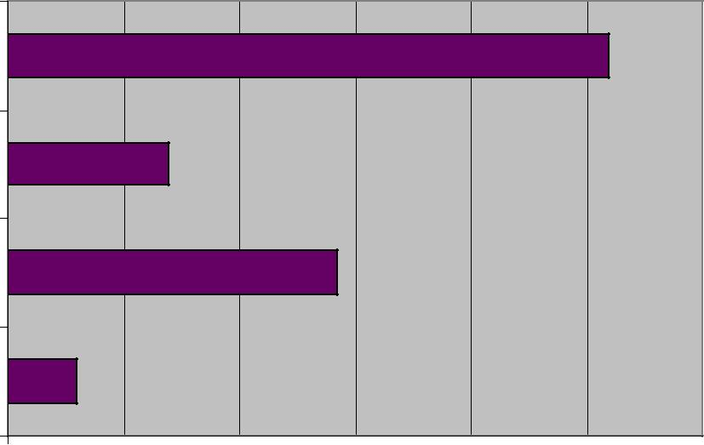

Married couple families

Other families

People living alone

Other non-family households

0.0% 10.0% 20.0% 30.0% 40.0% 50.0% 60.0%

Percent of Households

Source: U.S. Census Bureau, 2010 American Community Survey

11

Median Household Income

Median income is a mid-point which divides the income distribution into two equal groups, half having income above that amount and half having income below that amount. Median household income has grown more slowly in Highlands County compared to Florida.

Table 1: Median Household Income Highlands County
and Florida, 2000 and 2010 and Percent of Change

Median Household Income

Year | Highlands County | State of Florida
2000 | 30,160 | 38,819
2010 | 34,946 | 47,661
Increase | 15.9% | 23.9%
Source: U.S. Census Bureau, 2000 and 2010 American Community Survey

Distribution of Household Income

Highlands County has about the same percentage of households with income and benefits of $10,000 or less as Florida, but it has a higher percentage of households in the $10,000 to $50,000 range than Florida. Above $50,000, Highlands County has a lower percent of households than Florida.

Figure 11

Household Income Distribution, Highlands County, 2010

25.0%
20.0%
15.0% | Highlands
10.0% | Florida
5.0%
0.0%
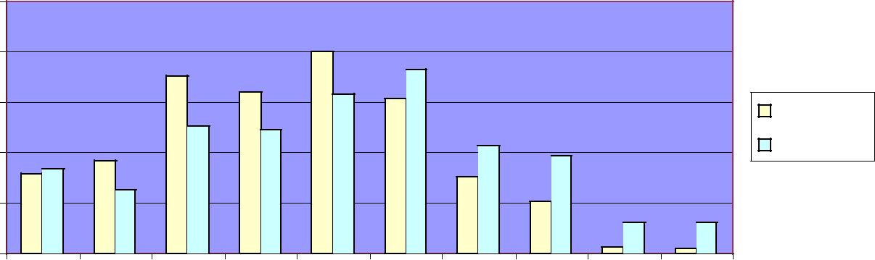
 |  | 0,000 |  |  |  | 999 |  |  | 999 |  |  | 99 |  |  | 999 |  | $74,999 |  | $99,999 |  |  |  | $149,999 |  | $199,999 |  |  | more
 | $1 |  |  | $14, |  |  |  | $24, |  |  | $34,9 |  |  | $49, |  |  |  |  |  |  |  |  |  |  |  |  | or
 |  |  | to |  |  |  | to |  |  | to |  |  | to |  |  | to |  | to
an |  | 0 |  |  |  | 0 |  |  | 0 |  |  | 0 |  |  |  |  | 0 |  |  |  | o |  |  | to |  | 000
 |  |  |  |  |  |  |  |  |  |  |  |  |  | $50,000 |  |  |  |  |  |  | t
s th |  | 0 |  |  |  | 0 |  |  | 0 |  |  | 0 |  |  |  |  | 0 |  |  | 00,000 |  | 150,000 |  |  | $200,
s |  | 0,0 |  |  | 5,0 |  |  | 25,0 |  |  |  | 5,0 |  |  |  |  | $75,0
Le | $1 |  |  | $1 |  |  |  |  |  |  | $3
 |  |  |  |  |  |  |  | $ |  |  |  |  |  |  |  |  |  | $1
 |  |  |  |  |  |  |  |  |  |  |  |  |  |  |  |  |  |  |  |  | $

Source: U.S. Census Bureau, 2010 American Community Survey

12

Poverty

Highlands County has a higher percentage of residents living in poverty than Florida. A total of 19.3% of individuals were living in poverty in 2010. Of those living in poverty, 33% were under the age of 18; 19.7% were 18-64, and 11% were age 65 and older.

Figure 12

Poverty, By Age Groups, 2010

35.0%
30.0%
25.0%
20.0% |  |  | Highlands
15.0% |  |  | Florida
10.0%
5.0%
0.0%
All Ages | Under 18 | 18 to 64 | 65 years and
 | Years | Years | over
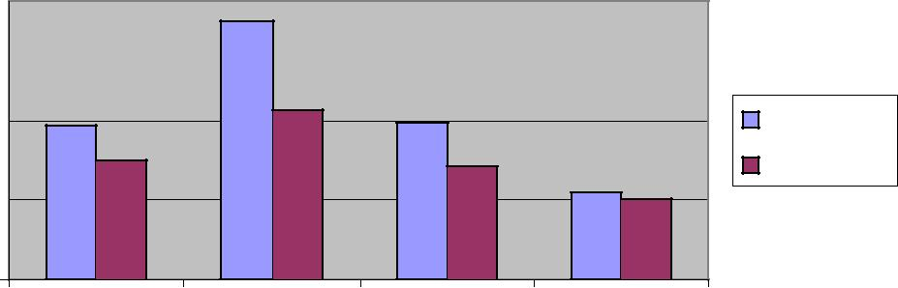
Source: U.S. Census, 2008-2010, American Community Survey, 3-Year Estimates

In Highlands County in 2010, 13.4% of all families lived in poverty and 28% of those families had children under age 18. The largest percent were female heads of household (37.6%). Living in poverty in 2010 meant that a family of four had a gross annual income of $22,050 or less.

Figure 13

Families in Poverty, 2010

60.0%
50.0%
40.0% | Highlands
30.0%
 | Florida
20.0%
10.0%
0.0%
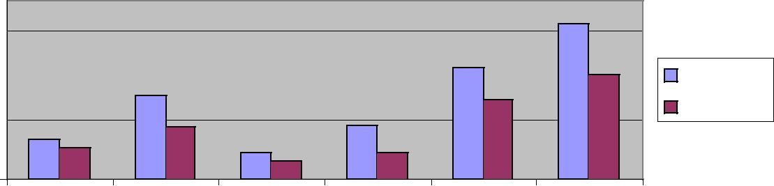
 |  |  |  |  |  |  |  | s |  |  |  |  | 8 |  |  |  |  |  |  |  |  | s |  |  |  |  |  |  |  | 8 |  |  |  |  |  |  |  |  |  |  |  |  | ) |  |  | 8
 |  |  |  |  |  |  |  |  |  |  |  | 1 |  |  |  |  |  |  |  |  |  |  |  |  |  |  |  |  | 1
 |  |  |  |  |  | e |  |  |  |  |  |  |  |  |  |  |  |  |  |  |  | e |  |  |  |  |  |  |  |  |  |  |  |  |  |  |  |  |  |  |  | d |  |  |  | 1
 |  |  |  |  | i |  |  |  |  |  |  | < |  |  |  |  |  |  |  |  |  | l |  |  |  |  |  |  | <
 |  |  |  |  | l |  |  |  |  |  |  |  |  |  |  |  |  |  |  |  | p |  |  |  |  |  |  |  |  |  |  |  |  |  |  |  |  |  |  |  | n |  |  |  |  | <
 |  |  |  |  | i |  |  |  |  |  |  | n |  |  |  |  |  |  |  |  |  |  |  |  |  |  |  | n |  |  |  |  |  |  |  |  |  |  | a
 |  |  |  | m |  |  |  |  |  |  |  |  |  |  |  |  |  |  | u |  |  |  |  |  |  |  |  |  |  |  |  |  |  |  |  |  | b |  |  |  |  |  |  |  |  | n
 |  | a |  |  |  |  |  |  |  |  | e |  |  |  |  |  |  |  | o |  |  |  |  |  |  |  | e |  |  |  |  |  |  |  |  | s |  |  |  |  |  |  |  |  | e
 |  | F |  |  |  |  |  |  |  |  | r |  |  |  |  |  |  | C |  |  |  |  |  |  |  |  | r |  |  |  |  |  |  | u |  |  |  |  |  |  |  |  |  |  | r
 |  |  |  |  |  |  |  |  |  | d |  |  |  |  |  |  |  |  |  |  |  |  |  |  |  | d |  |  |  |  |  |  |  | h |  |  |  |  |  |  |  |  |  | d
 | l |  |  |  |  |  |  |  |  | l |  |  |  |  |  |  | d |  |  |  |  |  |  |  | l |  |  |  |  |  |  |  |  |  |  |  |  |  |  |  |  |  |  | l
l |  |  |  |  |  |  |  |  |  | i |  |  |  |  |  |  |  |  |  |  |  |  |  |  | i |  |  |  |  |  |  |  | o |  |  |  |  |  |  |  |  |  |  | i
A |  |  |  |  |  |  |  |  | h |  |  |  |  |  |  | e |  |  |  |  |  |  |  | h |  |  |  |  |  |  |  |  |  |  |  |  |  |  |  |  |  |  |  | h
 |  |  |  |  |  |  |  |  | C |  |  |  |  |  | i |  |  |  |  |  |  |  | C |  |  |  |  |  |  |  |  | n
 |  |  |  |  |  |  |  |  |  |  |  |  |  | r |  |  |  |  |  |  |  |  |  |  |  |  |  |  |  |  | ( |  |  |  |  |  |  |  |  |  |  |  |  | C
 |  |  |  |  |  |  |  | h |  |  |  |  |  | r |  |  |  |  |  |  |  | h
 |  |  |  |  |  |  |  |  |  |  |  |  | a |  |  |  |  |  |  |  |  |  |  |  |  |  |  |  |  |  | d |  |  |  |  |  |  |  |  |  |  |  | h
 |  |  |  |  |  |  | t |  |  |  |  |  |  |  |  |  |  |  |  |  |  | t |  |  |  |  |  |  |  | a |  |  |  |  |  |  |  |  |  |  |  | t
 |  |  |  |  |  | i |  |  |  |  |  | M |  |  |  |  |  |  |  |  |  | i |  |  |  |  |  |  |  |  |  |  |  |  |  |  |  |  |  |  |  | i
 |  |  |  |  | w |  |  |  |  |  |  |  |  |  |  |  |  |  |  |  | w |  |  |  |  |  |  |  | e |  |  |  |  |  |  |  |  |  |  | w
 |  |  |  |  |  |  |  |  |  |  |  |  |  |  |  |  |  |  |  |  |  |  |  |  |  |  |  |  | h
 |  |  |  |  | s |  |  |  |  |  |  |  |  |  |  |  |  |  |  | s |  |  |  |  |  |  |  | e |  |  |  |  |  |  |  |  |  | ,
 |  |  | e |  |  |  |  |  |  |  |  |  |  |  |  |  |  |  | e |  |  |  |  |  |  |  |  |  |  |  |  |  |  |  |  |  | d
 |  | i |  |  |  |  |  |  |  |  |  |  |  |  |  |  |  |  | l |  |  |  |  |  |  |  | l |  |  |  |  |  |  |  | a
 |  | l |  |  |  |  |  |  |  |  |  |  |  |  |  |  |  | p |  |  |  |  |  |  |  |  | a
 |  | i |  |  |  |  |  |  |  |  |  |  |  |  |  |  |  |  |  |  |  |  |  |  |  | m |  |  |  |  |  |  |  | e
 | m |  |  |  |  |  |  |  |  |  |  |  |  |  |  |  | u |  |  |  |  |  |  |  |  |  |  |  |  |  |  |  |  | h
a |  |  |  |  |  |  |  |  |  |  |  |  |  |  |  | o |  |  |  |  |  |  |  |  | e |  |  |  |  |  |  | e
F |  |  |  |  |  |  |  |  |  |  |  |  |  |  | C |  |  |  |  |  |  |  |  | F |  |  |  |  |  |  |  | l
 |  |  |  |  |  |  |  |  |  |  |  |  |  | d |  |  |  |  |  |  |  |  |  |  |  |  |  |  |  |  | a
 |  |  |  |  |  |  |  |  |  |  |  |  | e |  |  |  |  |  |  |  |  |  |  |  |  |  |  |  |  |  | m
 |  |  |  |  |  |  |  |  |  |  |  | i |  |  |  |  |  |  |  |  |  |  |  |  |  |  |  |  | e
 |  |  |  |  |  |  |  |  |  |  |  | r
 |  |  |  |  |  |  |  |  |  |  |  | r |  |  |  |  |  |  |  |  |  |  |  |  |  |  |  |  | F
 |  |  |  |  |  |  |  |  |  |  |  | a
 |  |  |  |  |  |  |  |  |  |  | M

Source: U.S. Census, 2008-2010, American Community Survey, 3-Year Estimates

13

Major Employers

According to the Heartland Workforce Board, the public sector employed more than 4,000 workers in Highlands County in 2011. The largest private sector employers accounted for 23,486 jobs. The largest private sector employer was Florida Hospital Heartland Division. Major public and private employers are listed below.

TABLE 2: PRIVATE AND PUBLIC SECTOR EMPLOYMENT, HIGHLANDS COUNTY, 2011
Private Sector

Florida Hospital Heartland Division

Number of Employees 1,300

Highlands Regional Medical Center

Number of Employees 500

Cross Country Automotive Services

Number of Employees 500

Wal-Mart Sebring

Number of Employees 450

Medical Data Systems

Number of Employees 387

Delray Plants/Highlands Greenhouse

Number of Employees 350

Lake Placid Heathcare

Number of Employees 290

Alan Jay Network

Number of Employees 290

Palms of Sebring Assisted Living

Number of Employees 264

Lowes

Number of Employees 125
Public Sector, 2011

Local Government

Number of Employees……………………………………..3,384

State Government

Number of Employees……………………………………….391

Federal Government

Number of Employees……………………………………… 246

Source: Enterprise Florida (private sector data) and Heartland Workforce Board (public sector data)

14

Major Employment Sectors

In Highlands County, the major employment sector is Educational Services, Health Care, and Social Assistance. Sectors with at least 5 percent of the civilian employed labor force are as follows:

Educational services, health care, and social assistance | 23.4%
Retail trade | 15.6%
Agriculture, forestry, fishing and hunting, and mining | 9.1%
Professional, scientific, management, administrative,
waste management services | 8.5%
Construction | 8.2%
Arts, entertainment, recreation, accommodation and food services | 8.2%
Public administration | 5.7%

Labor Force

The annual unemployment rate in Highlands County rose from 4.8% in 2000 to 11.3% in 2010. The rate dropped slightly to 10.4% in 2011. The unemployment rate for June 2012 was 8.9%.

Florida’s unemployment rate went from 3.9% in 2000 to 11.3% in 2010 and then decreased to 10.5% in 2011. The unemployment rate for Florida for June 2012 was 9.0%.

These rates are not seasonally adjusted.

Figure 14

Unemployment Rates, by Year

 | 12.0%
 | 10.0%
Percent | 8.0% | 2000
 | 6.0% | 2010
 | 4.0% | 2011
 | 2.0%
 | 0.0%
 | Highlands | Florida
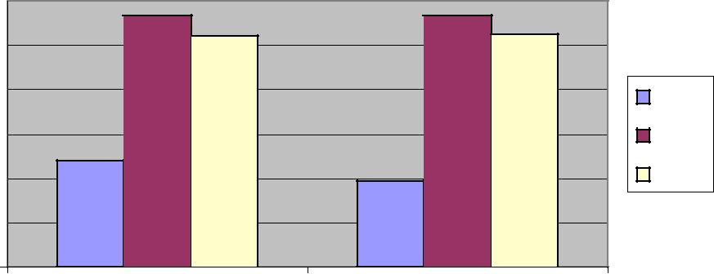
Source: U.S. Census, 2008-2010, American Community Survey, 3-Year Estimates

15

Educational Attainment

A total of 56.8% of Highlands County’s 2010 population aged 25 and older have a high school degree or less, and 43.2% have some college or a higher education degree

Figure 15

Highlands County Educational Attainment, 2010

 |  |  |  | Less than 9th grade
9.1% | 5.0% | 7.7% | 13.2% | High school, no diploma
7.2% |  |  |  | High school graduate, GED
 |  |  |  | Some college, no degree
21.9% |  |  | 35.9% | Associate's degree
 |  |  |  | Bachelor's degree
 |  |  |  | Graduate or professional
 |  |  |  | degree
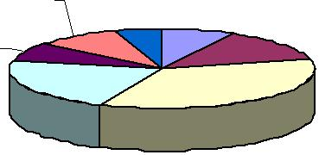
Source: U.S. Census, 2008-2010, American Community Survey, 3-Year Estimates

16

III. MAJOR CAUSES OF DEATH AND PREMATURE DEATH

Leading Causes of Death

The five major causes of death and premature death in both Highlands County and Florida, measured in terms of the three-year age adjusted death rate, are Heart Disease, Cancer, Chronic Lower Respiratory Disease, Stroke, and Unintentional Injuries.

The leading causes of death vary by age group. According to the Florida Vital Statistics 2010 Annual Report,

- Unintentional injuries are the leading cause of death for Florida residents and for Highlands County residents ages 1-44;

- Cancer is the leading cause of death for Florida and Highlands County residents ages 45-64;

- Heart disease is the leading cause of death for Florida and Highlands County residents ages 65 and over; and

- Conditions associated with complications in the perinatal period are the leading cause of death for infants less than 1 year old.

17

Heart Disease

Heart disease is the leading cause of death in Highlands County and Florida. Although deaths from heart disease have declined, Highlands County’s death rate of 145.9 for 2009-2011 is higher than the Healthy People 2020 goal of 100.8 deaths per 100,000 population.

Figure 16

 |  | Heart Disease Age-Adjusted Death Rate,
 |  | 3 Year Rolling Rates
100,000 | 250
 | 200 | Highlands
 | 150
per | 100 | State
 | 50
Rate
 | 0
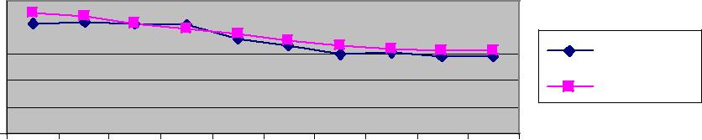
 | -02 |  | -03 |  | -04 |  |  |  | 5 |  |  |  | 6 | -07 |  | -08 |  |  | -09 |  |  |  | 0 | -11
 |  |  |  |  |  |  |  | 0 |  |  |  | 0 |  |  |  |  |  |  |  |  |  | 1
 |  |  |  |  |  |  | - |  |  |  | - |  |  |  |  |  |  |  |  |  | -
 | 00 |  | 01 | 2002 |  | 2003 |  |  |  | 04 |  |  |  | 05 |  | 6 |  | 7 |  | 08 |  |  |  | 09
 |  |  |  |  |  |  |  |  |  |  |  |  |  |  |  | 0 | 0
20 |  | 20 |  |  |  |  |  |  | 0 |  |  |  | 20 |  | 20 |  | 20 |  | 0 |  |  |  | 20
 |  |  |  |  |  |  |  |  | 2 |  |  |  |  |  |  |  |  |  | 2
Year

Source: Florida Department of Health CHARTS.

Deaths from heart disease are declining for all races. But the heart disease death rate for Blacks in Highlands County and in Florida is higher than the rate for Whites.

Figure 17

Heart Disease Age-Adjusted Death Rate,

3-Year Rolling Rates, Race

100,000 | 400
 | 300
 | 200
per
 | 100
Rate
 | 0
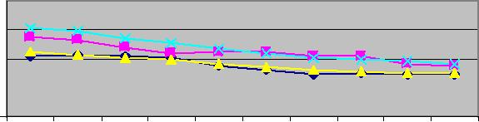
-02 |  |  | -03 |  | -04 |  | -05 |  |  | -06 |  |  |  | 7 | -08 |  |  | -09 |  |  |  | 0 |  | -11
 |  |  |  |  |  |  |  |  |  |  |  |  | 0 |  |  |  |  |  |  |  | 1
 |  |  |  |  |  |  |  |  |  |  |  | - |  |  |  |  |  |  |  | -
2000 |  | 1 |  | 2002 |  | 2003 |  |  | 4 |  | 2005 |  |  |  | 6 |  | 7 |  |  | 8 |  |  | 2009
 | 00 |  |  |  |  |  |  | 00 |  |  |  |  |  | 20 | 0 | 00 |  |  | 200
 | 2 |  |  |  |  |  |  | 2 |  |  |  |  |  |  |  | 2
Year

Highlands White

Highlands Black

State White

State Black

Source: Florida Department of Health CHARTS

18

Hispanics in Highlands County have lower death rates from heart disease than the State’s Hispanics and than non-Hispanics.

Figure 18

 | Heart Disease Age-Adjusted Death Rate,
 |  | 3-Year Rolling Rates, Ethnicity
100,000 | 200 |  |  | Highlands Hispanic
 | 150
 | 100 |  |  | Highlands Non-
per
 |  |  |  | Hispanic
 | 50
Rate |  |  |  | State Hispanic
 | 0
 | 2004-06 | 2005-07 | 2006-08 | State Non-Hispanic
 |  | Year
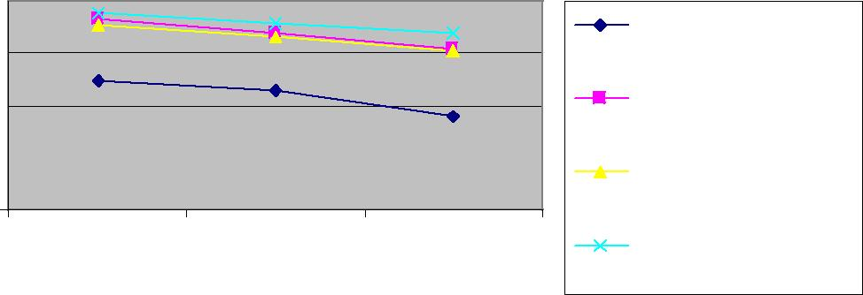
Source: Florida Department of Health CHARTS.

19

Cancer

Cancer is the second leading cause of death in Highlands County and in Florida. For those from ages 45-64, it is the leading cause of death.

Death rates from cancer have declined slightly for both Highlands County and Florida from 2000-2011. With a cancer death rate of 152.3, Highlands County has exceeded the Healthy People 2020 goal of 160.6 deaths per 100,000 population.

Figure 19

 | All Cancers Age-Adjusted Death Rate,
 | 3-Year Rolling Rates
100,000 | 200
 | 150
 | Highlands
per | 100
 | State
 | 50
Rate
 | 0
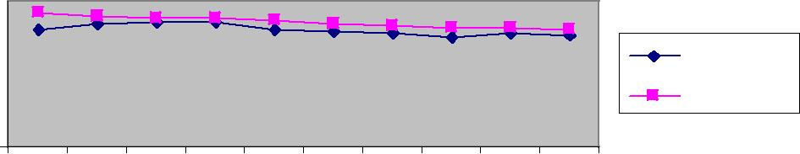
-02 |  |  |  |  | 3 |  |  |  | 4 | -05 |  | -06 |  |  |  | 7 |  | -08 |  | -09 |  | -10 |  |  |  | 1
 |  |  |  | 0 |  |  |  | 0 |  |  |  |  |  |  | 0 |  |  |  |  |  |  |  |  |  | 1
 |  |  | - |  |  |  | - |  |  |  |  |  |  | - |  |  |  |  |  |  |  |  |  | -
0 |  | 1 |  |  |  | 2 |  |  |  | 3 |  | 4 |  | 5 |  |  | 2006 |  |  | 7 |  | 8 |  | 9
0 | 0 |  |  |  | 200 |  |  |  |  | 0 |  | 0 | 00 |  |  |  |  |  |  | 0 |  | 0 | 200
20 | 20 |  |  |  |  |  |  |  | 20 |  | 20 |  | 2 |  |  |  |  |  | 20 |  | 20
Year

Source: Florida Department of Health CHARTS.

The cancer death rate for Blacks in Highlands County has declined in the last ten years and is now lower than that for Whites in Highlands County.

Figure 20

All Cancers Age-Adjusted Death Rate, by Race, 3-Year Rolling Rates

Rate per 100,000

400
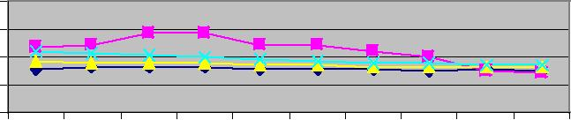
300
200
100
0

 | -02 |  |  | -03 |  |  | -04 |  |  | -05 |  |  | -06 |  |  | -07 |  |  | -08 |  |  | -09 |  | -10 |  | -11
0 |  |  | 1 |  |  | 2 |  |  | 3 |  |  | 4 |  |  | 5 |  |  | 6 |  |  | 7 |  | 2008 |  | 2009
0 |  | 0 |  |  | 0 |  |  | 0 |  |  | 0 |  |  | 0 |  |  | 0 |  |  | 0
20 |  | 20 |  |  | 20 |  |  | 20 |  |  | 20 |  |  | 20 |  |  | 20 |  |  | 20
Year

Highlands White

Highlands Black

State White

State Black

Source: Florida Department of Health CHARTS

The death rate from cancer for Hispanics in Highlands County is lower than for non-Hispanics and lower than the State rate for both Hispanics and non-Hispanics.

20

FIGURE 21
 | All Cancers Age-Adjusted Death Rate,
 |  | 3-Year Rolling Rates, Ethnicity
100,000 | 200 |  |  | Highlands Hispanic
 | 150
 | 100 |  |  | Highlands Non-
per
 |  |  |  | Hispanic
 | 50
Rate |  |  |  | State Hispanic
 | 0
 | 2004-06 | 2005-07 | 2006-08 | State Non-Hispanic
 |  | Year
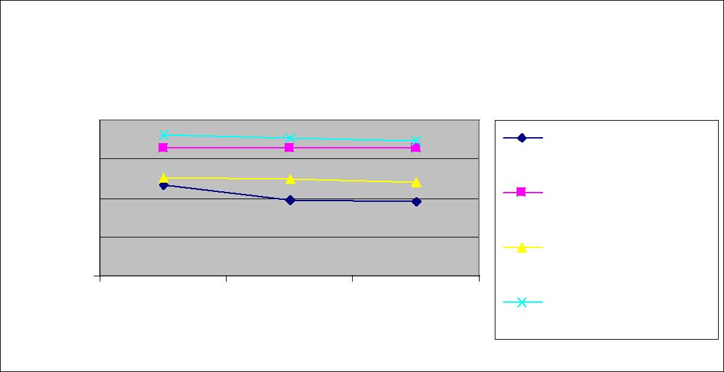
Source: Florida Department of Health CHARTS

Table 3 shows that the County had a higher death rate for lung cancer and for cervical cancer than the State. It also ranks in the bottom 25 out of all 67 counties for cervical cancer. It has not met the Healthy People 2020 goals for lung cancer, cervical cancer, and melanoma.

TABLE 3: Most Common Causes of Death from Cancer, Highlands County, 2010
 |  |  |  |  |  |  |  |  |  |  | County
 |  |  |  |  |  |  |  |  |  |  | Trend |  |  | Healthy
 |  |  |  | County Quartile^{A} |  |  |  |  |  |  | (click |  |  | People
 |  |  |  | 1=most favorable |  |  |  |  | County | State | to |  |  | 2020
 | Indicator | Year(s) | Rate Type | 4=least favorable |  |  |  |  | Rate | Rate | view) |  |  | Goals
 | Lung Cancer
 | Age-adjusted death rate⁷ | 2008-10 | Per 100,000 |  |  |  |  |  | 49.7 | 47.2 | No | Trend |  | 45.5
 | Colorectal Cancer
 | Age-adjusted death rate⁷ | 2008-10 | Per 100,000 |  |  |  |  |  | 13.1 | 14.6 | No | Trend |  | 14.5
 | Breast Cancer
 | Age-adjusted death rate⁷ | 2008-10 | Per 100,000 |  |  |  |  |  | 17.4 | 21.0 | No | Trend |  | 20.6
 | Prostate Cancer
 | Age-adjusted death rate⁷ | 2008-10 | Per 100,000 |  |  |  |  |  | 16.1 | 18.2 | No | Trend | 21.2
 | Cervical Cancer
 | Age-adjusted death rate⁷ | 2008-10 | Per 100,000 |  |  |  |  |  | 5.5 | 2.7 | No | Trend | 2.2
 | Melanoma
 | Age-adjusted death rate⁷ | 2008-10 | Per 100,000 |  |  |  |  |  | 2.7 | 2.8 | No | Trend | 2.4
Source: Florida Department of Health CHARTS

^{A/} Florida CHARTS uses quartiles to compare health data from one county to another county. 1 = Most favorable situation or 25% of counties; 2 or 3 = Average or 50% of counties; 4 = Least favorable situation = Least favorable situation.

21

Chronic Lower Respiratory Disease

The third leading cause of death in Highlands County and Florida is Chronic Lower Respiratory Disease (CLRD). CLRD refers to a group of diseases that cause airflow blockage and breathing-related problems. These include chronic bronchitis, emphysema, and some forms of asthma. The leading cause of CLRD is smoking.

Death rates from CLRD increased in Highlands County from 2000 to 2011, while death rates for the State remained about the same. The death rate for Highlands County is lower than the Healthy People 2020 goal of 98.5 deaths/100,000 population, but it is higher than the CLRD death rate for Florida.

Figure 22

Chronic Lower Respiratory Disease Age-Adjusted Death

 |  | Rate, 3-Year Rolling Rate
100,000 | 60
 | 50
 | 40 | Highlands
per | 30 | State
 | 20
 | 10
Rate
 | 0
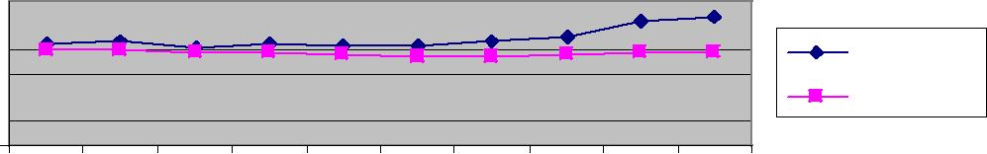
 |  | 2 |  |  | 3 |  |  | 4 |  |  | 5 |  |  | 6 |  |  | 7 |  |  | 8 |  |  | 9 |  |  | 0 |  |  | 1
 | 0 |  |  | 0 |  |  | 0 |  |  | 0 |  |  | 0 |  |  | 0 |  |  | 0 |  |  | 0 |  |  | 1 |  |  | 1
- |  |  | - |  |  | - |  |  | - |  |  | - |  |  | - |  |  | - |  |  | - |  |  | - |  |  | -
00 |  |  | 01 |  |  | 02 |  |  | 03 |  |  | 04 |  |  | 05 |  |  | 06 |  |  | 07 |  |  | 08 |  |  | 09
20 |  |  | 20 |  |  | 20 |  |  | 20 |  |  | 20 |  |  | 20 |  |  | 20 |  |  | 20 |  |  | 20 |  |  | 20
Year

Source: Florida Department of Health CHARTS

The white population in Highlands County has a higher death rate from CLRD than the Black population. In addition, the death rate for Whites is increasing, while the death rate for Blacks is declining.

Figure 23

Chronic Lower Respiratory Disease Age-Adjusted Death

Rate, 3-Year Rolling Rates, Race

100,000 | 60
 | 50
 | 40
 | 30
per
 | 20
 | 10
Rate
 | 0
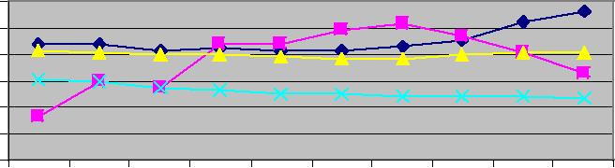
-02 |  | -03 |  | -04 |  | -05 |  |  |  | 6 |  | -07 |  | -08 |  | -09 |  | -10 |  | -11
 |  |  |  |  |  |  |  |  | 0
 |  |  |  |  |  |  |  | -
2000 | 2001 |  |  | 002 | 003 |  |  | 4 |  |  | 2005 |  | 2006 |  | 2007 |  | 2008 |  |  | 009
 |  |  |  |  |  |  | 0
 |  |  |  |  |  |  | 0
 |  |  | 2 |  | 2 |  | 2 |  |  |  |  |  |  |  |  |  |  |  | 2
Year

Highlands White

Highlands Black

State White

State Black

Source: Florida Department of Health CHARTS

22

Highlands County Hispanics experience a higher death rate from CLRD than the State Hispanic population, and than non-Hispanics.

Figure 24

Chronic Lower Respiratory Disease Age-
Adjusted Death Rate, 3-Year Rolling Rates,
 |  | Ethnicity
60 |  | Highlands Hispanic
50
40 |  | Highlands Non-
30 |  | Hispanic
20 |  | State Hispanic
10
0 |  | State Non-Hispanic
2004-06 | 2005-07 | 2006-08
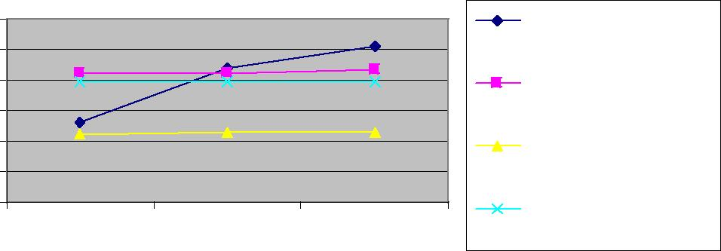
Source: Florida Department of Health CHARTS

23

Stroke

Strokes are the fourth leading cause of death in Highlands County. From 2009-2011, Highlands County’s death rate from strokes was slightly lower than the State stroke death rate. Highlands meets the Healthy People 2020 target goal of 33.8 deaths per 100,000.

Figure 25

 |  | Stroke Age-Adjusted Death Rate,
 |  | 3-Year Rolling Rates
100,000 | 50
 | 40 | Highlands
 | 30
per | 20 | State
 | 10
Rate
 | 0
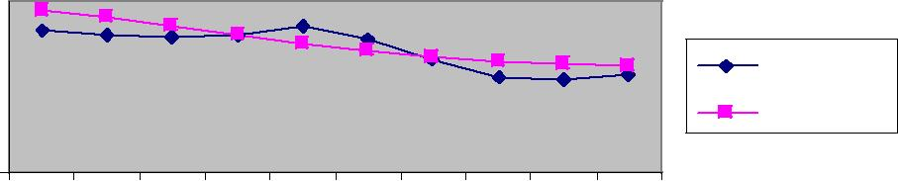
-02 |  | -03 |  | -04 |  | -05 |  | -06 |  | -07 |  |  |  |  | 8 | -09 |  | -10 |  |  |  | 1
 |  |  |  |  |  |  |  |  |  |  |  |  |  | 0 |  |  |  |  |  |  | 1
 |  |  |  |  |  |  |  |  |  |  |  |  | - |  |  |  |  |  |  | -
0 |  | 1 |  | 2 |  | 3 |  | 4 | 2005 |  |  | 6 |  |  |  | 7 |  | 8 |  | 9
0 | 0 |  | 200 |  |  | 0 | 0 |  |  |  | 200 |  |  |  |  | 0 | 0 |  | 200
20 | 20 |  |  |  | 20 |  | 20 |  |  |  |  |  |  |  | 20 |  | 20
Year

Source: Florida Department of Health CHARTS

The Black population has a higher death rate from strokes than the white population. But the death rate is declining for both racial groups.

Figure 26

Stroke Age-Adjusted Death Rate,

3-Year Rolling Rates, Race

100,000 | 120
 | 100
 | 80
 | 60
per
 | 40
 | 20
Rate
 | 0
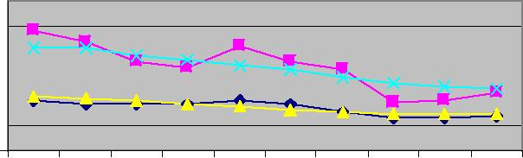
-02 |  |  |  | 3 | -04 |  |  |  | 5 | -06 |  |  |  | 7 | -08 |  |  |  | 9 | -10 |  |  |  | 1
 |  |  | 0 |  |  |  |  | 0 |  |  |  |  | 0 |  |  |  |  | 0 |  |  |  |  | 1
 |  | - |  |  |  |  | - |  |  |  |  | - |  |  |  |  | - |  |  |  |  | -
0 |  | 1 |  |  | 2 |  | 3 |  |  | 4 |  | 5 |  |  | 6 |  | 7 |  |  | 8 |  | 9
0 | 00 |  |  |  | 0 | 200 |  |  |  | 0 | 00 |  |  |  | 0 |  | 0 |  |  | 0 |  | 0
20 | 2 |  |  | 20 |  |  |  |  | 20 |  | 2 |  |  | 20 |  | 20 |  |  | 20 |  | 20
Year

Highlands White

Highlands Black

State White

State Black

Source: Florida Department of Health CHARTS

24

The death rate from stroke has only been measured for Hispanics since 2004. Stroke death rates for the Hispanic population in Highlands County are lower than the stroke death rates for non-Hispanics in Highlands County and than the State Hispanic rate.

Figure 27

Stroke Age-Adjusted Death Rate,

3-Year Rolling Rates, Ethnicity

100,000 | 60
 | 40
per | 20
Rate | 0
 | 2004-06 | 2005-07 | 2006-08
 |  | Year
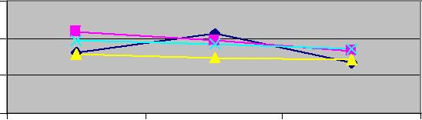
Highlands

Hispanic

Highlands Non-

Hispanic

State Hispanic

State Non-

Hispanic

Source: Florida Department of Health CHARTS.

25

Unintentional Injuries

Unintentional injuries are the fifth leading cause of deaths in Highlands County. Unintentional injuries include those that result from motor vehicle collisions, falls, poisonings, drowning, suffocation, choking, animal bites, and recreational activities.

Highlands County and the State have an unintentional injury death rate respectively of 45.8 and 43.1 per 100,000 population. The Healthy People 2020 goal is 36.0.

Figure 28

Unintentional Injuries Age-Adjusted Death Rate,

 |  | 3-Year Rolling Rates
100,000 | 60
 | 50
 | 40 | Highlands
per | 30 | State
 | 20
 | 10
Rate
 | 0
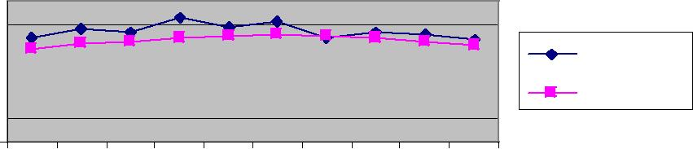
-02 |  |  |  | 3 | -04 |  | -05 |  |  |  | 6 | -07 |  | -08 |  |  |  | 9 | -10 |  | -11
 |  |  | 0 |  |  |  |  |  |  | 0 |  |  |  |  |  |  | 0
 |  | - |  |  |  |  |  |  | - |  |  |  |  |  |  | -
0 |  | 1 |  |  | 2 |  | 3 |  | 4 |  |  | 5 |  | 6 |  | 7 |  |  | 8 |  | 9
0 | 0 |  |  | 200 |  | 0 |  | 0 |  |  | 0 |  | 0 |  | 0 |  |  | 200 |  | 0
20 | 20 |  |  |  |  | 20 |  | 20 |  |  | 20 |  | 20 |  | 20 |  |  |  |  | 20
Year

Source: Florida Department of Health CHARTS.

Blacks in Highlands County and in the State have a lower death rate from unintentional injuries than the white population in either Highlands County or Florida. From 2007-2011, there was also a sharp drop in the Black death rate in Highlands County from unintentional injuries

Figure 29

Unintentional Injuries Age-Adjusted Death Rate,

3-Year Rolling Rates, Race

100,000 | 60
 | 50
 | 40
 | 30
per
 | 20
 | 10
Rate
 | 0
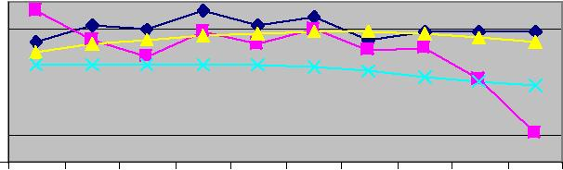
-02 |  |  |  | 3 | -04 |  | -05 |  | -06 |  | -07 |  |  |  | 8 | -09 |  |  |  |  | 0 |  |  | 1
 |  |  | 0 |  |  |  |  |  |  |  |  |  |  | 0 |  |  |  |  |  | 1 |  |  | 1
 |  | - |  |  |  |  |  |  |  |  |  |  | - |  |  |  |  |  | - |  |  | -
0 |  | 1 |  |  | 2 |  | 3 |  | 4 |  | 5 |  | 6 |  |  | 7 |  | 8 |  |  |  | 9
0 |  | 0 |  |  | 0 |  | 0 | 200 |  |  | 0 | 00 |  |  |  | 0 | 0 |  |  |  | 200
20 | 20 |  |  | 20 |  | 20 |  |  |  | 20 |  | 2 |  |  | 20 |  | 20
Year

Highlands White

Highlands Black

State White

State Black

Source: Florida Department of Health CHARTS

26

The non-Hispanic population in Highlands County and in the State has a higher death rate from unintentional injuries than the Hispanic population.

Figure 30

Unintentional Injuries Age-Adjusted Death Rate, 3-

Year Rolling Rates, Ethnicity

100,000 | 60
 | 50
 | 40
 | 30
per
 | 20
Rate
 | 10
 | 0
 | 2004-06 | 2005-07 | 2006-08
 |  | Year
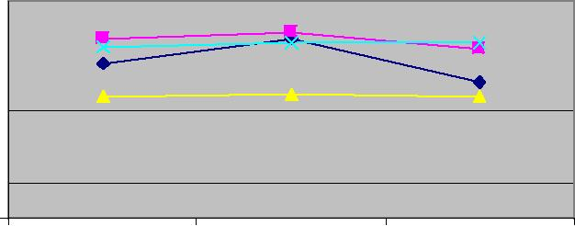

Highlands Hispanic

Highlands Non-

Hispanic

State Hispanic

State Non-Hispanic

Source: Florida Department of Health CHARTS.

The cause of unintentional injury deaths varies by age. The leading cause of unintentional injury death in infants less than 1 year of age in Florida is suffocation. In Highlands County for the three-year period 2008-2010, there were 4 reported cases of infant deaths from unintentional injuries.

Suffocation is the leading cause of unintentional injury deaths for young children 1-4 years of age in Florida. In Highlands County for the three-year period 2008-2010, there have been 2 cases of unintentional drowning deaths or a death rate of 16.8 per 100,000.

Motor vehicle crashes are the leading cause of death from unintentional injuries among children, adolescents, and young adults between the ages of 5 and 24 in Florida. In Highlands County for the three year period 2008-2010, there were 12 deaths from motor vehicle crashes or a death rate of 20.2 per 100,000.

Unintentional poisoning is the leading cause of unintentional injury death among adults 25 to 64 years of age in Florida. The majority of unintentional poisoning results from drug overdoses. In Highlands County for the three-year period 2008-2010, there have been 18 deaths from unintentional poisonings or a death rate of 14.2 deaths per 100,000.

Falls are the leading cause of fatal injuries for adults 65 and older in Florida. In Highlands County for the three-year period 2008-2010, there have been 26 deaths from falls or a death rate of 27.1 per 100,000.

27

IV. CHRONIC DISEASES

Chronic Disease Health Status, Adults

Death rates are only one measure of the health of a community and underscore the seriousness of chronic diseases. Chronic diseases can result in pain and suffering, cause major limitations in activity and a decreased quality of life, and eventually lead to costly hospitalizations.

Table 4 presents the Highlands County death rate, incidence rate, hospitalization rate, and screening rate for various chronic diseases, including coronary heart disease, cancers, chronic lower respiratory disease, strokes, and diabetes.

The County rate is compared to the State rate and, where applicable, to the Healthy People 2020 national goals. The County rate is also compared to the disease rate in other counties.

County trends are indicated when 12 or more years of data are available.
Trend is getting better and is statistically significant
Trend is getting worse and is statistically significant
Trend is not statistically significant
Blank cell – Not enough data to compute a trend

Table 4 reveals that Highlands County did not compare favorably in 2008-2010 to the State, other Florida counties, or the Healthy People 2020 goal for several chronic diseases, including chronic lower respiratory disease (CLRD), asthma, diabetes, and melanoma.

- CLRD. The CLRD age-adjusted death rate was higher than both the State rate and the rate in three-quarters of the other Florida counties. The rate was also significantly worse than in previous years. The age-adjusted hospitalization rate was 640.3 while the Healthy People 2020 goal is 50.1.

- Asthma. The asthma hospitalization rate in Highlands County was 1052.1 per 100,000 population. This is higher than the State rate, and the rate in three-quarters of the other Florida counties. It also was worse than in previous years.

- Diabetes. The diabetes age-adjusted hospitalization rate was 2488.3 per 100,000 population, which is higher than the State rate and higher than half the other Florida counties. It also was worse than in previous years.

- Melanoma. The age-adjusted melanoma age-adjusted incidence rate 23.8 which is higher than the State and higher than three-quarters of the other Florida counties. It also was worse than in previous years.

28

Table 4: Highlands County Chronic Diseases, Health Status of Adults
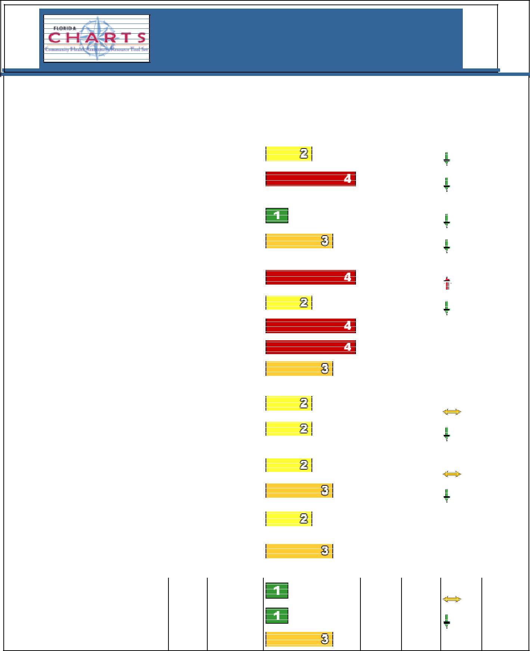
Highlands County, Florida

County Health Status Summary

 |  |  |  |  |  |  | Quartile^{A} |  |  |  |  | County |  |  |  | Healthy
 |  |  |  |  | County |  |  |  |  |  |  | Trend |  |  |  | People
 |  |  |  |  | 1=most |  | favorable |  |  | County | State | (click |  |  | to | 2020
 |  | Indicator | Year(s) | Rate Type | 4=least favorable |  |  |  |  | Rate | Rate | view) |  |  |  | Goals
 |  | Chronic Diseases
 |  | Coronary Heart Disease
 |  | Coronary heart disease age-adjusted | 2008-10 | Per 100,000 |  |  |  |  |  | 101.9 | 108.1 | Better |  |  |  | 100.8
 |  | death rate
 |  | Coronary heart disease age-adjusted | 2008-10 | Per 100,000 |  |  |  |  |  | 636.7 | 410.0 | Better
 |  | hospitalization rate
 |  | Stroke
 |  | Stroke age-adjusted death rate | 2008-10 | Per 100,000 |  |  |  |  |  | 27.3 | 31.5 | Better |  |  |  | 33.8
 |  | Stroke age-adjusted hospitalization rate | 2008-10 | Per 100,000 |  |  |  |  |  | 300.8 | 269.2 | Better
 |  | Heart Failure
 |  | Heart failure age-adjusted death rate | 2008-10 | Per 100,000 |  |  |  |  |  | 11.5 | 8.0 | Worse
 |  | Congestive heart failure age-adjusted | 2008-10 | Per 100,000 |  |  |  |  |  | 99.7 | 152.2 | Better
 |  | hospitalization rate
 |  | Adults with diagnosed hypertension | 2010 | Percent |  |  |  |  |  | 43.3% | 34.3%
 |  | Adults who have diagnosed high blood | 2010 | Percent |  |  |  |  |  | 41.5% | 38.6% |  |  |  |  | 13.5%
 |  | cholesterol
 |  | Adults who had their cholesterol checked | 2007 | Percent |  |  |  |  |  | 69.7% | 73.3%
 |  | in the past five years
 |  | Lung Cancer
 |  | Lung cancer age-adjusted death rate | 2008-10 | Per 100,000 |  |  |  |  |  | 49.7 | 47.2 | No Trend |  |  |  | 45.5
 |  | Lung cancer age-adjusted incidence rate | 2006-08 | Per 100,000 |  |  |  |  |  | 74.5 | 67.1 | Better
 |  | Colorectal Cancer
 |  | Colorectal cancer age-adjusted death | 2008-10 | Per 100,000 |  |  |  |  |  | 13.1 | 14.6 | No Trend |  |  |  | 14.5
 |  | rate
 |  | Colorectal cancer age-adjusted | 2006-08 | Per 100,000 |  |  |  |  |  | 46.9 | 42.7 | Better
 |  | incidence rate
 |  | Adults 50 years of age and older who | 2010 | Percent |  |  |  |  |  | 57.0% | 56.4%
 |  | received a sigmoidoscopy or
 |  | colonoscopy in the past five years
 |  | Adults 50 years of age and older who
 |  | received a blood stool test in the past | 2010 | Percent |  |  |  |  |  | 13.7% | 14.7%
 |  | year
 |  | Breast Cancer
 |  | Breast cancer age-adjusted death rate | 2008-10 | Per 100,000 |  |  |  |  |  | 17.4 | 21.0 | No Trend
 |  |  |  |  |  |  |  |  |  |  |  |  |  |  | 20.6
 |  | Breast cancer age-adjusted incidence | 2006-08 | Per 100,000 |  |  |  |  |  | 80.9 | 110.9 | Better
 |  | rate
 |  | Women 40 years of age and older who
 |  |  | 2010 | Percent |  |  |  |  |  | 57.9% | 61.9%
 |  | received a mammogram in the past year

^{A/} Florida CHARTS uses quartiles to compare health data from one county to another county. 1 = Most favorable situation or 25% of counties; 2 or 3 = Average or 50% of counties; 4 = Least favorable situation Data Sources: Deaths – Florida Department of Health, Office of Vital Statistics;

Risk Factors (BRFSS) – Florida Department of Health, Bureau of Epidemiology; Hospitalizations – Florida Agency for Health Care Administration (AHCA);

Cancer Incidence – University of Miami (FL) Medical School, Florida Cancer Data System

29

Table 4: Highlands County Chronic Diseases, Health Status of Adults (continued)
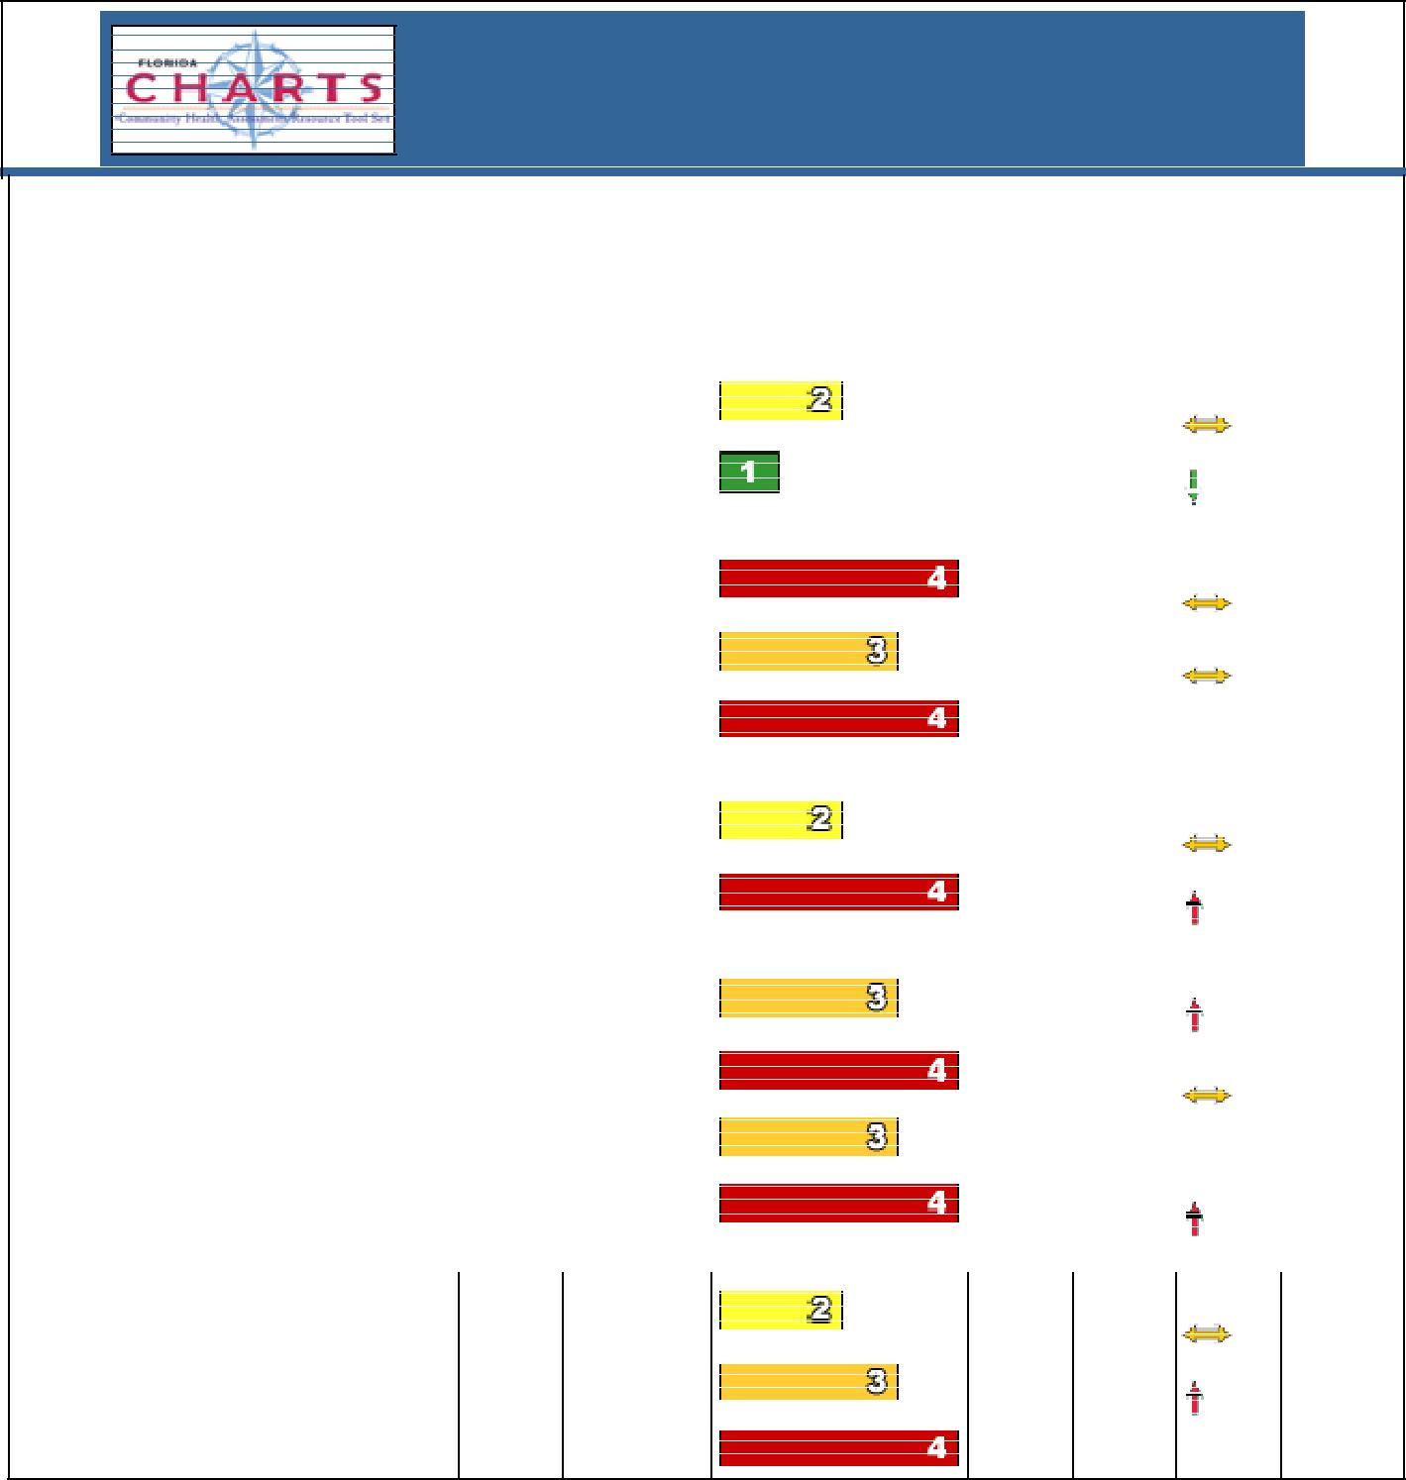
Highlands County, Florida

County Health Status Summary

 |  |  |  |  |  |  |  |  |  |  |  | County |  |  |  |  | Healthy
 |  |  |  |  | County |  | Quartile^{A} |  |  |  |  | Trend |  |  |  |  | People
 |  |  |  |  | 1=most |  | favorable |  |  | County | State | (click |  |  |  | to | 2020
 |  | Indicator | Year(s) | Rate Type | 4=least favorable |  |  |  |  | Rate | Rate | view) |  |  |  |  | Goals
 |  | Chronic Diseases (continued)
 |  | Prostate Cancer
 |  |  |  |  |  |  |  |  |  |  |  | No |  |  | Trend
 |  | Prostate cancer age-adjusted death rate | 2008-10 | Per 100,000 |  |  |  |  |  | 16.1 | 18.2 |  |  |  |  |  | 21.2
 |  | Prostate cancer age-adjusted incidence | 2006-08 | Per 100,000 |  |  |  |  |  | 107.1 | 133.2 | Better
 |  | rate
 |  | Cervical Cancer
 |  |  |  |  |  |  |  |  |  |  |  | No |  |  | Trend
 |  | Cervical cancer age-adjusted death rate | 2008-10 | Per 100,000 |  |  |  |  |  | 5.5 | 2.7 |  |  |  |  |  | 2.2
 |  | Cervical cancer age-adjusted incidence | 2006-08 | Per 100,000 |  |  |  |  |  | 11.4 | 9.0 | No |  |  | Trend
 |  | rate
 |  | Women 18 years of age and older who | 2010 | Percent |  |  |  |  |  | 51.1% | 57.1% |  |  |  |  |  | 93%
 |  | received a Pap test in the past year
 |  | Melanoma
 |  |  |  |  |  |  |  |  |  |  |  | No |  |  | Trend
 |  | Melanoma age-adjusted death rate | 2008-10 | Per 100,000 |  |  |  |  |  | 2.7 | 2.8 |  |  |  |  |  | 2.4
 |  | Melanoma age-adjusted incidence rate | 2006-08 | Per 100,000 |  |  |  |  |  | 23.8 | 17.9 | Worse
 |  | Chronic Lower Respiratory Diseases
 |  | Chronic lower respiratory diseases | 2008-10 | Per 100,000 |  |  |  |  |  | 51.6 | 38.7 | Worse
 |  | (CLRD) age-adjusted death rate
 |  |  |  |  |  |  |  |  |  |  |  | No |  |  | Trend
 |  | CLRD age-adjusted hospitalization rate | 2008-10 | Per 100,000 |  |  |  |  |  | 640.3 | 364.6 |  |  |  |  |  | 50.1
 |  | Adults who currently have asthma | 2010 | Percent |  |  |  |  |  | 9.9% | 8.3%
 |  | Asthma age-adjusted hospitalization rate | 2008-10 | Per 100,000 |  |  |  |  |  | 1052.1 | 759.3 | Worse
 |  | Diabetes
 |  |  |  |  |  |  |  |  |  |  |  | No |  |  | Trend
 |  | Diabetes age-adjusted death rate | 2008-10 | Per 100,000 |  |  |  |  |  | 22.7 | 19.9 |  |  |  |  | 65.8
 |  | Diabetes age-adjusted hospitalization |  |  |  |  |  |  |  |  |  | Worse
 |  |  | 2008-10 | Per 100,000 |  |  |  |  |  | 2488.3 | 2215.7
 |  | rate
 |  | Adults with diagnosed diabetes | 2010 | Percent |  |  |  |  |  | 14.2 | 10.4

^{A/} Florida CHARTS uses quartiles to compare health data from one county to another county. 1 = Most favorable situation or 25% of counties; 2 or 3 = Average or 50% of counties; 4 = Least favorable situation = Least favorable situation.

Data Sources:

Deaths – Florida Department of health, Office of Vital Statistics

Risk Factors (BRFSS) – Florida Department of health, Bureau of Epidemiology Hospitalizations – Florida Agency for health Care Administration (AHCA)

Cancer Incidence – University of Miami (FL) Medical School, Florida Cancer Data System

30

There are many factors that contribute to chronic diseases and premature death. In 2002, 2007, and 2010, the Florida Department of Health conducted a Behavioral Risk Factor Surveillance System (BRFSS) telephone survey in each of the Florida counties. A total of 35,000 interviews were completed statewide, including more than 500 in Highlands County. Prevalence rates were weighted to represent all Florida adults. Responses to questions on chronic disease risk factors are shown in Tables 5 and 6.

Table 5: Highlands County Chronic Diseases, Risk Factors for Adults
Highlands County, Florida

County Health Status Summary

 |  |  |  |  |  |  |  |  |  |  | County | Healthy
 |  |  |  | County |  | Quartile^{A} |  |  |  |  | Trend | People
 |  |  |  | 1=most |  | favorable |  |  | County | State | (click to | 2020
 | Indicator | Year(s) | Rate Type | 4=least favorable |  |  |  |  | Rate | Rate | view) | Goals
 | Actual Causes of Death*
 | Physical Activity
 | Adults who meet moderate physical | 2007 | Percent |  |  |  |  |  | 35.3% | 34.6%
 | activity recommendations¹
 | Adults who meet vigorous physical | 2007 | Percent |  |  |  |  |  | 22.8% | 26.0%
 | activity recommendations¹
 | Adults who engage in no leisure-time | 2002 | Percent |  |  |  |  |  | 33.6% | 26.4% |  | 32.6%
 | physical activity¹
 | Overweight and Obesity
 | Adults who consume at least five servings | 2007 | Percent |  |  |  |  |  | 33.5% | 26.2%
 | of fruits and vegetables a day¹
 | Adults who are overweight¹ | 2010 | Percent |  |  |  |  |  | 34.1% | 37.8%
 | Adults who are obese¹ | 2010 | Percent |  |  |  |  |  | 30.3% | 27.2% |  | 30.6%
 | Tobacco Use
 | Adults who are current smokers¹ | 2010 | Percent |  |  |  |  |  | 19.8% | 17.1% |  | 12%
Source: Risk Factors (BRFSS) – Florida Department of Health, Bureau of Epidemiology

Table 6: Highlands County Chronic Diseases, Risk Factors for Children
School-aged Child and Adolescent Profile, Highlands County

 |  |  |  |  |  | County |  | Quartile
 |  |  |  |  |  | 1=most |  | favorable | County |  |  | County |  |  |  | State
 | Measure | Rate Type |  | Year(s) |  | 4=least favorable |  |  | Number |  |  | Rate |  |  |  | Comparison
 | Modifiable Behaviors Leading to Premature Death
 | Insufficient Physical Activity
 | Percent of students without sufficient vigorous physical activity
 | Middle school |  | Percent |  | 2010 |  |  |  |  |  |  |  |  |  | 32.5% |  |  | 30.7%
 | High school |  | Percent |  | 2010 |  |  |  |  |  |  |  |  |  | 38.5% |  |  | 39.1%
 | Overweight
 | Percent of students reporting BMI at or above 95th percentile
 | Middle school |  | Percent |  | 2010 |  |  |  |  |  |  |  |  |  | 13.7% |  |  | 11.7%
 | High school |  | Percent |  | 2010 |  |  |  |  |  |  |  |  |  | 15.5% |  |  | 11.5%
 | Tobacco Use
 | Percent of students smoking cigarettes in the past 30 days
 | Middle school |  | Percent |  | 2010 |  |  |  |  |  |  |  |  |  | 8.3% |  | 4.9%
 | High school |  | Percent |  | 2010 |  |  |  |  |  |  |  |  |  | 19.0% |  | 13.1%
Source: Risk Factors (BRFSS) – Florida Department of Health, Bureau of Epidemiology

31

V. COMMUNICABLE AND INFECTIOUS DISEASES

Vaccine Preventable Diseases

In the United States, vaccines have reduced or eliminated many infectious diseases. But the viruses and bacteria that cause these diseases still exist and can be passed on to people who are not protected by vaccinations. Travelers can unknowingly bring diseases into the U.S., and if we were not protected by vaccinations, the diseases could quickly spread throughout the population.

Table 7 shows that the rate of vaccine preventable diseases in both Highlands County and the State is low. However, compared to the other 66 counties, 50% or more of the counties have a lower rate of vaccine preventable diseases.

There was no statistically significant change in the rate of cases in Highlands County in 2008-2010 compared to previous years.

Table 7: Vaccine Preventable Disease Rate per 100,000 population, 2008-2010
Highlands County, Florida

County Health Status Summary

 |  |  |  |  |  |  |  |  |  | County
 |  |  |  | County |  | Quartile^{A} |  |  |  | Trend |  | Healthy
 |  |  |  | 1=most |  | favorable |  | County | State | (click | to | People
 | Indicator | Year(s) | Rate Type | 4=least favorable |  |  |  | Rate | Rate | view) |  | 2020 Goals
 | Vaccine Preventable Diseases
 | Vaccine preventable diseases | 2008-10 | Per 100,000 |  |  |  |  | 3.4 | 3.9 | No Trend
Source: Florida Department of Health, Division of Disease Control

Table 8 shows the age-adjusted rate per 100,000 of Pertussis (Whooping Cough), Acute Hepatitis B, and Haemophilus Influenza (Flu) in Highlands County and the State. These are three vaccine preventable diseases that are common among certain population groups and in certain areas of the country.

Pertussis has been on the rise in the United States in the last year. While pertussis in adults may be mild and not considered serious, infants who are exposed usually require hospitalization. Fortunately, Highlands County had a very low incidence of pertussis from 2008-2010 and no cases in children under 7.

Hepatitis is an inflammation of the liver caused by a group of viruses. Hepatitis B may be sexually transmitted. The rate of Hepatitis B in Highlands County was lower than the State rate in 2008-2010.

Flu is seasonal and generally strikes the elderly population more often and more severely than it does younger age groups with the exception of infants. In Highlands County, the rate of flu cases is low but it is higher than the rate for the State.

32

Table 8: Vaccine Preventable Diseases, by Type

Rolling 3-Year Rate, per 100,000, 2008-2010
 | County | State
Pertussis | 0.7 | 2.0
Acute Hepatitis B | 2.4 | 1.8
Haemophilus Influenza | 1.7 | 1.1
Source: Florida Department of Health, Division of Disease Control

Most parents follow the Centers for Disease Control’s recommendations for infant immunizations and for boosters for children as they go through school. U.S. immunization rates are high, Table 9 shows that in 2008-2010, close to 100% of children were fully immunized by the time they reached kindergarten.

An annual influenza vaccine is recommended for adults. Highlands County had a high rate for administration of the flu vaccine in 2008-2010 compared to the State, and it ranked among the top 25% among the 67 counties administering the vaccine.

Pneumococcal vaccinations are recommended for adults 65 years of age and older and for persons 2 years and older who have chronic heart or lung disorders. Highlands County had a higher immunization rate than the State in 2008-2010 and also ranked in the top 25 percent among counties administering this vaccine.

Table 9: Screenings for Vaccine Preventable Diseases

Rolling 3-Year Rate, per 100,000, 2008-2010
County State
Kindergarten Children
Fully Immunized | 97% | 96.3%
Adults who ever received
pneumonia vaccinations | 37.9 | 30.6
Adults who received a flu
shot in the past year | 43.0 | 36.5

Source, Florida Department of Health, Division of Disease Control

Tuberculosis

Tuberculosis is a bacterial infection caused by Myobacterium tuberculosis. The TB bacteria usually attack the lungs, but can attack any part of the body. TB can affect anyone, but it places a heavier burden on groups such as the poor, foreign-born from countries with high TB rates; people with depressed immune systems, and people in institutional settings The United States is at an all-time low in the number of persons diagnosed with active TB disease.

In 2008-2010, Highlands County had a low incidence of TB. Although it ranked in the 3rd quartile compared to other counties, it had a lower incidence of TB than the State. It did not meet the Healthy People 2020 goal. There has been no statistically significant trend.

33

Table 10: Tuberculosis Rate per 100,000, 2008-2010
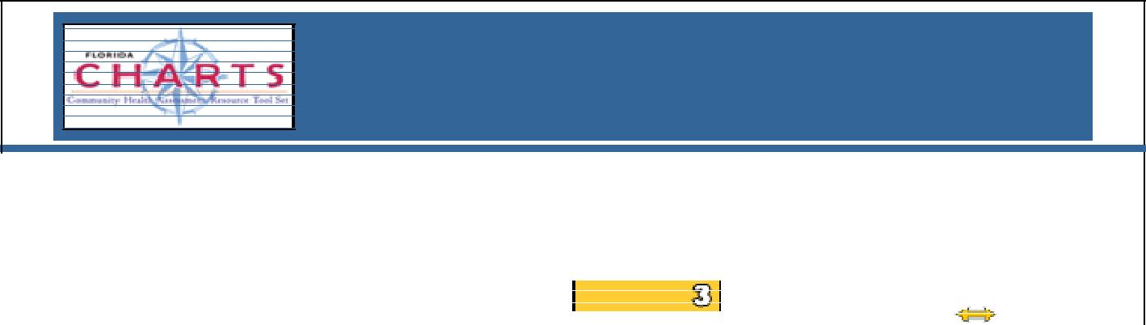
Highlands County, Florida

County Health Status Summary

 |  |  |  |  |  | Quartile^{A} |  |  |  | County |  | Healthy
 |  |  |  | County |  |  |  |  |  | Trend |  | People
 |  |  |  | 1=most |  | favorable |  | County | State | (click | to | 2020
 | Indicator | Year(s) | Rate Type | 4=least favorable |  |  |  | Rate | Rate | view) |  | Goals
 | Tuberculosis
 | TB cases reported¹⁰ | 2008-10 | Per 100,000 |  |  |  |  | 3.0 | 4.6 | No Trend |  | 1.0
Source, Florida Department of Health, Division of Disease Control

HIV/AIDS

The Human Immunodeficiency Virus (HIV) that causes Acquired Immune Deficiency Syndrome (AIDS) can be spread through sexual contact, needle sharing, breastfeeding, and during pregnancy and birth. The Centers for Disease Control (CDC) estimates that more than one million people are living with HIV in the United States.

The age-adjusted death rate for HIV/AIDS in Highlands County is slightly higher than the State rate. Highlands County also has not met the Healthy People 2020 goal. There was no statistically significant change in the HIV/AIDS adjusted death rate in 2008-2010 compared to previous years.

In terms of number of HIV and AIDS cases reported, the County rate for 2008-2010 was considerably lower than the State rate.

Table 11: HIV/AIDS Rates, Per 100,000, 2008-2010
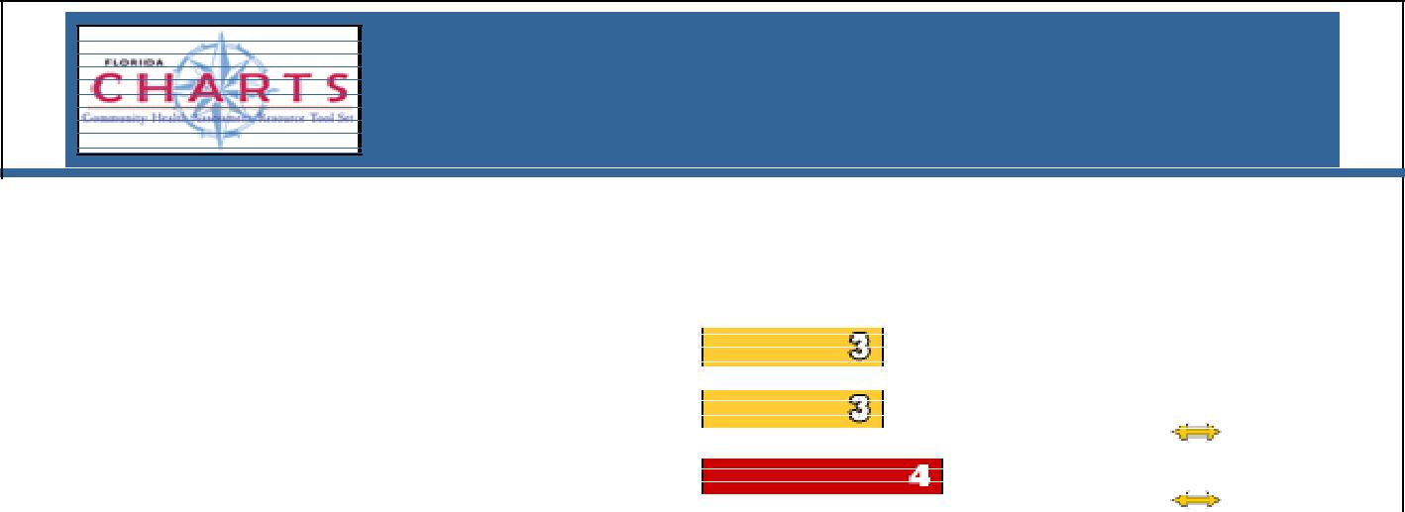
Highlands County, Florida

County Health Status Summary

 |  |  |  |  |  | Quartile^{A} |  |  |  |  | County |  |  | Healthy
 |  |  |  | County |  |  |  |  |  |  | Trend |  |  | People
 |  |  |  | 1=most |  | favorable |  |  | County | State | (click |  | to | 2020
 | Indicator | Year(s) | Rate Type | 4=least favorable |  |  |  |  | Rate | Rate | view) |  |  | Goals
 | HIV/AIDS
 | HIV cases reported | 2008-10 | Per 100,000 |  |  |  |  |  | 16.1 | 33.2
 | AIDS cases reported | 2008-10 | Per 100,000 |  |  |  |  |  | 13.4 | 21.2 | No | Trend
 | HIV/AIDS age-adjusted death rate | 2008-10 | Per 100,000 |  |  |  |  |  | 6.6 | 6.5 | No | Trend |  | 3.7
Source, Florida Department of Health, Division of Disease Control & Office of Vital Statistics

34

Sexually Transmitted Diseases (STDs)

Sexually transmitted diseases or sexually transmitted infections (STDs/STIs) are among the most commonly reported diseases. They are spread from person to person through sexual contact.

Highlands County has a lower rate of Chlamydia and gonorrhea cases reported in 2008-2010 than the State. While the rate of gonorrhea cases reported decreased in 2008-2010 compared with previous years, the rate of Chlamydia cases reported increased. The syphilis rate in Highlands County remained low in 2008-2010 and showed no significant change from previous years.

Table 12: Sexually Transmitted Disease Rates, Per 100,000, 2008-2010
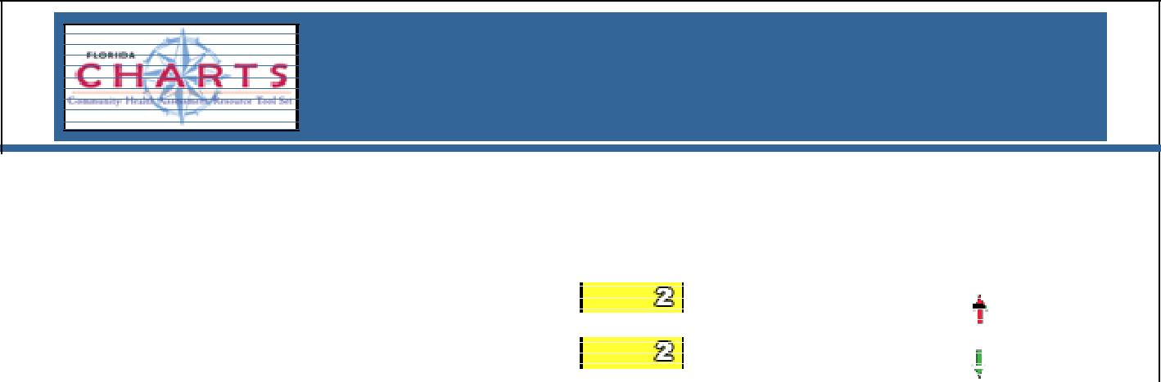
Highlands County, Florida

County Health Status Summary

 |  |  |  |  |  |  | Quartile^{A} |  |  | County |  |  | Healthy
 |  |  |  |  | County |  |  |  |  | Trend |  |  | People
 |  |  |  |  | 1=most |  | favorable | County | State | (click to |  |  | 2020
 | Indicator |  | Year(s) | Rate Type | 4=least favorable |  |  | Rate | Rate | view) |  |  | Goals
 | Sexually-Transmitted Diseases
 | Chlamydia cases reported | 2008-10 |  | Per 100,000 |  |  |  | 322.0 | 388.8 | Worse
 | Gonorrhea cases reported | 2008-10 |  | Per 100,000 |  |  |  | 107.6 | 185.4 | Better
 | Infectious syphilis cases reported | 2008-10 |  | Per 100,000 |  |  |  | 1.3 | 5.8 | No Trend
Source, Florida Department of Health, Division of Disease Control

Enteric Disease

Enteric infections are caused by ingestion of food or water that is contaminated with a bacteria, virus, or protozoa. It results in gastrointestinal symptoms, such as diarrhea and vomiting. In 2008-2010, Highlands County had a rate of 35.0 cases per 100,000. This was slightly lower than the rate in 2007-2009. It was also lower than the rate for Florida.

35

VI. MATERNAL, INFANT, AND YOUNG CHILD HEALTH

This section provides data on births, deaths, and pregnancies. It also provides data on health related issues affecting pregnant women, their fetuses, and infants as well as children from ages 1-5.

Birth Rates

Highlands County has a lower birth rate than the State. In Florida and in Highlands County, the three-year rolling birth rate declined slightly from 2006-2008 to 2008-2010.

Figure 31

Total Resident Live Births, 3-Year Rolling Rates

 | 14
Females | 12
 | 10
 | 8 |  |  |  |  |  |  |  |  |  |  |  |  | Highlands
1,000
 | 6 |  |  |  |  |  |  |  |  |  |  |  |  | Florida
per | 4
Rate | 2
 | 0
 | -02 | -03 |  |  | 4 | -05 |  | -06 | -07 |  |  | 8 | -09 | -10
 |  |  |  | 0 |  |  |  |  |  |  | 0
 |  |  | - |  |  |  |  |  |  | -
 | 0 | 001 | 2002 |  |  | 3 |  | 04 | 005 | 2006 |  |  | 7 | 008
 | 200 |  |  |  |  | 200 | 20 |  |  |  |  |  | 200
 |  | 2 |  |  |  |  |  |  | 2 |  |  |  |  | 2
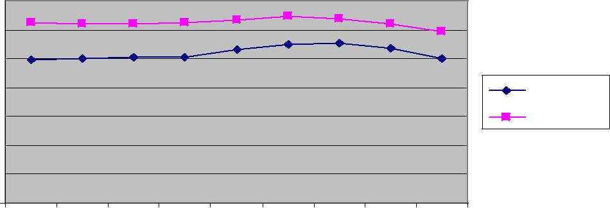
Source: Florida Department of Health, Bureau of Vital Statistics

Blacks have a higher birth rate than Whites in both Florida and Highlands County. The three-year rolling birth rate among Blacks declined slightly in the county between 2006-2008 and 2008- 2010.

Figure 32

Total Resident Live Births by Race, 3-Year Rolling Rates

Females | 25
 | 20
 | 15
1,000
 | 10
per | 5
Rate
 | 0
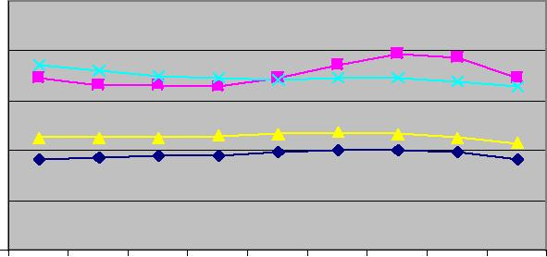
-02 |  | -03 |  | -04 |  |  | -05 |  | -06 |  |  | -07 |  |  | -08 |  | -09 |  |  |  | 0
 |  |  |  |  |  |  |  |  |  |  |  |  |  |  |  |  |  |  |  | 1
 |  |  |  |  |  |  |  |  |  |  |  |  |  |  |  |  |  |  | -
000 | 2001 |  |  | 002 |  |  | 03 |  | 004 |  |  | 05 |  | 006 |  |  | 7 | 2008
 |  |  |  |  |  | 0 |  |  |  |  | 0 |  |  |  |  | 00
2 |  |  | 2 |  | 2 |  |  | 2 |  | 2 |  |  | 2 |  |  | 2

Highlands White

Highlands Black

Florida White

Florida Black

Source: Florida Department of Health, Bureau of Vital Statistics

36

Hispanic birth rates in Highlands County and in Florida are higher than non-Hispanic birth rates. Three-year rolling birth rates among Hispanics declined between 2006-2208 and 2008-2010.

Figure 33

Total Resident Live Births, by Ethnicity, 3-Year Rolling Rates

Females | 25
 | 20
 | 15
1,000
 | 10
per | 5
Rate
 | 0
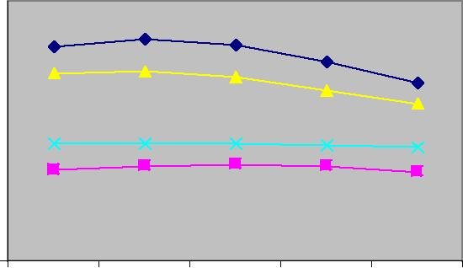
 |  | 6 | -07 | -08 |  |  | 9 |  |  | 0
 | 0 |  |  |  |  | 0 |  |  | 1
- |  |  |  |  | - |  |  | -
4 |  |  | 2005 | 6 | 7 |  |  | 8
0 |  |  |  | 0 | 0 |  |  | 0
0 |  |  |  | 0 | 0 |  |  | 0
2 |  |  |  | 2 | 2 |  |  | 2

Highlands Hispanic

Highlands Non-

Hispanic

Florida Hispanic

Florida Non-

Hispanic

Source: Florida Department of Health, Bureau of Vital Statistics

Birth Outcomes and Pregnancies

Table 13 includes data on births, birth outcomes, and pregnancies in Highlands County from 2008-2010. Data are compared to the State and the other 66 counties. County quartiles are divided into most favorable or top 25% of counties; least favorable or bottom 25% of counties, and 2nd and 3rd quartiles or the middle 50% of counties.

Areas where the greatest improvements are needed are highlighted below.

- Births to Mothers Ages 15-19. The birth rate for mothers ages 15-19 in Highlands County was 52.9 per 1,000 females, making it considerably higher than the State rate of 36.8.

- Repeat Births to Mothers Ages 15-19. Repeat births to mothers ages 15-19

accounted for 21.9% of the total births in Highlands County compared to 18.4% for the State. Highlands County ranked in the 4th quartile on this measure.

- Births to Unwed Mothers. Highlands County also ranked unfavorably in the percentage of births to unwed mothers, with a total of 54.3% compared to the State rate of 47.3%. Again, Highlands County ranked in the bottom 25% when compared to other counties.

- Births to Mothers with a High School Education. Women without as high school education accounted for 26.5% of all births to women 18 years of age

37

and older in Highlands County. That compares to 15.4% for the State and places Highlands County in the 4th quartile on this measure.

- Low-Birth Weight Babies and Babies Born Pre-Term. The percentage of low-

birth weight babies and babies born pre-term in Highlands County is comparable to the percentages for the State. Highlands County ranks in the 3rd quartile when compared to other Florida counties.

- Women Overweight and Obese at Time of Conception. In Highlands County, births to women who were obese at the time of pregnancy totaled 26.5%, while births to mothers who were overweight totaled 24.3%. These are higher than

the comparable State figures of 19.4% and 23.3% respectively. Highlands County ranked in the 4th quartile for percentage of women who were obese at conception, and in the 3rd quartile for percentage of women who were overweight at conception.

- Pap Smear in Year Prior to Pregnancy. Looking only at one-year rather than three-year data among females 17 years of age and older who became pregnant in 2010, 51.1%indicated that they had had a pap smear in the previous year, compared to the State percentage of 57.1%. Highlands County ranked in the bottom 25% when compared to other counties on this measure.

- Women with 1st Trimester Prenatal Care. A total of 73.1% of women for whom prenatal status was known received care in the first trimester. That is lower than the State’s 78.1%, and placed Highlands County in the 3rd quartile.

- Women with Late or No Prenatal Care. The percent of births to women who received late or no prenatal care was 5%, the same as the State. But once again, Highlands County ranked in the 3rd quartile, when compared to the other counties.

- Prenatal Care and the Kotelchuck Index. The Kotelchuck Index compares actual to expected prenatal visits and groups them into four categories. Inadequate = received less than 50% of expected visits; Intermediate = received 50% to 79% of expected visits; Adequate = received 80% to 109% of expected visits; and Adequate Plus = received 110% or more of expected visits. According to this index, women who gave birth with adequate care totaled 66.5%. This compared favorably to the State’s 46.8%. But it did not compare favorably to the other counties. Highlands County ranks in the bottom 25%.

- Women with Births Covered by Medicaid. A total of 66.5% of births were

covered by Medicaid. This compares favorably with the State but not so favorably with the other counties. Highlands County ranked in the 4th quartile compared to other counties.

- Women Who Breastfed. A total of 72% of mothers initiated breastfeeding in

Highlands County compared to 79% for the State. Highlands County ranked in the 4th quartile compared to other counties.

38

Table 13: Births and Pregnancies, 2008-2010
Highlands County

Birth and Pregnancy Profiles

 |  |  |  |  | County Quartile¹ |  |  |  |  |  |  |  | County | County | State
 | Rate Type | Year(s) |  |  | 1=most favorable
Measure |  |  |  |  | 4=least favorable |  |  |  |  |  |  |  | Number | Rate | Comparison
Births, Demographic Data
Total births | Per 1,000 population | 2008-10 |  |  |  |  |  |  |  |  |  |  | 996 | 10.0 | 11.9
White births | Per 1,000 white population | 2008-10 |  |  |  |  |  |  |  |  |  |  | 793 | 9.2 | 10.8
Black births | Per 1,000 black population | 2008-10 |  |  |  |  |  |  |  |  |  |  | 166 | 17.3 | 16.5
Other nonwhite births | Per 1,000 other nonwhite | 2008-10 |  |  |  |  |  |  |  |  |  |  | 38 | 10.7 | 12.5
 | population
Hispanic births | Per 1,000 Hispanic | 2008-10 |  |  |  |  |  |  |  |  |  |  | 289 | 17.2 | 15.1
 | population
Non-Hispanic births | Per 1,000 non-Hispanic | 2008-10 |  |  |  |  |  |  |  |  |  |  | 706 | 8.6 | 10.9
 | population
Births, Family Characteristics
Births to mothers ages 15- | Per 1,000 females 15-19 | 2008-10 |  |  |  |  |  |  |  |  |  | 131 |  | 52.9 | 36.8
19
Repeat births to mothers | Percent of births 15-19 | 2008-10 |  |  |  |  |  |  |  |  |  | 29 |  | 21.9% | 18.4%
ages 15-19
Births to mothers > 35 | Per 1,000 females > 35 | 2008-10 |  |  |  |  |  |  |  |  |  | 67 |  | 1.9 | 4.7
Total births to unwed | Percent of births | 2008-10 |  |  |  |  |  |  |  |  |  | 541 |  | 54.3% | 47.3%
mothers
Births among unwed | Percent of births 15-19 | 2008-10 |  |  |  |  |  |  |  |  |  | 112 |  | 86.0% | 90.0%
mothers ages 15-19
Births among unwed | Percent of births 20-54 | 2008-10 |  |  |  |  |  |  |  |  |  | 426 |  | 49.4% | 42.6%
mothers ages 20-54
Births with father | Percent of births
acknowledged on birth |  | 2008-10 |  |  |  |  |  |  |  |  |  | 861 |  | 86.4% | 86.5%
certificate
Births to mothers > 18
without high school | Percent of births > 18 | 2008-10 |  |  |  |  |  |  |  |  |  | 243 |  | 26.5% | 15.4%
education
Births to mothers born in | Percent of births | 2008-10 |  |  |  |  |  |  |  |  |  | 226 |  | 22.7% | 31.2%
other countries
Births with inter-pregnancy | Percent of births | 2008-10 |  |  |  |  |  |  |  |  |  | 244 |  | 40.5% | 38.0%
interval < 18 months
Births, Poor Birth Outcomes
Births < 1500 grams (very | Percent of births | 2008-10 |  |  |  |  |  |  |  |  |  |  | 18 | 1.8% | 1.6%
low birth weight)
Births < 2500 grams (low | Percent of births | 2008-10 |  |  |  |  |  |  |  |  |  |  | 88 | 8.8% | 8.7%
birth weight)
Births < 37 weeks gestation | Percent of births | 2008-10 |  |  |  |  |  |  |  |  |  |  | 139 | 14.0% | 13.9%
(preterm)
Birth defects (structural and | Per 10,000 births | 2006-08 |  |  |  |  |  |  |  |  |  |  | 26 | 239.7 | 228.6
genetic) ratio to total births
Congenital heart defects | Per 10,000 births | 2006-08 |  |  |  |  |  |  |  |  |  |  | 5 | 42.5 | 73.0
Chromosomal abnormalities | Per 10,000 births | 2006-08 |  |  |  |  |  |  |  |  |  |  | 2 | 15.2 | 15.2
(Trisomy 13, 18, & 21)
Multiple births (twins or more) | Percent of births | 2008-10 |  |  |  |  |  |  |  |  |  |  | 28 | 2.8% | 3.2%

39

Table 13: Birth and Pregnancies, 2008-2010 (continued)
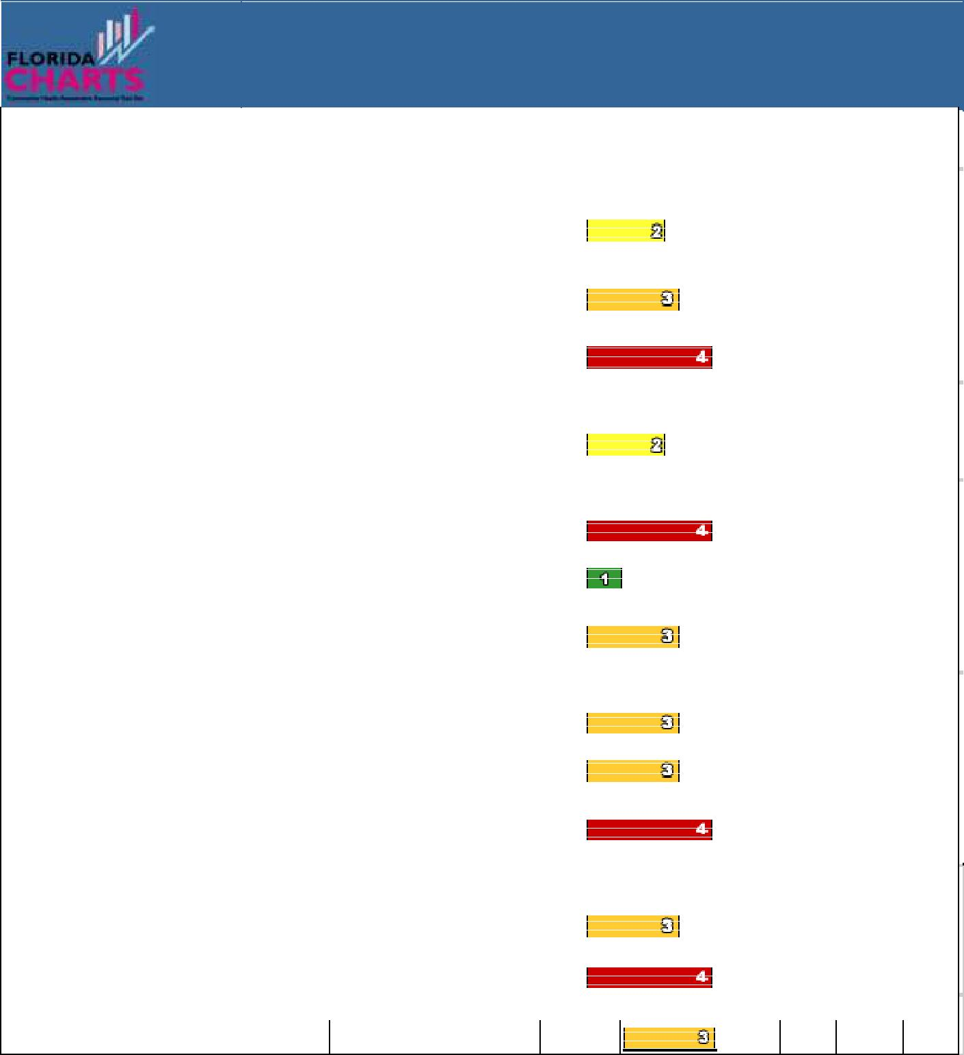
Highlands County

Birth and Pregnancy Profile

 |  |  |  |  |  | County |  |  |  | Quartile¹ |  |  |  |  | County | County | State
 |  | Rate Type |  | Year(s) |  | 1=most |  |  |  | favorable
 | Measure |  |  |  |  | 4=least favorable |  |  |  |  |  |  |  |  | Number | Rate | Comparison
 | Health Behaviors at Time of Conception
 | Births to underweight
 | mothers at time pregnancy | Percent of births |  | 2008-10 |  |  |  |  |  |  |  |  |  |  | 116 | 11.6% | 11.9%
 | occurred²
 | Births to overweight
 | mothers at time pregnancy | Percent of births |  | 2008-10 |  |  |  |  |  |  |  |  |  |  | 242 | 24.3% | 23.3%
 | occurred³
 | Births to obese mothers at | Percent of births |  | 2008-10 |  |  |  |  |  |  |  |  |  |  | 264 | 26.5% | 19.4%
 | time pregnancy occurred⁴
 | Health Behavior During Pregnancy
 | Births to mothers who
 | report smoking during | Percent of births |  | 2008-10 |  |  |  |  |  |  |  |  |  |  | 104 | 10.5% | 6.9%
 | pregnancy
 | Health Care Prior to Pregnancy
 | Females > 17 with pap | Percent of females > 17 |  | 2010 |  |  |  |  |  |  |  |  |  |  |  | 51.1% | 57.1%
 | smear in preceding year
 | Females > 17 who have a | Percent of females > 17 |  | 2010 |  |  |  |  |  |  |  |  |  |  |  | 92.2% | 84.5%
 | personal doctor
 | Females > 17 who have any
 | type of health care | Percent of females > 17 |  | 2010 |  |  |  |  |  |  |  |  |  |  |  | 82.1% | 84.2%
 | insurance coverage
 | Health Care During Pregnancy
 | Births with 1st trimester | Percent of births w/ known |  | 2008-10 |  |  |  |  |  |  |  |  |  |  | 680 | 73.1% | 78.1%
 | prenatal care | PNC status
 | Births with late or no | Percent of births w/ known |  | 2008-10 |  |  |  |  |  |  |  |  |  |  | 49 | 5.2% | 5.1%
 | prenatal care | PNC status
 | Births with adequate | Percent of births w/ known
 | prenatal care (Kotelchuck |  |  | 2008-10 |  |  |  |  |  |  |  |  |  |  | 579 | 62.2% | 69.5%
 | index) | PNC status
 | Self-Pay, Insurance
 | Births to uninsured women
 | (“self-pay” checked on birth | Percent of births |  | 2008-10 |  |  |  |  |  |  |  |  |  |  | 83 | 8.4% | 9.5%
 | certificate)
 | Births covered by Medicaid⁵ | Percent of births |  | 2008-10 |  |  |  |  |  |  |  |  |  |  | 663 | 66.5% | 46.8%
 | Breastfeeding
 | Mothers who initiate breastfeeding |  | Percent |  | 2008-10 |  |  |  |  |  |  |  |  | 709 71.2% 79.0%

^{1/} Where applicable, the County rate is compared to the rate in other counties, using Quartiles. 1 = Most favorable or top 25% of counties; 2 or 3 = Average or middle 50%-75% of counties; 4 = Least favorable situation or bottom 25% of counties. Blanks indicate that not enough data was available to

calculate a quartile or that a quartile calculation was not appropriate. ^{2/} Underweight = BMI of 18.5 or less
^{3/} Overweight = BMI between 25.0 and 29.9
⁴/ Obese = BMI of 30 or more

⁵/ May underestimate actual percent of births paid for by Medicaid Source: Florida Department of Health, Bureau of Vital Statistics

Florida Department of Health, Bureau of Epidemiology, for Health Care Prior to Pregnancy data

40

Death Rates >0-1 Years of Age

Table 14 includes data on the causes of death in fetuses and infants in Highlands County from 2008- 2010. County data is compared to State data and data from the other 66 Florida counties.

Areas where the greatest improvements are needed are highlighted below.

- Hospitalizations and ER Visits for Unintentional Falls. Highlands County had a higher rate of hospitalizations and ER visits than the State for infants less than 1 year of age. Highlands County also ranked in the bottom 25% of counties on this measure.

- Deaths of Infants. Highlands County had a higher neonatal, post-neonatal, and infant death rate per 1,000 births than the State and ranked in the 3rd quartile compared to other counties.

Table 14: Deaths > 0-1 Year of Age, 2008-2010
Highlands County

Deaths > 0-1

Year of Age
 |  |  |  | County |  |  | Quartile¹ |  |  |  |  | State
 |  |  |  | 1=most |  |  | favorable |  |  | County | County | Comparis
Measure | Rate Type |  | Year(s) | 4=least favorable |  |  |  |  |  | Number | Rate | on
Injuries and Injury-related Deaths
Hospitalizations for all non-fatal |  | Per 100,000 | 2008-10 |  |  |  |  |  |  | 3 | 324.8 | 289.3
unintentional injuries < 1 |  | population < 1
Hospital/ER treated non-fatal |  | Per 100,000 | 2008-10 |  |  |  |  |  |  | 49 | 4774.3 | 3627.2
unintentional falls < 1 |  | population < 1
Hospitalizations for non-fatal traumatic |  | Per 100,000 | 2008-10 |  |  |  |  |  |  | 2 | 162.4 | 195.1
brain injuries < 1 |  | population < 1
Child passengers < 1 injured or killed |  | Per 100,000 | 2008-10 |  |  |  |  |  |  | 3 | 259.8 | 351.9
in motor vehicle crashes |  | population < 1
Other Deaths
Fetal deaths |  | Per 1,000 | 2008-10 |  |  |  |  |  | 6 |  | 6.3 | 7.2
 |  | deliveries
Neonatal deaths (<28 days) |  | Per 1,000 live | 2008-10 |  |  |  |  |  | 5 |  | 5.0 | 4.5
 |  | births
Post-Neonatal deaths (28-364 days) |  | Per 1,000 live | 2008-10 |  |  |  |  |  | 3 |  | 3.0 | 2.4
 |  | births
Infant deaths (0-364 days) |  | Per 1,000 live | 2008-10 |  |  |  |  |  | 8 |  | 8.0 | 6.9
 |  | births
Deaths from SUID (sudden |  | Per 100,000 live | 2008-10 |  |  |  |  |  | <2 |  | 100.4(u) | 98.8
unexpected infant death) |  | births
1/ The County rate is compared to the rate in other counties, using Quartiles. 1 = Most favorable or top 25% of counties; 2 or 3 = Average or middle 50%-75% of counties; 4 = Least favorable situation or bottom 25% of counties. Blanks indicate not enough data was available to calculate a quartile or a quartile calculation was not appropriate.

Source: Florida Department of Health, Bureau of Vital Statistics

Florida Agency for Health Care Administration, for data related to injuries requiring hospitalization

Florida Department of Highway Safety and Motor Vehicles, for motor vehicle crash data

41

Health Issues, Children 1-5 Years of Age

Table 15 includes data for 2008-2010 on illnesses, hospitalizations, and injuries for children ages 1-5 in Highlands County and the State. Highlands County is also ranked compared to the other 66 Florida counties on each measure.

Areas where the greatest improvements are needed are highlighted below.

- Asthma. Highlands County has a much higher rate than the State of hospitalizations for asthma. Highlands County ranks in the 4th quartile compared to other counties on this measure.

- Traumatic Brain Injuries and Poisonings. Highlands County has a much higher rate than the State of hospitalizations for traumatic brain injuries, as well as for non-fatal unintentional poisonings.

Table 15: Health-Related Issues, Children, Ages 1-5
Highlands County

Health–ReIated Issues,

Children, Ages 1-5

 |  |  | County |  |  | Quartile¹
 |  |  | 1=most |  |  | favorable |  |  |  |  | County | County | State
Measure | Rate Type | Year(s) | 4=least favorable |  |  |  |  |  |  |  | Number | Rate | Comparison
Asthma hospitalizations 1-5 | Per 100,000 population | 2008-10 |  |  |  |  |  |  |  |  | 111 | 2232.0 | 877.8
 | 1-5
WIC children 2 and older who | Percent of WIC children
are overweight or at risk of |  | 2010 |  |  |  |  |  |  |  |  |  | 30.7% | 29.5%
 | > 1
overweight
Overall cancer incidence rate | Per 100,000 population | 2006-08 |  |  |  |  |  |  |  |  | <2 | 6.8(u) | 22.3
Ages 1-5 | 1-5
Hospitalizations ages 1-5 for all | Per 100,000 population | 2008-10 |  |  |  |  |  |  |  |  | 14 | 280.7 | 230.2
non fatal unintentional injuries | 1-5
...Near drownings | Per 100,000 population | 2008-10 |  |  |  |  |  |  |  |  | <2 | 13.4(u) | 16.5
 | 1-5
...Traumatic brain injuries | Per 100,000 population | 2008-10 |  |  |  |  |  |  |  |  | 4 | 73.5 | 43.3
 | 1-5
Hospital/ER treated non fatal | Per 100,000 population
unintentional poisonings ages 1- |  | 2008-10 |  |  |  |  |  |  |  |  | 32 | 634.9 | 402.8
5⁸ | 1-5
...Unintentional falls | Per 100,000 population | 2008-10 |  |  |  |  |  |  |  |  | 263 | 5272.7 | 4329.4
 | 1-5
...Motor vehicle related injuries | Per 100,000 population | 2008-10 |  |  |  |  |  |  |  |  | 26 | 521.3 | 407.3
 | 1-5
Child passengers ages 1-5 | Per 100,000 population
injured or killed in motor vehicle |  | 2008-10 |  |  |  |  |  |  |  |  | 12 | 233.9 | 323.4
crashes⁹ | 1-5
1/ The County rate is compared to the rate in other counties, using Quartiles. 1 = Most favorable or top 25% of counties; 2 or 3 = Average or middle 50%-75% of counties; 4 = Least favorable situation or bottom 25% of counties. Blanks indicate not enough data was available to calculate a quartile or a quartile calculation was not appropriate.

Source: Florida Agency for Health Care Administration, for data on hospitalizations Florida Department of Health, WIC and Nutrition Services

University of Miami Medical School, for cancer data
Florida Department of Highway Safety & Motor Vehicles, for data on motor vehicle crashes

42

VII. MENTAL HEALTH

Mental health plays an important role in people’s ability to maintain good physical health. One way to measure mental health is by asking people how they feel. Another is to look at the suicide rates and the rates of domestic violence.

Mental Health Indicators for Adults and Children

The BRFSS telephone surveys conducted in 2007 and 2010 included questions about mental health. Responses, shown in Table 16, reveal the following:

- In 2007, more than 90% of Highlands County adults and adults statewide said they enjoyed “good mental health”, and slightly less than 10% reported “poor mental health on 14 or more of the past 30 days”.

- In 2010, the percentage of adults reporting “good mental health” had declined to 88%, while the percentage reporting “poor mental health on 14 of the past 30 days” was close to 12%.

- Adults also were asked whether they always or usually receive the social and emotional support they need. While the percent responding positively increased slightly from 2007 to 2010, there were still approximately 25% in Highlands County and 20% statewide who said they did not always or usually receive the support they needed.

Table 16: Mental Health Indicators for Adults
Mental Health Indicators | Highlands |  | State
 | 2007 | 2010 | 2007 | 2010
Adults with good mental health, Overall | 90.5% | 88.3% | 90.3% | 88.2%
Adults who had poor mental health on 14 or more of | 9.5% | 11.7% | 9.7% | 11.8%
the past 30 Days, Overall
Adults who always or usually receive the social and | 74.9% | 76.6% | 77.9% | 79.5%
emotional support they need
Source: Risk Factors (BRFSS) – Florida Department of Health, Bureau of Epidemiology

Table 17 includes data on matters related to the emotional development and mental health of school aged children and adolescents from 2008-2010. Highlands County is compared to the State and to the other 66 Florida counties. There is the greatest disparity between Highlands County and the State and other Florida counties in the following areas:

- Rate of Referrals to the Department of Juvenile Justice. Highlands County’s rate of referral to the Department of Juvenile Justice was 1089.1 per 10,000

children and adolescents between the ages of 10 and 17 compared to the State rate of 658.8. Highlands County also ranked in the bottom 25% or the 4th Quartile of all Florida counties on this measure.

- Violent Acts in School. Highlands County had a rate of 5.6 violent acts in school per 1,000 students in grades K-12, compared to the State rate of 2.8.

43

Highlands County also ranked in the bottom 25% or the 4th Quartile of all Florida counties on this measure.

- Child Abuse. Highlands County had a rate of 13.2 per 1,000 children, aged 5-

11, who experienced child abuse compared to the State rate of 20.6. That placed Highlands County in the 3rd quartile among Florida counties.

Table 17: Mental Health Indicators for School-Aged Children and Adolescents
Highlands County,

Florida

 |  |  |  |  | School-aged | Child |  |  | and
 |  |  |  |  | Adolescent Profile
 |  |  |  |  |  |  |  |  |  | County |  |  | Quartile¹
 |  |  |  |  |  |  |  |  |  | 1=most |  |  | favorable |  |  |  | County | County | State
Measure |  |  |  |  | Rate Type |  | Year(s) |  |  | 4=least favorable |  |  |  |  |  |  | Number | Rate | Comparison
Non-fatal hospitalizations for self-inflicted injuries per 100,000 pop. (3-yr rate)²
12-18 |  |  |  |  | Per 100,000 |  |  | 2008-10 |  |  |  |  |  |  |  | 3 |  | 41.6 | 46.0
19-21 |  |  |  |  | Per 100,000 |  |  | 2008-10 |  |  |  |  |  |  |  | <2 |  | 36.0(u) | 81.8
Non-fatal hospitalizations for eating disorders per 100,000 pop. (3-yr rate)²
12-18 |  |  |  |  | Per 100,000 |  |  | 2008-10 |  |  |  |  |  |  |  | <2 |  | 0.0(u) | 9.0
19-21 |  |  |  |  | Per 100,000 |  |  | 2008-10 |  |  |  |  |  |  |  | <2 |  | 12.0(u) | 6.9
Suicide deaths per 100,000 population (3-year rate)³
12-18 |  |  |  |  | Per 100,000 |  |  | 2008-10 |  |  |  |  |  |  |  | <2 |  | 0.0(u) | 3.4
19-21 |  |  |  |  | Per 100,000 |  |  | 2008-10 |  |  |  |  |  |  |  | <2 |  | 12.0(u) | 10.4
Percent of emotionally
handicapped |  |  | children |  | Percent |  |  | 2009-10(SY) |  |  |  |  |  |  |  | 147 |  | 1.2% | 1.0%
in grades K-12⁴
Referrals |  |  |  | to
Department |  |  |  | of | Per 10,000 |  |  | 2008-10 |  |  |  |  |  |  |  | 901 |  | 1089.1 | 658.8
Juvenile |  | Justice |  | per
10,000 pop. 10-17⁵
Violent acts in school
per | 1,000 |  | students |  | Per 1,000 |  |  | 2009-10(SY) |  |  |  |  |  |  |  | 68 |  | 5.6 | 2.8
grades K-12⁶
Children |  |  |  | 5-11
experiencing |  |  |  | child | Per 1,000 |  |  | 2008-10 |  |  |  |  |  |  |  | 93 |  | 13.2 | 10.6
abuse | per | 1,000 |  | pop.
5-11⁷
Children |  |  |  | 5-11
experiencing |  |  | sexual |  | Per 1,000 |  |  | 2008-10 |  |  |  |  |  |  |  | 4 |  | 0.6 | 0.6
violence |  | per |  | 1,000
pop. 5-11⁷
1/ The County rate is compared to the rate in other counties, using Quartiles. 1 = Most favorable or top 25% of counties; 2 or 3 = Average or middle 50%-75% of counties; 4 = Least favorable situation or bottom 25% of counties. Blanks indicate not enough data was available to calculate a quartile or a quartile calculation was not appropriate.

2/ Florida Agency for Health Care Administration

3/ Florida Department of Health, Bureau of Vital Statistics

4/ Florida Department of Education, Education and Accountability Service 5/ Florida Department of Juvenile Justice

6/ Florida Department of Education, Office of Safe Schools 7/ Florida Department of Children and Families

44

Suicide

The death rate from suicide in Highlands County declined from a high of 20.3 deaths per 100,000 in 2004-2006 to 12.9 in 2007-2009. But in 2008-2010, the suicide death rate increased to 15. The death rate from suicide is currently higher than the overall State rate.

Figure 34

 |  | Suicide (All means), Age Adjusted Death Rate,
 |  | 3-year Rolling Rate
 | 25
100,000 | 20
 | 15 | Highlands
per | 10 | State
Rate | 5
 | 0
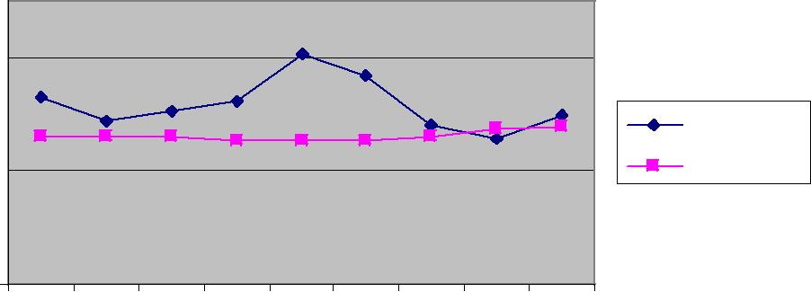
-02 |  |  |  | 3 |  | -04 |  | -05 |  |  | -06 |  | -07 |  |  | -08 |  | -09 |  |  |  | 0
 |  |  | 0 |  |  |  |  |  |  |  |  |  |  |  |  |  |  |  |  |  | 1
 |  | - |  |  |  |  |  |  |  |  |  |  |  |  |  |  |  |  |  | -
0 |  | 1 |  |  |  | 002 |  | 003 |  | 004 |  | 2005 |  |  | 6 |  |  | 7 |  | 8
200 | 200 |  |  |  |  |  |  |  |  |  |  |  |  | 200 |  |  | 200 |  | 200
 |  |  |  |  | 2 |  | 2 |  | 2

Source: Florida Department of Health, Bureau of Vital Statistics

Domestic Violence

Domestic violence rates are increasing in Highlands County while the overall State rate is declining.

Figure 35

 |  | Total Domestic Violence Offenses,
 |  | 3-Year Rolling Rates
 | 800
100,000 | 700
 | 600
 | 500 | Highlands
per | 400 | Florida
 | 300
Rate | 200
 | 100
 | 0
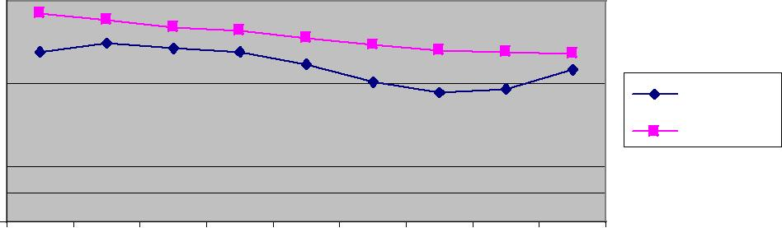
 |  | 2 |  |  | 3 |  |  | 4 |  |  | 5 |  |  | 6 |  |  | 7 |  |  | 8 |  | 9 |  | 0
 | 0 |  |  | 0 |  |  | 0 |  |  | 0 |  |  | 0 |  |  | 0 |  |  | 0 |  | 0 |  | 1
 | - |  |  | - |  |  | - |  |  | - |  |  | - |  |  | - |  |  | - |  | - |  | -
0 |  |  | 1 |  |  | 2 |  |  | 3 |  |  |  | 4 |  | 5 |  |  | 6 |  |  | 7 |  | 8
0 |  | 0 |  |  | 0 |  |  | 0 |  |  |  | 0 |  |  | 0 |  | 0 |  |  | 0 |  |  | 0
0 |  | 0 |  |  | 0 |  |  | 0 |  |  | 0 |  |  |  | 0 |  | 0 |  |  | 0 |  |  | 0
2 |  | 2 |  |  | 2 |  |  | 2 |  |  | 2 |  |  | 2 |  |  | 2 |  |  | 2 |  | 2

Source: Florida Department of Health, Bureau of Vital Statistics

45

ALCOHOL, DRUG, AND TOBACCO USE

Alcohol Use by Adults

The BRFSS telephone surveys included questions about alcohol use and tobacco use by adults.

As shown in Table 18, the percentage of adults in Highlands County who reported that they engage in heavy or binge drinking declined from 2007 to 2010. Highlands County adults also reported lower percentages of heavy or binge drinking than adults statewide.

Table 18: Adults Who Engage in Heavy or Binge Drinking
Adults who engage in | Highlands County |  |  | Florida
 | 2007 | 2010 | 2007 |  | 2010
heavy or binge drinking
 | 14.1% | 12.5% | 16.2% |  | 15.0%
Source: Risk Factors (BRFSS) – Florida Department of Health, Bureau of Epidemiology

Alcohol Use by Students

School children also have been queried about their use of alcohol. In 2008 and 2010, the Florida Youth Substance Abuse Survey was conducted in middle schools and high schools throughout the State. In Highlands County, the survey was administered to more than 1,200 students. Results, shown in Table 19, reveal the following:

- Alcohol Use. The percentage of middle school students and high school students in Highlands County who reported alcohol use in the past 30 days declined from 2008 to 2010.

- Binge Drinking. The percentage of high school students who reported binge drinking also declined, while the percentage of middle school students who reported binge drinking increased.

- County vs State. In both 2008 and 2010, a greater percentage of students in Highlands County drank and engaged in binge drinking than statewide.

Table 19: Alcohol Use, by Adolescents, by Grade
 | Middle School |  |  |  |  | High School
 | Highlands |  | Florida |  |  | Highlands |  | Florida
 | 2008 | 2010 | 2008 |  | 2010 | 2008 | 2010 | 2008 |  | 2010
Alcohol use in past | 22.8% | 20.4% | 17.3% |  | 16.8% | 42.5% | 41.7% | 39.5% |  | 38.0%
30 days
Binge drinking in | 9.9% | 11.3% | 6.2% |  | 6.9% | 27.9% | 22.6% | 21.5% |  | 19.6%
past 30 days
Source: Florida Youth Substance Abuse Surveys, 2008 & 2010, Department of Children and Families

46

Drug Use by Students

Table 20 presents findings from the Florida Youth Substance Abuse Survey on the use of illegal substances by middle school and high school students.

- Middle School. More than 7% of middle school students in Highlands County used one or more drugs in 2008. That percentage dropped to less than 5% in 2010. The most commonly used drugs were marijuana and hashish, followed closely by inhalants. A smaller percentage used these drugs in 2010 than in 2008. The percentage of all other drugs used was minimal and ranged from 0.6% to 2%.

- High School. A total of 13% of high school students in Highlands County used one or more drugs in 2008. That number increased to almost 16% in 2010. The most commonly used drugs were marijuana and hashish. Prescription pain relievers were a distant second. The percentage using marijuana and hashish increased from 2008 to 2010, while the percentage using prescription pain relievers declined.

- County vs State. The most commonly used drugs among both middle school students and high school students in the State overall were the same choices as among Highlands County middle school and high school students.

Table 20 Illegal Drug Use, by Adolescents, by Grade
 |  |  |  | Middle School |  |  |  |  | High School
 | Past 30 Day Trend |  |  | Highlands |  | Florida |  |  | Highlands |  | Florida
 |  |  |  | Co. |  |  |  |  | Co.
 |  |  | 2008 |  | 2010 | 2008 | 2010 | 2008 |  | 2010 | 2008 | 2010
 | Marijuana, Hashish |  | 7.4 |  | 4.8 | 4.4 | 5.7 | 13.0 |  | 15.9 | 16.2 | 18.6
 | Inhalants |  |  | 6.7 | 3.9 | 5.2 | 4.8 |  | 2.0 | 1.9 | 2.2 | 2.0
 | Cocaine/Crack Cocaine |  | 1.6 |  | 1.2 | 0.6 | 0.7 | 3.1 |  | 1.4 | 2.1 | 0.9
 | Depressants |  |  | 0.9 | 1.0 | 1.0 | 1.1 |  | 2.1 | 1.6 | 3.0 | 2.7
 | Prescription | Pain | 2.0 |  | 2.3 | 2.3 | 2.2 | 4.0 |  | 3.0 | 3.9 | 3.4
 | Relievers
 | LSD, PCP, Mushrooms |  |  | 0.6 | 0.9 | 0.6 | 0.7 |  | 1.9 | 0.8 | 0.6 | 1.4
Source: Florida Youth Substance Abuse Surveys, 2008 & 2010, Department of Children and Families

47

Tobacco Use by Adults

The BRFSS telephone surveys conducted in 2007 and 2010 also included questions about smoking. As shown in Table 22, Table 22 provides responses to questions.

- Current Smokers. The percentage of individuals who identify themselves as smokers in Highlands County increased from 2007 to 2010, while the percentage statewide declined.

- Smokers Who Tried to Quit. The percentage of current smokers in Highlands County who reported trying to quit declined from 2008 to 2010, while the percentage statewide increased.

- Former Smokers. The percentage of former smokers in Highlands County who said they have quit was about the same in 2008 and 2010, while the percentage statewide increased.

Table 21: Tobacco Use, by Adults
 | Highlands |  | Florida
 | 2007 | 2010 | 2007 | 2010
Current smokers | 15.1% | 19.8% | 19.3% | 17.1%
Smokers who tried to | 50.8% | 46.1% | 53.2% | 60.1%
quit in the past year
Former smokers | 31.4% | 31.6% | 26.2% | 29.8%
Source: Risk Factors (BRFSS) – Florida Department of Health, Bureau of Epidemiology

Tobacco Use By Students

The Florida Youth Substance Abuse Survey also included questions about the use of cigarettes. Survey results are as follows.

- Middle School. The percentage of Highlands County middle school students who reported smoking during a 30-day period decreased from 2008 to 2010

- High School. The percentage of Highlands County high school students who reported smoking during a 30-day period also decreased from 2008 to 2010.

- County vs State. Middle school students in Highlands County reported smoking at almost twice the rate statewide. High school students reported smoking at a rate almost a third higher than the rate statewide.

Table 22: Tobacco Use, by Adolescents
 |  |  | Middle School |  |  |  | High School
 | Past 30 Day Trend |  | Highlands Co. |  | Florida |  | Highlands Co. |  | Florida
 |  |  | 2008 | 2010 | 2008 | 2010 | 2008 | 2010 | 2008 |  | 2010
 | Cigarettes |  | 9.0% | 7.9% | 4.7% | 4.5% | 17.1% | 16.4% | 12.6% |  | 12.1%
Source: Florida Youth Substance Abuse Surveys, 2008 & 2010, Department of Children and Families

48

VIII. ORAL HEALTH

Community Water Supplies and Fluoridated Water

In Highlands County, 92% of the population obtains its drinking water from community water supplies. Community water supplies are less at risk of contamination by agricultural chemicals, industrial solvents, and heavy metals than private drinking water supplies.

Despite access to community water supplies, only 61% of the population in Highlands County has fluoridated water. According to the Public Health Dental Program of the Florida Department of Health, water fluoridation can prevent tooth decay (dental caries), and lack of fluoridation can greatly affect the quality of life of children, particularly those of low socioeconomic status.

Dental sealants are also considered effective in preventing tooth decay, and the Highlands County Health Department has a sealant program for its young dental patients. Sealants are plastic/composite materials that provide protection to the grooves of the teeth which are most susceptible to decay.

Oral Health Indicators

The BFRSS surveys included questions on oral health. Results are shown in Table 23.

The percentage of Highlands County residents who visited a dentist and who had their teeth cleaned in 2010 was less than the percentage of Florida residents statewide that did so. A greater percentage of Highlands County residents had a tooth removed than Florida residents statewide.

Table 23: Adults Who Had Dental Work Performed
 | Highlands | Florida
Adults who visited a dentist or dental clinic in 2010 | 56.9% | 64.7%
Adults who had their teeth cleaned in 2010 | 54.3% | 60.9%
Adults who had a permanent tooth removed | 64.2% | 53.0%
because of tooth decay or gum disease in 2010
Source: Risk Factors (BRFSS) – Florida Department of Health, Bureau of Epidemiology

49

IX. ENVIRONMENTAL HEALTH

Air Quality

Outdoor air quality is measured by the Air Quality Index (AQI), a national system for gauging conditions which can be harmful to human health. The higher the AQI, the higher the level of pollution.

There are 35 Florida counties in which carbon monoxide, nitrogen dioxide, sulfur dioxide, ozone, lead, and particulate matter are monitored to arrive at the AQI. There are three rural counties, including Highlands County, where only ozone is measured. In the remaining Florida counties, the AQI is not measured.

An AQI value of 50 represents good air quality, and an AQI over 300 represents hazardous air quality. The AQI for Highlands County for 2010 is presented in Table 24.

Table 24:AQI Breakdown for Highlands County, 2010
# of days | Good | Moderate | Unhealthy for | Unhealthy | Very | Hazardous
AQI values | <=0 | 51-100 | Sensitive |  | Unhealthy
 |  |  | Groups
O₃ | 351 | 14 | 0 | 0 | 0 | 0
Source: Florida Department of Environmental protection

Lead Poisoning

Lead poisoning rates in Highlands County increased from a low of 3.7 in 2001-2003 to a high of 7.7 per 100,000 population in 2008-2010. The rates for 2007-2009 and 2008-2010 were more than twice those for Florida overall.

Figure 36

Lead Poisoning, 3-Year Rolling Rates

 | 25
100,000 | 20
 | 15 |  |  |  |  |  |  |  |  |  |  |  |  |  |  |  |  |  |  |  |  |  |  |  |  | Highlands
per | 10 |  |  |  |  |  |  |  |  |  |  |  |  |  |  |  |  |  |  |  |  |  |  |  |  | Florida
Rate | 5
 | 0
 |  |  | 2 |  |  | 3 |  |  | 4 |  |  | 5 |  |  | 6 |  |  | 7 |  |  | 8 |  |  | 9 |  | 0
 |  | 0 |  |  | 0 |  |  | 0 |  |  | 0 |  |  | 0 |  |  | 0 |  |  | 0 |  |  | 0 |  | 1
 |  | - |  |  | - |  |  | - |  |  | - |  |  | - |  |  | - |  |  | - |  |  | - |  | -
 | 0 |  |  | 1 |  |  | 2 |  |  | 3 |  |  | 4 |  |  | 5 |  |  | 6 |  |  | 7 |  |  | 8
 | 0 |  |  | 0 |  | 0 |  |  | 0 |  |  | 0 |  |  | 0 |  |  | 0 |  |  | 0 |  |  |  | 0
 | 0 |  | 0 |  |  | 0 |  |  | 0 |  |  | 0 |  |  | 0 |  |  | 0 |  |  | 0 |  |  | 0
 | 2 |  | 2 |  |  | 2 |  |  | 2 |  |  | 2 |  |  | 2 |  |  | 2 |  |  | 2 |  |  | 2
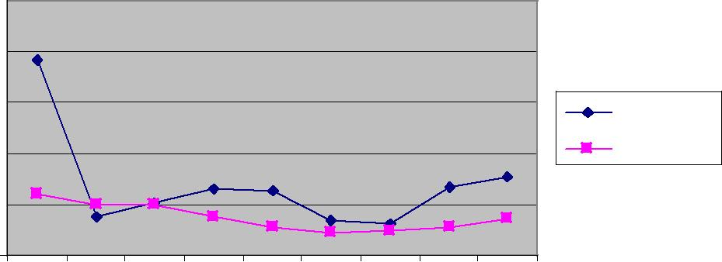
Source: Florida Department of health, Bureau of Epidemiology

50

Children under the age of 6 are particularly susceptible to poisoning from lead-based paints. In Highlands County, the lead poisoning rates for children under 6 have fluctuated greatly from 2000 to 2010. They have been consistently higher than the State rate for most years and were almost three times higher than the State rate in 2008-2010.

Figure 37

 |  | Lead Poisoning < 6 Years of Age,
 |  | 3-Year Rolling Rates
 | 140
100,000 | 120
 | 100
 | 80 | Highlands
per | 60 | Florida
 | 40
Rate
 | 20
 | 0
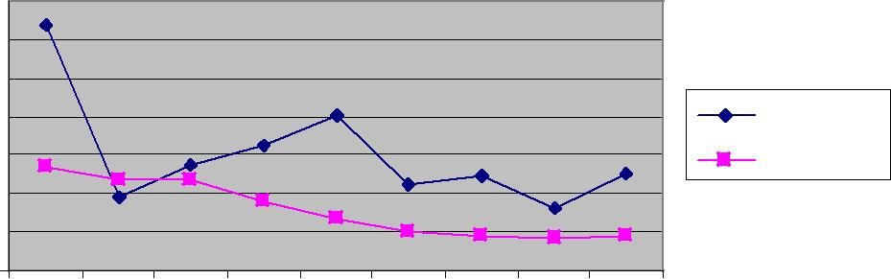
 |  | 2 |  |  |  | 3 |  |  |  | 4 |  |  |  | 5 |  |  |  | 6 |  |  |  | 7 |  |  |  | 8 |  |  |  | 9 |  |  | 0
 | 0 |  |  |  | 0 |  |  |  | 0 |  |  |  | 0 |  |  |  | 0 |  |  |  | 0 |  |  |  | 0 |  |  |  | 0 |  |  | 1
- |  |  |  | - |  |  |  | - |  |  |  | - |  |  |  | - |  |  |  | - |  |  |  | - |  |  |  | - |  |  | -
0 |  |  |  | 1 |  |  |  | 2 |  |  |  | 3 |  |  |  | 4 |  |  |  | 5 |  |  |  | 6 |  |  |  | 7 |  |  | 8
0 |  |  |  | 0 |  |  |  | 0 |  |  |  | 0 |  |  |  | 0 |  |  |  | 0 |  |  |  | 0 |  |  |  | 0 |  |  | 0
0 |  |  |  | 0 |  |  | 0 |  |  |  |  | 0 |  |  |  | 0 |  |  | 0 |  |  |  |  | 0 |  |  |  | 0 |  | 0
2 |  |  | 2 |  |  |  | 2 |  |  |  | 2 |  |  |  | 2 |  |  |  | 2 |  |  |  | 2 |  |  |  | 2 |  |  | 2

Source: Florida Department of health, Bureau of Epidemiology

Access to Recreational Facilities

In the University of Wisconsin’s County Health Rankings (2012), Highlands County was ranked on Access to Recreational Facilities. It received a score of 10. This measure represents the number of recreational facilities per 100,000 population in the county.

Highlands County fared better than Florida overall, which has a rate of 9 recreational facilities per 100,000 population, but it ranked below the national benchmark of 16.

Access to Healthy Foods

The University of Wisconsin’s County Health Rankings (2012) also measured the County on Limited Access to Healthy Foods. Limited access to healthy foods measures the proportion of the population who are both living in poverty and do not live close to a grocery store. Living close to a grocery store in rural counties means living less than 10 miles from a grocery store.

In Highlands County, 2 percent of the population has limited access to healthy foods. In Florida overall, 9 percent of the population has limited access to healthy foods.

51

Fast Food Restaurants

The University of Wisconsin’s County Health Rankings (2012) also measured the percent of restaurants that are fast food establishments. In Highlands County, 48% of restaurants are fast food establishments. That compares with 45% for the State overall. The national benchmark is 25%.

52

X. HEALTH CARE RESOURCES

Health Care Facilities

Highlands County has three hospitals and five nursing homes. The County compares favorably with the State in terms of number of hospital beds, acute care beds, and nursing home beds. In each category, Highlands County has more beds per 100,000 population than the State overall.

The County does not compare as favorably with the State in terms of specialty care beds for adult psychiatric patients. Highlands County has fewer beds per 100,000 population than the State overall.

Table 25: Selected Health Care Facilities, 2009
 |  |  |  | Number |  | Highlands County | Florida
 | Type |  |  |  |  | Rate per 100,000 | Rate per 100,000
 |  |  |  | of Beds
 |  |  |  |  |  | Population | Population
 | Total Hospital Beds |  | 335 |  |  | 339.4 | 320.1
 | Acute Care Beds |  | 318 |  |  | 322.1 | 265.0
 | Specialty Care Beds |  | 17 |  |  | 17.2 | 18.4
 | (Adult Psychiatric)
 | Nursing Home Beds |  | 598 |  |  | 605.4 | 438.0
Source: Agency for Health Care Administration

Other selected health care facilities that are licensed in Highlands County are shown below.

Table 26: Selected Licensed Facilities by Type and Capacity, 2010

Highlands County
Type of Facility | Number | Capacity
Adult Family Care Home | 1 | 5
Ambulatory Surgical Center | 4 | N/A
Assisted Living | 11 | 723
Clinical Labs | 16 | N/A
End Stage Renal Disease | 3 | N/A
Home Health | 9 | N/A
Homemaker/Companion | 9 | N/A
Home Medical Equipment | 8 | N/A
Intermediate Care for the | 1 | 24
Developmentally Disabled
Rural Health Clinics | 13 | N/A
Source: www.floridahealthfinder.gov

53

Health Care Providers: Physicians, Dentists, and Mental Health Professionals

Highlands County is below the state rate for licensed physicians. The County has almost 60% fewer physicians per 100,000 population than the State, including low rates of pediatricians, obstetricians/gynecologists, and internists. Only the rate of family practice physicians comes close to the state rate.

Table 27: Licensed Physicians, 2009-2010
 |  | Highlands County | Florida
Type of Physician | Number | Rate per 100,000 | Rate per 100,000
 |  | Population | Population
Family Practice | 23 | 23.3 | 28.8
Internists | 33 | 33.4 | 58.6
OB/GYN | 4 | 4.1 | 11.9
Pediatricians | 11 | 11.1 | 25.2
Total Physicians | 192 | 194.5 | 335.7
Source: Florida Department of Health, Division of Medical Quality Assurance

Highlands County is also below the State rate for total licensed dentists. It has about 60% fewer dentists per 100,000 population than the State.

Table 28: Licensed Dentists, 2009-2010
 |  | Highlands County | Florida
Type of Physician | Number | Rate per 100,000 | Rate per 100,000
 |  | Population | Population
Dentists | 37 | 37.5 | 63.5
Source: Florida Department of Health, Division of Medical Quality Assurance

The State also has more than twice the number of mental health professionals per 100,000 population as Highlands County. Highlands County has a shortage of clinical social workers, marriage and family therapists, mental health counselors, and psychologists.

Table 29: Licensed Mental Health Professionals, 2011
 |  |  |  | Highlands |  |  |  |  |  | Florida
 | Type of License |  |  | Number |  |  | Rate per |  |  | Number |  |  | Rate per
 |  |  |  |  |  |  | 100,000 |  |  |  |  |  | 100,000
 | Licensed Clinical |  | 19 |  |  | 18.5 |  |  | 7,255 |  |  | 38.3
 | Social Workers
 | Marriage and Family |  | 6 |  |  | 5.8 |  |  | 1,519 |  |  | 8.0
 | Therapists
 | Mental Health |  | 24 |  |  | 23.4 |  |  | 7,783 |  |  | 41.1
 | Counselors
 | Psychologists |  | 5 |  |  | 4.9 |  |  | 4,433 |  |  | 23.4
 | Total Mental Health |  | 54 |  |  | 52.6 |  |  | 20,990 |  |  | 110.9
 | Professionals
Source: Florida Department of Health, Division of Medical Quality Assurance, and ESRI

54

Manpower Shortage Designations

The federal government’s Health Resources and Services Administration collects information and classifies areas of the country regarding the availability of health care services. There are two types of designations: Health Professional Shortage Areas (HPSA) and Medically Underserved Areas or Populations (MUA or MUP).

Designation as a HPSA or an MUA or MUP means that an area or a population group has a shortage of primary care, dental care or mental health providers, as well as barriers to accessing care. These barriers can include lack of public transportation, large distances and long travel times to health care facilities, and high poverty. The area or population group must have a population to physician ratio greater than 3,000 to one.

As shown in Table 30, Highlands County has been designated a HPSA and an MUP because of its low income and migrant and seasonal farmworker populations. These population groups also face cultural and linguistic barriers to health care.

Table 30: Manpower Shortage Area Designations, 2010

Highlands County
Designation | Type
Primary Health Professional Shortage Area | Low Income/Migrant Farm Worker
Dental Health Professional Shortage Area | Low Income/Migrant Farm Worker
Mental Health Professional Shortage Area | Low Income/Migrant Farm Worker
Medically Underserved Population | Low Income/Migrant Farm Worker
Source: U.S. Department of Health and Human Services, Health Professional Shortage Areas

55

XII. HEALTH CARE ACCESS

Financial Barriers

Table 30 provides statistics on the uninsured in 2008-2010 in Highlands County.

- Nearly 34% of those 18-64 years of age were uninsured.

- A greater percentage of males than females were uninsured.

- Nearly 40% of Hispanics were uninsured.

- A total of 50% of those who were unemployed and 31% of those who were employed were without insurance.
- Nearly 25% of households with incomes under $25,000 are uninsured.

Table 31: Estimated Number and Percent Without Health Insurance, 2008-2010

Highlands County
 | Number Uninsured | Percent Uninsured
Age
Under 18 | 2,828 | 15.5
18 to 64 years | 16,219 | 33.3
65+ years | 223 | 0.7
Gender
Male | 10,670 | 22.3
Female | 8,600 | 17.2
Race/Ethnicity
White | 15,589 | 18.7
Black | 2,073 | 22.1
Hispanic | 6,438 | 38.8
Employment Status
Employed | 10,165 | 30.8
Unemployed | 2,427 | 50.5
Not in Labor Force | 3,850 | 9.2
Household Income
Under $25,000 | 6,231 | 23.2
$25,000 to $49,999 | 7,718 | 21.4
$50,000 to $74,999 | 3,355 | 19.3
$75,00-0 to $99,999 | 1,373 | 14.3
$100,000 | 593 | 7.5
Source: US Census Bureau, 2009 American Community Survey

56

Table 32 shows the percent of the population, by type of coverage, who had insurance coverage in 2010.

- Approximately 63% of the population had private insurance. Of these, nearly 40% were covered by their employers. A smaller percentage of people directly purchased insurance.

- Approximately 55% had public insurance. More than one-third had Medicare coverage, and one-fifth had Medicaid.

Table 32: Percent of Population by Insurance Provider, 2010^{1/}
 | Highlands County
Provider |  | Percent of Population
Private
Employer Provided |  | 37.8
Direct Purchase |  | 20.6
Tri-Care |  | 4.9
Public
Medicare |  | 35.1
Medicaid |  | 21.4
VA |  | 7.4
Source: American Community Survey, 2010
^{1/} Individuals may have more than one provider. Direct purchase includes supplemental Medicare policies; Medicaid includes joint Medicare/Medicaid. Persons over 65 may also have employer provided coverage

Younger and low-income individuals are less likely to seek regular medical care and are less likely to have health insurance when compared with older and higher income individuals. Table 32 indicates responses to the 2010 Behavioral Risk Factor Surveillance Survey (BRFSS) questions related to the receipt of regular medical care.

Table 33 Adults Who Received Regular Medical Care, 2010

Highlands County
Percent |  | Age |  |  | Income
 | 18-44 | 45-64 | 65+ | <$25,000 | $25,000- | >$50,000
 |  |  |  |  | $50,000
Adults who have a personal | 75.4 | 84.5 | 95.0 | 78.9 | 89.4 | 91.3
doctor.
Adults who were not able | 33.4 | 23.2 | 3.5 | 35.8 | 12.9 | 9.3
to see a doctor in the past
year due to cost
Adults who had a medical |  |  |  | 63.7 | 66.8 | 69.6
check up in the last year
Adults with any type of | 57.3 | 77.4 | 99.1 | 67.2 | 84.7 | 95.8
health insurance
Source: Risk Factors (BRFSS) – Florida Department of Health, Bureau of Epidemiology

57

Even when individuals have insurance, some plans may not cover certain services or the reimbursement rates may be too low for providers to accept patients. This is particularly true for Medicaid patients and to a lesser extent, Medicare and privately insured patients, according to a 2011 study by the Centers for Disease Control and Prevention’s National Center for Health Statistics.

Although 96% of U.S. office-based physicians accepted new patients in 2011, rates varied by payment source. Thirty-one percent of physicians were unwilling to accept any new Medicaid patients; 17 percent would not accept new Medicare patients, and 18 percent would not accept new privately insured patients. Physicians in smaller practices and those in metropolitan areas were less likely than others to accept Medicaid patients. Higher State Medicaid to Medicare fee ratios were correlated with greater acceptance of new Medicaid patients.

The study included a State breakdown of the percentage of physicians accepting new Medicaid patients. Florida ranked third worst among the 50 States, behind New Jersey and California. Thirty-one percent of Florida physicians reported that they were unwilling to accept any new Medicaid patients.

Florida’s reimbursement rates for Medicaid and Medicare do not compare favorably with other States. According to the Kaiser Family Foundation’s State Health Facts, Florida ranks 8th lowest in the nation for Medicaid reimbursement for all services and for primary care services. For OB services, Florida’s Medicaid reimbursement rates are better, ranking at 35th lowest.

Structural Barriers

Highlands County does not have a public transportation system. Some people must travel large distances with long travel times to get to their destinations. Some people do not have cars. Some older people are no longer able to drive. Taxi service is limited and expensive.

Veolia Transportation, Inc. is the Community Transportation Coordinator for Highlands County. The company transports low-income, disabled, elderly and other eligible transportation disadvantaged Highlands County residents. Tables 34-38 provide statistics on trips and unmet trip requests from July 1, 2011 to June 30, 2012. Findings are as follows.

- Low-income and disabled individuals aged 18-64 were the main population group served.

- Elderly individuals 65 and older were the second most populous group served.

- The majority of individuals transported were ambulatory.

- Approximately half of the trips were for employment purposes.

58

- Medical trips accounted for slightly more than a third of the total.

- Remaining trips--slightly more than 15% were for other purposes. These were categorized as life-sustaining, nutritional, and education/training/daycare trips.

- Unmet trip requests totaled 1,022 or less than 1 percent of the total trip requests.

- The majority of unmet trip requests were for medical purposes. Lack of funding was the primary reason why the company denied service.

Table 34: Trips by Population Served, Highlands County, July 1, 2011 – June 30, 2012

(n=128,274)
Population |  |  | Low Income |  | Disabled |  |  | Low Income |  | Other
 |  |  |  |  |  |  |  | and Disabled
Elderly |  |  | 4,095 |  | 7,219 |  |  | 3,646 |  | 22,282
Children |  |  | 679 |  | 72 |  |  | 106 |  | 2,124
Other |  |  | 13,086 |  | 19,312 |  |  | 46,720 |  | 8,933
Source: Veolia Transportation Company
Table 35: Trips, by Mobility of Population, Highlands County,
 |  |  | July 1, 2011 – June 30, 2012
 |  | Mobility |  |  |  |  |  | Total
 |  | Ambulatory |  |  |  |  |  | 108,073
 |  | Non-Ambulatory |  |  |  |  |  | 19,513
 |  | Stretcher |  |  |  |  |  | 688
 |  | Total Trips |  |  |  |  |  | 128,274
 | Source: Veolia Transportation Company
 |  | Table 36: Trips, by Type of Trip, Highlands County,
 |  |  | July 1, 2011 – June 30, 2012
 |  | Type of Trip |  |  |  |  |  | Number
 |  | Medical |  |  |  |  |  | 44,573
 |  | Employment |  |  |  |  |  | 64,611
 |  | Education/Training/Daycare |  |  |  |  |  | 2,693
 |  | Nutritional |  |  |  |  |  | 7,978
 |  | Life-Sustaining/Other |  |  |  |  |  | 8,419
 |  | Total Trips |  |  |  |  |  | 128,274
 |  | Source: Veolia Transportation Company

59

Table 37: Unmet Trip Requests, Highlands County,
July 1, 2011 – June 30, 2012

Type of Trip |  | Number
Medical |  | 479
Employment |  | 0
Education/Training/Daycare |  | 0
Nutritional |  | 154
Life-Sustaining/Other |  | 389
Total |  | 1,022
Source: Veolia Transportation Company

Table 38: Reason Trip Was Denied, Highlands County,
July 1, 2011 – June 30, 2012

Reason |  | Number
Lack of Funding |  | 964
Lack of Vehicle
Availability |  | 0
Lack of Driver Availability |  | 10
Other |  | 48
Source: Veolia Transportation Company

Veolia Transportation’s revenue sources and dollar amounts for FY 2011-2012 are provided in Table 39.

Medicaid was the primary source of income. It was 44 percent of the total revenue. Next largest source of revenue was the transportation disadvantaged program (TD). TD funds totaled 34 percent of income.

Table 39: Revenue Sources, Veolia Transportation, Highlands County,

July 1, 2011 – June 30, 2012
 | Source of Revenue | Amount | Percent
 | Self | 879 | < .1%
 | Transportation Disadvantaged | 631,280 | 34%
 | Medicaid | 814,096 | 44%
 | Agency for Persons with Disabilities | 102,726 | 5.5%
 | Children’s Medical Services | 6,801 | .3%
 | Florida Department of Transportation 16,17 | 239,884 | 12.9%
 | Department of Elder Affairs | 46,720 | 2.5%
 | Other | 11,320 | .6%
 | Total | $1,853,706 | 100%
 | Source: Veolia Transportation Company

60

Personal Barriers

Personal barriers may also affect one’s ability to successfully access health care. Such barriers may be the result of a lack of knowledge about the healthcare system, skepticism about the effectiveness of prevention, environmental challenges for people with disabilities, and cultural, linguistic, health literacy, and educational factors.

61

