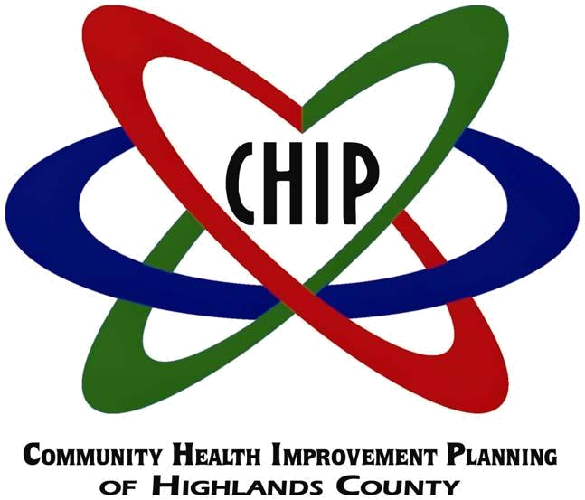

Action Plan 2012-2015

Prepared by The Health Council of West Central Florida in collaboration with the Highlands County Health Department

TABLE OF CONTENTS

- Introduction

 | Methodology | 2
 | Community Health Improvement Plan (CHIP) Elements | 2
 | Community Health Improvement Plan (CHIP) Participants, by Agency | 3
II. | Community Health Status Profile Report: Executive Summary | 4
III. | Community Health Survey: Executive Summary | 9
IV. | Vision and Values | 11
V. | Community Themes and Strengths Assessment | 12
VI. | Local Public Health System Assessment | 16
VII. | Gap Analysis | 17
VIII. | Forces of Change Assessment | 19
IX. | Identification and Prioritization of Strategic Issues | 25
X. | Formulation of Goals and Strategies | 26
XI. | Action Plan 2012-2015 | 28

APPENDICES
APPENDIX A: Community Health Improvement Plan Individual Participants | 37
APPENDIX B: Ten Essential Public Health Services | 39
APPENDIX C: Local Public Health System Assessment Participants | 41

- INTRODUCTION

In April 2011, Highlands County Health Department engaged in an agreement with the Health Council of West Central Florida to assist with the updating of its community health improvement partnerships planning process (CHIP). The process selected was the MAPP process, which stands for Mobilizing for Action through Planning and Partnerships.
This is a community driven highly participatory process working to bring together not only healthcare providers, but mental health and social service agencies, public safety agencies, education and youth development organizations, recreation agencies, economic development agencies, environmental agencies, local governments, neighborhood associations, and civic groups. All contribute to the health and welfare of the community.
On the third Thursday of each month CHIP partners met to discuss one element of the plan. Meetings were held at Children’s Advocacy Center, 1968 Sebring Parkway.
Through the MAPP Process, the team completed a local public health system assessment and developed, distributed collected and assessed a community health survey with the help of community partners which contributed to the creation of the Community Health Assessment Profile. The team used data from these assessments as well as the Florida Legislative Office of Economic Development, the National Public Health Performance Standards Local Public Health Assessment of Highlands County 11-11-2011, US Census Bureau, Florida Department of health CHARTS (Community Health Assessment Resource Tool Set), Florida Department of Health Bureau of Epidemiology, Florida Department of Health Division of Disease Control, Florida Department of Health Bureau of Vital Statistics, Florida Department of Health Environmental Protection Agency, Florida Department of Children and Families, Florida Youth and Substance Abuse Survey, Agency for Health Care Administration, Florida Department of Health Division of Medical and Quality Assurance, U.S. Department of Health and Human Services, Health Professional Shortage Areas, and Veolia Transportation Company.
The outcome of this process was the identification of gaps in our healthcare system and identification of strategic issues to be addressed by our community. This led to the development of goals and a strategic plan that are included in this action plan.

METHODOLOGY

From July 2011 through June 2012, the Highlands County Health Department and its Community Health Improvement Planning partners updated the County’s Community Health Improvement Plan (CHIP), using a process called Mobilizing for Action through Planning and Partnerships (MAPP).

The MAPP process was developed by the National Association of County and City Health Officials and the Centers for Disease Control and Prevention.

MAPP is a community-driven, highly participatory process which is intended to bring together not only health care providers, but also mental health and social service agencies, public safety agencies, education and youth development organizations, recreation agencies, economic development agencies, environmental agencies, local governments, neighborhood associations, and civic groups. All contribute to the health and welfare of the community.

Each month for a year, CHIP partners met to discuss one element of the Plan. The Health Council of West Central Florida facilitated the meetings and prepared bulleted summaries of the plan elements. The Health Department and CHIP partners reviewed the summaries and gave final approval. These summaries provided the basis in part for the CHIP 2012-2015.

In addition, the Highlands County Health Department in conjunction with the Health Council conducted a Community Health Survey and prepared a Community Health Status Profile Report. Results of the Profile and the Survey are included in the CHIP.

CHIP ELEMENTS

CHIP 2012-2015 includes the following plan elements:

  - Community Health Status Profile Report: Executive Summary*
  - Community Health Survey: Executive Summary*
  - Vision and Values

  - Community Themes and Strengths Assessment
  - Local Public Health System Assessment, Overall Results**
  - Gap Analysis
  - Forces of Change Assessment

  - Identification and Prioritization of Strategic Issues
  - Formulation of Goals and Strategies

  - Action Plan 2012-2015

- The complete document is available at www.highlandschip.org.

- A full report is available at www.highlandschip.org.

CHIP PARTICIPANTS, BY AGENCY

Agencies which were represented at one or more MAPP meetings are listed below. Names of the agency participants can be found in Appendix I.

Alliant
Balance

Central Florida Health Care
Drug Free Highlands

Florida Department of Children and Families

Florida Hospital Heartland
Healthy Families

Healthy Start Coalition for Hardee, Highlands, and Polk Counties Heartland Rural Health Network

Highlands County Board of County Commissioners
Highlands County Health Department

Highlands County Homeowners Association
Highlands County School Board

Highlands County Sheriff’s Office
Highlands Regional Medical Center

Highlands County Veterans Services Office
Redlands Christian Migrant Association

Samaritan’s Touch Care Center

South Florida Community College
Tri-County Human Services

United Health Care

II. Community Health Status Profile Report: Executive Summary

POPULATION

Highlands County is the 34th most populous county in Florida. It has just under 100,000 population. It is a rural county, so there are fewer persons per square mile compared to Florida.

One-third of the population is 65 and older. In addition to full-time residents, the County has a seasonal population of snowbirds or winter visitors.The County also has a migrant population and a seasonal farmworker population.

The population is primarily white (81%). African Americans are the next most populous racial group (9.4%).Hispanics are the main ethnic group. Hispanics comprise slightly more than 17% of the population.

SOCIO-ECONOMIC CHARACTERISTICS

Family households make up approximately 2/3 of the population. Family households are comprised mostly of married couple families.

Non-family households comprise 1/3 of the population. Most non-family households are people living alone.

Median household income was just under $35,000 in 2010 in Highlands County. In Florida, it was close to $48,000. Highlands County has a higher percentage of residents living in poverty than Florida. In 2010, more than 19% were living in poverty. Of those, 33% were children under the age of 18; 20% were ages 18-64, and 11% were 65 and older.

The unemployment rate in Highlands County averaged 11.3% in 2010, and 10.4% in 2011. In June 2012, it was 8.9%. Local government is the largest employer. Highlands County has a high school graduation rate of 73 percent and only 43 percent have some college.

The Highlands County School District had close to a 400 percent increase in the population of homeless children and families from 2010-2011 to 2011-2012.

MAJOR CAUSES OF DEATH

Leading causes of death in Highlands County are heart disease, cancer, chronic lower respiratory disease (CLRD), stroke, and unintentional injuries.

Heart disease is the leading cause of death for individuals 65 and older. Cancer is the leading cause of death for those aged 45-64.

The leading causes of death for those aged 1-44 are unintentional injuries; and the leading causes of death for infants less than one year of age are complications in the perinatal period.

Blacks have higher death rates than Whites from heart disease, cancer, and strokes. They have a lower death rate from CLRD.

Hispanics have lower death rates than non-Hispanics from heart disease, cancer, and strokes, but a higher death rate from CLRD.

CHRONIC DISEASES

Highlands County does not score well or compare well to the State and other Florida counties for several diseases, including CLRD, asthma, and diabetes.

In 2008-2010, the age-adjusted hospitalization rates in Highlands County for CLRD, asthma, and diabetes were higher than in previous years. The rates were also higher than the State rates for these diseases. In addition, at least 75% of the other Florida counties had a lower hospitalization rate for CLRD and asthma, while 50% had a lower hospitalization rate for diabetes.

The incidence rate for melanoma was higher in Highlands County in 2008-2010 than in previous years. Highlands County had a higher incidence rate for melanoma than the State.

Risk factors for chronic diseases include not engaging in physical activity and being overweight or obese.

More than one-third of the County’s adults do not engage in any leisure time physical activity. Thirty-three percent are overweight, and 30% are obese.

Less than 40% of students engage in sufficient vigorous physical activity, and 14% of middle school students and 16% of high school students are overweight.

COMMUNICABLE AND INFECTIOUS DISEASES

The incidence of communicable diseases in Highlands County is low.

Highlands County has a lower rate of tuberculosis, influenza, hepatitis, HIV/AIDS cases, and STDs (gonorrhea and Chlamydia) than the State

Highlands County ranked in the top 25% of Florida counties for administration of the influenza and the pneumococcal vaccines in 2008-2010.

MATERNAL, INFANT AND YOUNG CHILD HEALTH

The rate of births in Highlands County declined from 2006-2008 to 2008-2010. The rate of births to Blacks also declined over that same time period. However,

Blacks still have a higher birth rate than Whites.

Highlands County ranks in the bottom quartile when compared to other Florida counties in terms of births to mothers aged 15-19, repeat births to mothers aged 15-19, births to unwed mothers, births to mothers with a high school education, births to women who had adequate prenatal care, and women who breastfed.

Highlands County ranks n the 3rd quartile among Florida counties in terms of women who were overweight and obese at time of conception, women with a 1st Trimester prenatal care, and women with late or no prenatal care.

Highlands County has a higher rate of hospitalizations and emergency room visits than the State for infants less than 1 year of age.

Highlands County has a higher neonatal, post-neonatal, and infant death rate per 1,000 births than the State.

Highlands County has a much higher rate of hospitalization for asthma in children ages 1-5 than the State. It also has a higher rate of hospitalizations for traumatic brain injuries and poisonings in children 1-5.

MENTAL HEALTH, SUICIDE, AND DOMESTIC VIOLENCE

The percentage of adults reporting “good mental health” declined from 2007 to 2010, and the number reporting “poor mental health on 14 of the past 30 days” increased.

The Highlands County School District has a higher rate of referrals to the Department of Juvenile Justice than the State. It also reports more violent acts in school than are reported for the State overall.

The death rate from suicide in Highlands County is higher than the overall State rate, and it is increasing.

Domestic violence rates are increasing in Highlands County while the overall State rate is declining.

ORAL HEALTH

Only 61% of the population in Highlands County has fluoridated water.

The percentage of Highlands County residents who visited a dentist and who had their teeth cleaned in 2010 was less than the percentage of Florida residents statewide who did so.

ALCOHOL, DRUG, AND TOBACCO USE

The percentage of adults who reported that they engage in heavy or binge drinking declined from 2007 to 2010 in Highlands County. Adults in Highlands County also engaged in less heavy or binge drinking than adults statewide.

The percentage of adults who reported that they smoked increased from 2007 to 2010 in Highlands County. The percentage who tried to quit declined.

In both 2008 and 2010, a greater percentage of students in Highlands County drank and engaged in binge drinking than statewide

Middle school students in Highlands County reported smoking at almost twice the rate of all middle school students in Florida. High school students reported smoking at a rate almost a third higher than the rate statewide.

The percent of middle school students in Highlands County who used one or more drugs declined from 2008 to 2010, while the percent of high school students who used one or more drugs increased. Marijuana and hashish were the most popular drugs.

ENVIRONMENTAL HEALTH

The Air Quality Index (AQI) in Highlands County is measured for ozone. In 2010, Highlands County had an AQI of Good on 351 days and an AQI of Moderate on 14 days.

Lead poisoning rates in Highlands County are more than twice those for Florida overall in 2008-2010.

Lead poisoning rates for children under the age of 6 in Highlands County were almost three times higher than the State rate in 2008-2010.

HEALTH CARE RESOURCES

The County compares favorably with the State in terms of number of hospital beds, acute care beds, and nursing home beds. It does not compare favorably with the State in terms of specialty care beds for adult psychiatric patients.

Highlands County has close to 60% fewer physicians per 100,000 population than the State. That includes a lower rate of pediatricians, obstetricians and gynecologists, and internists. Only the rate of family practice physicians comes close to the State rate.

Highlands County is also below the State rate for total licensed dentists. It has about 60% fewer dentists per 100,000 population than the State.

The State also has twice the number of mental health professionals per 100,000 population as Highlands County.

Highlands County has been designated a Health Professional Shortage Area and a Medically Underserved Population by the federal government due to the shortage of primary care, dental, and mental health practitioners to serve low income and migrant farm worker populations.

HEALTH CARE ACCESS

Nearly 34% of those 18-64 years of age in Highlands County were uninsured in 2008-2010.

A greater percentage of males than females were uninsured. Nearly 40% of Hispanics were uninsured.

A total of 50% of those who were unemployed and 31% of those who were employed were without insurance.

Nearly 25% of households with incomes under $25,000 were uninsured.

Medicaid and to a lesser extent Medicare and private insurance patients are sometimes denied access to physicians because of the low reimbursement rates for services.

Highlands County does not have a public transportation system. That creates barriers to accessing care.

Highlands County has a Community Transportation Coordinator. The company transports low income, elderly, disabled and other eligible transportation disadvantaged Highlands County residents. The resources are not sufficient to meet the needs.

The entire Health Status Profile Report can be accessed at www.highlandschip.org

III. Community Health Survey Results, Executive Summary

The Highlands County Health Department conducted a community health survey from February through April 2012. The survey included questions about personal health, quality of health care services, access to health care, and quality of life in Highlands County.

More than 1,100 individuals responded to the survey. Three-quarters were female. Seventy percent were between the ages of 26 and 64. Seventy percent were white; nine percent Black; and 17 percent Hispanic. Ninety-two individuals answered the survey in Spanish.

Participating in the survey were clientele at local health and social service agencies; employees at the two local hospitals, the Health Department, and South Florida Community College; parishioners at local churches; and attendees at the Highlands County Fair.

Respondents’ Rating of Personal Health Status

Seventy-nine percent of whites, 68 percent of blacks, and 61 percent of Hispanics rated their health as either good or excellent.

Among those who answered in Spanish, 45 percent rated their health as either excellent or good.

Respondents’ Rating of Quality of Health Care Services

Fifty percent of respondents rated local health care services as either “excellent” or “good.” Whites gave the health care system the same rating.

Blacks looked more favorably upon the system. 65 percent rated local health care services as either excellent or good.

Among Hispanics and those who answered the survey in Spanish, 49 percent and 42 percent respectively rated the health care system as excellent or good.

Respondents’ Rating of Access to Care

Those who reported the most difficulty in accessing the health care system were Hispanics/Latinos and those who answered the survey in Spanish.

The most common problems were not having a medical provider whom they see annually for preventive services; and not having insurance or the ability to pay out-of- pocket for care. Other problems reported were lack of knowledge about available services and an inability to understand and speak English well

Unmet Needs

Dental, vision and mental health/counseling were consistently in the top three unmet needs across all groups. Some minor variations occurred as follows:

Among the medically insured who have high deductibles or co-pays (398), dental, mental health/counseling and alternative medicine rated as the most difficult to obtain.

Among those who indicated they could not afford their medications (63), medications were the second most difficult service to obtain behind dental services, with vision and mental health tied for third place.

Among part-time employed individuals (118), endocrinology was ranked third behind dental and mental health.

Respondents’ Rating of Quality of Life

Respondents were asked to rate quality of life indicators around the following topics:

Is Highlands County a good place to raise children? Is Highlands County a good place to grow old?

Do you feel there is economic opportunity in Highlands County? Do you feel your community is a safe place to live?

Is there a network of support in Highlands County for individuals and families during times of stress and crisis?

Churches as an asset in the community received the strongest response with 79 percent of respondents rating them as excellent to good. No other service had strong ratings of excellent.

Transportation was rated as poor by more than half of respondents.

Shopping was rated fair to good by 72 percent of respondents.

Jobs with growth and higher education leading to economic opportunity were rated poor by more than half of respondents.

Recreation services were rated fair to poor by the majority of respondents.

Environment was rated good to excellent by nearly 60 percent of respondents.

Knowledge about networks of support in times of crisis was low overall.

The entire Community Health Survey can be accessed at www.highlandschip.org

IV. VISION AND VALUES

Participants were asked to answer the following question:

- What would we like our community to look like in 10 years?

Vision

Highlands County is a community that works together to help everyone realize their potential through the promotion of healthy behaviors, provision of opportunities for education and meaningful work, protection of our environment, development of comprehensive, high quality health and social services and building strong community ties.

Values

Highlands County is a community that:

- Is inclusive - where everyone has a voice and is considered in decision making. Has eliminated health disparities.
- Understands and values cultural differences.

Supports families and promotes connections between neighbors.

  - Values a healthy, safe and aesthetically pleasing environment that protects our natural resources.

- Offers opportunities for recreation, physical activity, cultural and artistic enrichment.
- Supports accessibility to health and community services through efficient and affordable transportation.

- Has a strong public health system to respond in the event of an emergency.

- Supports the development of high quality educational institutions and a skilled workforce.

- Provides a diverse economy with opportunities for sustainable living.

- Offers diverse housing options that are affordable and can meet the needs of various life stages.

- Values accessible, affordable and high quality health care throughout the lifespan to reduce injuries, disabilities and premature death.

- Focuses on the prevention of health and social problems.

- Recognizes that good health encompasses physical, mental, behavioral, emotional and spiritual well-being.

- Develops public policy based on the best interest of the community using evidence-based approaches, not political ideologies.

- Promotes meaningful collaborations among service providers, government and citizens.

V. COMMUNITY THEMES AND STRENGTHS

Participants were asked to answer the following questions:

- What is important to our community?

- How is quality of life perceived in our community?

- What assets do we have that can be used to improve community health?

STRENGTHS:

Environment

Affordable housing Rural lifestyle

Protected lands Civic pride

Façade grants

Arts and cultural offerings improving

Economic/ Education

International Baccalaureate Program in schools South Florida Community College

Good teachers and well equipped schools

New leadership of Economic Development Council Collaboration

Strong institutions (health and social services, faith community, government) with long term relationships between providers and high levels of trust

Leadership around important issues

Not willing to give up on issues-keep working on things until they improve Interfaith cooperation around community issues

Community Health Improvement Planning (CHIP)

More co-location of services and on-site partnering

Spirit of volunteerism and pool of part-time residents Effective outreach efforts

Willingness to share information between providers Models of successful partnerships in the community Leveraging charitable dollars

Institutions

- Financial support from Hospital Board and County Government

- Comprehensive Public Health system that doesn’t have high level of stigma associated with receiving care/services within the community

- Three hospitals developing as medical centers, centers of excellence (Robotic surgery, stroke, PCI, breast cancer, etc.)

- Federally Qualified Health Centers

- Samaritan’s Touch providing care for uninsured up to 200% FPL(some pharmacy, volunteer physicians, specialty care)

- Children’s Services Council and Advocacy Center Emergency Preparedness/response and recovery TIPPA has helped reduce teen pregnancy

- Drug Free Highlands-partnering with Operation Medicine Cabinet, partnering with 30 agencies

- Outreach to underserved communities by most providers

- Tobacco Free Coalition-increasing the number smoke free environments (employers, government buildings and campuses, hospitals)

- Peace River Domestic Violence Shelter

- VA Service Center serving increasing number of veterans Improving dental access for children

- Redlands Christian Migrant Association (RCMA) afterschool programs New Testament mission-homeless services

- Special Victim’s Unit that provides one-stop referral and service provision Healthy Start reducing infant deaths, strong in advocacy

- Tri-County Human Services serving as lead agency on major behavioral health grant

- NuHope partnering with hospitals to provide meals to discharged patients for up to 2 weeks if needed, congregate dining sites

- JASA- Detention based substance abuse treatment and aftercare
COMMUNITY THEMES

Need health care that is available, accessible, affordable, high quality and focuses on prevention and education.

What does available mean?

o Having enough providers for both primary and specialty care for everyone in the community.

- Having clinical placements available locally for providers in training. Includes all levels of care-outpatient/ambulatory, home health,

inpatient, nursing home, dental and mental health.

  - Having a functioning ER diversion program. What does accessible mean?

  - Providers are located in areas that can be easily reached.
  - Parking is ample and nearby.
  - Transportation options are expanded to include public transit.

  - Care is culturally and linguistically appropriate. Hours are convenient. What does affordable mean?

  - Funding source (private insurance, Medicaid, uninsured, Medicare, VA) should not limit ability to get care.

  - There is a place for charity funded care (Free Clinics). Reduce number of uninsured.

What does high quality mean?

  - Primary care for all ages.
o Have lower rates of inappropriate ER usage.

- Have low rates of hospital readmission, infections, and poor treatment outcomes.

  - Includes continuing education for providers and health literacy for consumers.

What does prevention/education mean?

  - Focus on prevention/behavioral aspects saves money. Smoking cessation, alcohol and substance abuse prevention and treatment,

suicide prevention, physical activity, access to nutritious foods, disease screening, immunizations, injury prevention (seat belts, not drinking and driving), sexuality and reproduction.
o Improving health literacy throughout the life span.

- Health education should take place in schools, workplace, churches, hospitals, and community centers. Use evidenced based programs.

Having a strong public health system

Having the ability to respond to natural and man made disasters and disease outbreaks.
Economic/Education

Having a well educated work force.

Developing “Green” jobs to support the community.

Diversity of industries with jobs that pay a living wage, offer benefits. Public schools with “A” ratings.

Post-secondary and vocational training options in the community. Keep dollars circulating in the community.

Environment

Includes natural and built environment Protecting air, water, and soil quality

Communities designed to be more walkable (sidewalks, bike paths, nearby schools, shopping)

Safe neighborhoods/low crime rates

Green Spaces, recreational areas, parks Broad range of affordable housing options Handicapped accessibility

Cultural and artistic offerings Zoning

Waste management, no illegal dumping, recycling

Collaboration

Community partners should collaborate in meaningful ways-decision making Supportive relationships between providers

Have a one-stop center

Expand volunteer opportunities especially with seasonal residents to better connect them to the community

Create a culture of common outcomes Focus on future generations

Establish trust between different groups in the community

Work on policy issues related to tobacco use, obesity, undocumented individuals needing services, education system, family-friendly and workplace wellness programs

VI. LOCAL PUBLIC HEALTH SYSTEM ASSESSMENT

Community leaders in the education, employment, economic development, health, mental health, and social service sectors as well as elected officials convened to assess the performance of the County’s public health system. A total of 70 individuals, representing more than 40 local organizations, ranked 10 core public health services, based on model standards for those services developed by the Centers for Disease Control and five national public health associations. The Ten Essential Public Health Services are listed in Appendix B. Assessment participants can be found in Appendix C.

Participants were divided into four groups. Each group discussed and ranked two of the Essential Public Health Services.

The votes were submitted to the Centers for Disease Control and Prevention which issued a Quantitative Report of Results.

Figure I displays performance scores for each Essential Service along with an overall score that indicates the average performance level across all 10 Essential Services. The range bars show the minimum and maximum values of responses within each Essential Service and within the overall score.

Figure 1: Summary of EPHS performance scores and overall score (with range)
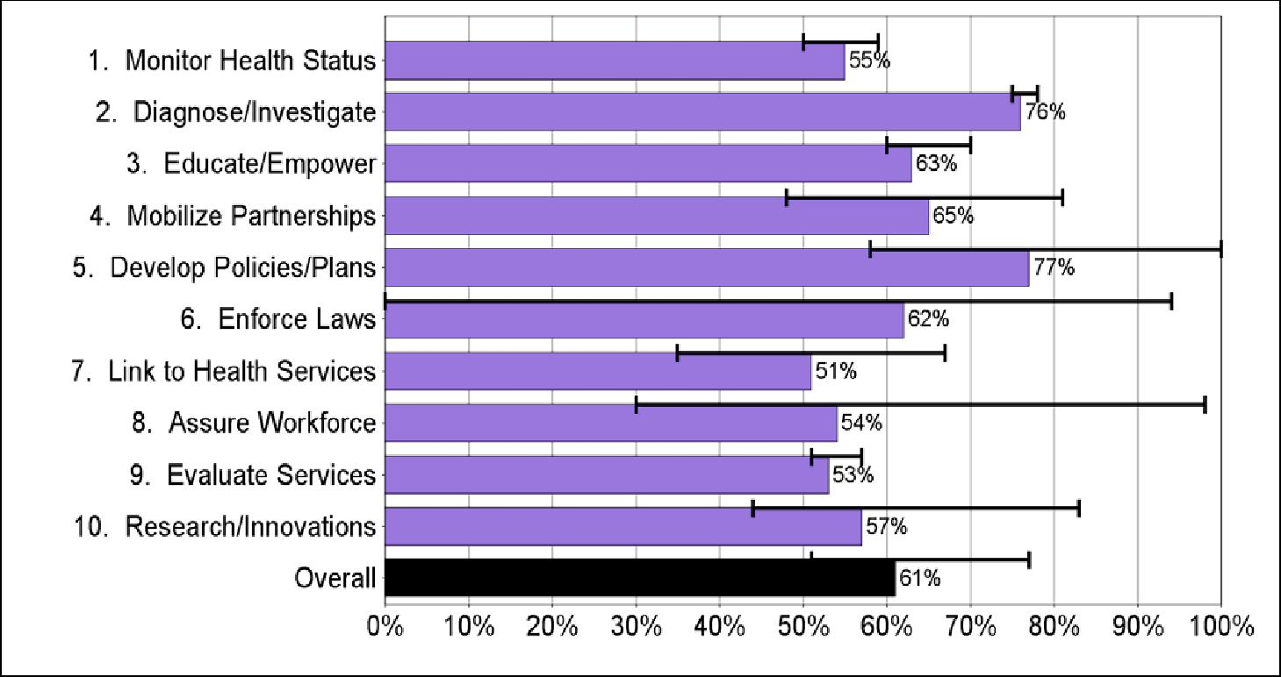

In addition to the Quantitative Report, the Highlands County Health Department prepared a Qualitative Report of Results. Both documents can be found at www.highlandschip.org.

VII. GAP ANALYSIS

Participants were asked to identify gaps in services. Reponses were as follows:

Access to medical services

Lack of availability of specialty care for high risk obstetrics, geriatrics, endocrinology, neurologic radiology, multidiscipline dementia assessment program, pediatric allergy/pulmonology. Must leave the county to obtain these services.

Lack of access to specialty care for Medicaid or other low income uninsured extends to other specialty providers that are available in the county.

Lack of adolescent specialists in general.

Limited transportation options if you don’t have a car or cannot drive. No existing alternative to ER after 7 or 8 p.m. for urgent care.

Services need to be more culturally and linguistically appropriate.

Access to vision care and glasses especially for diabetics is problematic.

Lab, imaging and diagnostic services can be limited depending on payer source. When patients on dialysis transition from the hospital to hospice care, they lose their financial support for dialysis. Hospice does not cover dialysis treatment.

Patients who come to hospitals needing dialysis treatment, instead of going to outpatient dialysis centers, must be treated as in-patients. That drives up the cost of care. In addition, dialysis treatment is needed on a recurring basis, so many of these patients come back to the hospital for further treatments, thus driving up not only the cost of care but the hospital’s readmission rates.

Beginning in March 2013, hospitals which exceed their Federally-determined target for readmission will be penalized with decreased funding.

Behavioral health care

Not enough providers at all levels of care-counselors, trained primary care physicians and psychiatrists to meet needs.

Need more suicide prevention outreach.

Limited local treatment options for prescription drug abuse and substance abuse in general.

Funding from State is insufficient to meet needs.

Additional barriers for Medicaid or other low income uninsured.
Lack of access to mental health medications. Not covered by County.

Need for support group facilitators for parents of children with ADD/ADHD. Lack of providers for adolescents.
Health and general literacy

Adult literacy programs are now charging and requiring participants to be a resident which creates additional barriers for basic literacy.

Health literacy improvements needed on how and why to take medications, use of supplements, children’s asthma disease management (for both parents and children), medical terminology, being a proactive patient.

Coordination of care

More widespread adoption of electronic medical records and systems that will “talk to each other” is needed.

More co-location of services, particularly behavioral health in medical settings. Need for navigators to assist individuals in coordinating care.

Need non-electronic means for enrolling in services for consumers who are not computer savvy.

Many senior citizens are without local support systems.

Prevention/Education

Need more services for prevention of heart disease, obesity, general hygiene, asthma, suicide prevention.

Providers

More local opportunities for workforce training and development needed for health and social service providers. (Hospitals offer training for employees but those outside of that setting have fewer opportunities).

Need better coordination/information sharing between providers on population level issues.

VIII. FORCES OF CHANGE ASSESSMENT

Participants were asked to answer the questions:

What legislative, technological, or other changes are occurring or might occur that affect the health of our community or the local public health system?

What specific threats or opportunities are generated by these occurrences? Responses were as follows.

Force | Threats Posed | Opportunities Created
Economic
Recession | Unemployment and | Increased efficiencies,
 | underemployment, higher | reducing duplication of effort,
 | poverty rates, delaying | more collaboration, more
 | retirement, increasing | volunteer potential
 | number of uninsured,
 | increasing mental health
 | issues as result of economic
 | circumstances
Decline of housing market | Abandoned properties, | Housing becoming more
 | blighted communities, | affordable, reduced tax
 | reduced tax receipts by local | burden for some residents,
 | government, increased | opportunities for investment
 | number of people living with | in real estate
 | others or homeless, reduction
 | of individual net worth
Local and State government | Reduced services to | Increased efficiencies,
budget reductions | community especially “soft” | reducing duplication of effort,
 | services, loss of jobs, safety | more collaboration,
 | net services aren’t being
 | funded
Rising cost of health care | Increased out of pocket | More attention to prevention
 | expenses for those with | and wellness, more personal
 | insurance, | responsibility for health
 | reduction/elimination of
 | health benefits, delays in
 | diagnosis or treatment of
 | conditions leading to poor
 | outcomes

Force | Threats Posed | Opportunities Created
Political/Governmental
2012 Elections | Healthcare is being tossed | Citizen education and
 | around like a football-nothing | advocacy, new candidates
 | is certain or predictable, voter | running for office
 | apathy, mistrust of
 | government
Healthcare Reform | Florida is suing over | Expanding care to more
 | Affordable Care Act and not | individuals leading to a
 | preparing for | healthier community,
 | implementation, Supreme | increased efficiencies and
 | Court decision could create | quality of care
 | more complications than it
 | solves, more cost for
 | Medicaid, State has turned
 | down funds related to
 | implementation of the law so
 | if it is upheld may not have
 | the resources/time to meet the
 | deadlines
Medicaid Reform | State request to expand | Improved health status of
 | managed care pilot project is | Medicaid participants, better
 | uncertain, impact on | coverage and access for some,
 | recipients is also uncertain,
 | may increase access
 | problems for specialty care
Immigration Reform | Local economy depends on | Create policy that makes
 | agriculture and migrant farm | sense for all, strengthening
 | workers-may leave if State | local agriculture as an
 | adopts restrictive approach, | economic engine

Force | Threats Posed | Opportunities Created
Technological
Electronic Health Records | Expense to practitioners, | Facilitate communication
 | concerns about | between providers, improve
 | confidentiality, will | continuity of care, improved
 | technology really allow | quality of care
 | information to be shared
 | across platforms
Technology | Increasing at such a rapid | Better utilization of time and
 | rate, becoming obsolete too | resources when in place
 | quickly leading to higher
 | costs or lack of funds to keep
 | up, need to update
 | equipment/retrain staff
 | frequently
Telemedicine/telepsychiatry | Financial investment | Expansion of services in the
 | required, infrastructure needs | community, better patient
 | to be in place in rural areas or | compliance,
 | people won’t be able to | transportation/geographic
 | access it, | isolation no longer a barrier to
 |  | care, can offer at more
 |  | flexible hours to
 |  | accommodate patient
 |  | schedules
Robotic Surgery | Cost of equipment and need | Faster recovery times, attracts
 | for trained professionals and | providers and retirees to area
 | sufficient demand to stay
 | competent
Electronic communication | Many elderly/poor do not | Enhance communications for
between doctors and patients | have access to computers/e- | some patients, saving office
 | mail, confidentiality issues, | visits
 | less personal connection

Force | Threats Posed | Opportunities Created
Social
Increase in hunger | Poor nutrition impacts overall | Community gardens,
 | health, children do poorly in | sustainable agriculture, small
 | school | scale farming
Large number of single parent | More poverty, less emotional | New program designs to
households | support | address needs of single parent
 |  | households, involvement of
 |  | community
High rates of child/domestic | Health and well-being, cost | Education, expansion of
partner abuse | for law | services and treatment options
 | enforcement/courts/child
 | welfare
High drop out rates | Inability to find work, | Adult education, new
 | increased poverty, inability to | programming for middle and
 | attract new economic | high schools
 | development, increased crime
Return of Veterans to the | Lack of VA services in local | Satellite facilities/services
community | area and no transportation to | could come into the county,
 | VA facilities, services for | workforce with different skill
 | PTSD and TBI are limited | sets, retired personnel as a
 | even within the VA system, | potential resource for
 | community system not | community building
 | prepared to assist with these
 | needs
Formerly migrant families | Providers not linguistically or | Expansion of skills among
staying in the community | culturally competent to serve | providers, families becoming
 | this community, | more integrated into the
 | undocumented individuals | community if staying for long
 | don’t qualify for some | period, development of lay
 | services, stress on safety net | community health care
 | services | worker programs
Variable birth rate | Hard to project number of | Create more comprehensive
 | OB physicians needed | and flexible system for
 |  | improving birth outcomes
More elderly working | Health problems being | Additional income/spending
 | exacerbated, fewer jobs for | power, less isolation
 | younger people

Force | Threats Posed | Opportunities Created
Medical
Increase in chronic | Negative impact on | Disease management
diseases/poor health status | individual and community | initiatives including navigator
 | health, increases in healthcare | programs, patient education
 | costs to individuals and | programs, employer wellness
 | employers, reduction in | programs, technologies and
 | productive years of life, need | treatment advances,
 | for more long term care
 | services
Increased need for mental health | Suicide/accidental death rates | Specialized drug treatment
and substance abuse treatment | increasing, violence and crime | programs for pregnant women,
 | increasing, poor educational | those dependent upon
 | outcomes, social isolation and | prescription drugs, opportunities
 | disconnection, co-morbidities | to co-locate services, additional
 | increase costs, treatment of | supports for independent living,
 | mental health as separate from | more support groups,
 | physical health can be | telepsychiatry expansion,
 | ineffective, law enforcement | prevention initiatives
 | costs increase, lack of
 | appropriate providers to manage
 | serious mental illnesses requires
 | those who need services to
 | travel out of county
State directive for Health | Fewer medical homes for | New healthcare delivery system
Departments to not provide | uninsured and working poor | centered on access to primary
primary care |  | care
Increasing need for long term care | Limited availability and high | Better continuum of care with
due to increasing life expectancy | cost. Possible cuts to Medicaid | quality community-based
and age of the existing population | as payer source, greater stress | services and supports when
 | on family caregivers, isolated | appropriate, support systems for
 | elderly injured or die due to lack | caregivers
 | of care
Large unmet need for dental | Poor overall health | New funding for programs to
services |  | address dental services
Supply/demand for healthcare | Hard to attract/retain qualified | Partnership with Colleges and
workforce | professionals in rural areas, may | Universities, recruitment of
 | need to travel long distances for | more providers for clinical
 | specialty care, lack of clinical | training, local opportunities for
 | training sites, bias toward | skill building/training
 | specialty care among students
Increased use of physician | May not be the best approach | Less expensive way to provide
extenders (ARNP, PA) | for all people, still need to train | primary care, can serve more
 | and attract primary care | people in a practice improving
 | physicians | access to care, walk-in clinics
 |  | based in drug and grocery stores
 |  | for acute care/prevention needs.

Force | Threats Posed | Opportunities Created
Environmental
EPA rules impacting agriculture | Coast of implementing | Better ground water, air and
 | regulations leading to higher | soil quality
 | food prices, fewer farmers
Medical waste disposal | Expensive, contributes to | New technologies to better
 | higher cost of care, water | manage waste
 | quality impact
Climate change | Increased number of sever | Better community design
 | weather events, higher | standards and storm
 | property insurance rates | mitigation
Health care financing
Bundling of payments | Lower job satisfaction, lower | Cost savings, increased job
 | patient satisfaction, less | satisfaction, better integration
 | flexibility in managing | of care for patient, increase in
 | practice, may drop | concierge care for those who
 | Medicare/Medicaid patents, | can afford it
 | lay off billing staff
Performance standards for | Formulas used do not account | Advocacy for policy change
hospitals | for certain local differences.
 | Hospitals could close if
 | funding is diverted away
 | from them
Increasing number Medicaid | Reimbursement rates are low, | Advocacy for policy change
recipients | some providers will decide | and increase of
 | not to accept Medicaid, | reimbursement rates
 | specialty care will be limited
Greater need for free/sliding fee | Many people falling through | Expansion of Federally
scale services | the cracks with regard to | Qualified Health Clinics, Free
 | eligibility for services | clinics, community-based care
 |  | systems
Long waits to become certified | Medicare patients have fewer | Adding staff to relieve back-
to accept Medicare for mental | options for care, providers | log
health | have harder time keeping the
 | doors open given large
 | Medicare population in the
 | County

IX. Identification and Prioritization of Strategic Issues

Based on the above assessments, participants were asked to answer the question: What are the most critical issues which must be addressed?

Responses follow.

Strategic Issue 1: How can we strengthen community partnerships to develop a coordinated, economical and prevention focused indigent health care system for the uninsured/under insured?

Discussion Points:

- Develop a broad-based effort of partners-including prevention-how to engage? (Need strong commitment from partners to make the work a priority)

- Identify partners that are missing in the discussion Determine “common ground” issues

- Have partners educate each other on specific challenges

- Determine areas for advocacy and specific strategies to educate consumers, policy makers, etc.

- Assess how Medicaid expansion/affordable care act may impact service delivery: Can existing providers meet demand? Can the payer mix work? Identify specialty care issues in need of attention-(ex: dialysis/hospital/outpatient/hospice)

- Explore the development of a one-stop center in an appropriate location in Sebring

- Meet with City to explore possible sites, identify barriers to implementation Develop telemedicine with another County

- Discuss challenges of electronic medical record implementation

- Educating public on services that are available-using partners to assist

Strategic Issue 2: How can we better integrate behavioral health into the system of care?

Discussion Points:

Engage Behavioral Health task force with CHIP or have a liaison to Behavioral Health Task Force

Identify service capacities and locations of behavioral health service providers Explore best practices for telemedicine and integrated service delivery models-

educate CHIP

Follow-up on prior recommendations regarding adult adolescent services
Engage behavioral health providers with physicians

NOTE: Strategic Issue 2 was incorporated into Strategic Issue 1 during the Action Plan development.

X. Formulation of Goals and Strategies and Identification of Barriers

Participants were asked what goals should be pursued to address the strategic issues? What strategies should be adopted to achieve the goals?

Strategic issue 2 was not addressed, because it was incorporated into Strategic Issue 1. Participants’ responses are given below.

Strategic Issue 1: How can we strengthen community partnerships to develop a coordinated, economical and prevention focused indigent health care system for the uninsured/under insured?

Goal | Strategies | Barriers | Implementation
Improve | Explore feasibility | Need to identify | Planning phase 18
accessibility of | of one-stop | sustainable funding | months –
health and social | center with |  | implement by
services | health and social | Organizational silos | year 3
 | service
 | components. | Organization and
 |  | government
 |  | policies
 |  | Lack of
 |  | transportation
 |  | Need to define
 |  | population/service
 |  | mix and providers
 |  | Turf guarding
 |  | Need appropriate
 |  | site
 | Assess | Lack of political | Would need
 | transportation | will to fund public | transportation
 | system for | transit | studies and
 | expansion | May not be cost | expertise
 | including non- | effective
 | public options | Large geographic
 |  | area-long distances
 |  | to travel
 |  | Cost of
 |  | fuel/liability
 |  | coverage

Goal | Strategies | Barriers | Implementation
Improve | Develop a | Cost to develop | Review existing
community and | publication/guide | and update | resources
provider
knowledge of | 2-1-1 system | Printed materials | Identify potential
health and social |  | can be out of date | lead agency
services for | Other provider - | quickly
better | operated |  | Community
coordination | clearinghouse | No funding for | awareness
 |  | navigators to assist | component
 |  | in using the
 |  | information | May need to start
 |  | Different and | small
 |  | changing eligibility
 |  | standards for
 |  | services
 |  | Getting the word
 |  | out to community
 |  | and providers
 |  | Need to update
 |  | regularly
 |  | Need to train
 |  | providers

Strategic Issue 2: How can we better integrate behavioral health into the system of care?

NOTE: Strategic Issue 2 was incorporated into Strategic Issue 1 during the Action Plan development.

XI. Action Plan 2012-2015

Participants were asked to answer the questions:

What action steps need to be taken? Who will assume lead responsibility? What kinds of resources are needed?

Within what time frame will the action steps be accomplished?

Highlands CHIP Action Plan

Strategic Priority 1: Improve accessibility of health and social services
Strategy 1.1: Explore the development of a One-Stop center in Sebring by December 2013
Activity/ Action Step | Lead Responsibility | Resources | Timeframe
Convene meeting of key stakeholders to  determine populations to be served and core  services to be provided | Ingrid Utech  (coordinator)  Meredith Lutz  (facilitator) |  | July- October,  29, 2012
Identify lead agency and partner  agencies and determine organizational  structure | Ingrid Utech  (coordinator)  Meredith Lutz  (facilitator) | Ongoing stakeholder  commitment to meetings,  meeting space | By January 31,  2013
Identify space needs for one-stop center | Lead  Agency/Partners |  | By March, 2013
Identify potential locations | Lead Agency/County  and/Health  Department |  | By August, 2013
Estimate costs to construct and furnish  facility | Lead Agency/County  and/Health  Department | Architectural and Engineering  services | By November,  2013
Determine if feasible to continue | Lead  Agency/Stakeholders |  | By December,  2013
Evidence of Success: (How will we know we are making progress? What are the benchmarks?)
Stakeholders participating in meetings
Evaluation Process: (How will we know that we have accomplished the goal? What are the measures?)
Decision to proceed or not to proceed.

Strategic Priority 1: Improve accessibility of health and social services
Strategy 1.2: Proceed with development of One-Stop Center if feasible to be completed by June 30, 2015.
Activity/ Action Step | Lead Responsibility | Resources | Timeframe
Develop MOAs among providers | Lead agencies/Partners | Legal Advice | By February 2014
Obtain site | Owner of Site | Funding | March 2014
Develop bid documents for architectural  and engineering services | Owner/Health Department | Funding | April 2014
Award A&E contract | Owner | Funding | May 2014
Develop bid documents for  construction/renovation | Owner | Funding | July 2014
Award construction/renovation contract | Owner | Funding | September 2014
One Stop Center Opens | Lead Agency/Partners |  | June 2015
Evidence of Success: (How will we know we are making progress? What are the benchmarks?)
Stakeholders participating in meetings
Evaluation Process: (How will we know that we have accomplished the goal? What are the measures?)
Decision to proceed or not to proceed.

Strategic Priority 1: Improve accessibility of health and social services
Strategy 1.3: Improve integration of behavioral health into systems of care
Activity/ Action Step | Lead Responsibility | Resources | Timeframe
Request CHIP representation on Behavioral Health Network (BHN) or request the Network appoint a liaison to CHIP | CHIP Co-chairs |  | July 2012
Appoint CHIP representative if approved by BHN or welcome/orient BHN member to CHIP | CHIP members |  | October 2012
Reporting on BHN activities monthly at CHIP meeting | Designated Representative |  | Ongoing-Monthly
Idenify all providers (public and private) of behavioral health services for participation in one-stop discussions | Robert Palusek, Gaye Williams, Dorothy Reed |  | May 2013
Provide and in-depth presentation to CHIP members on continuum of care and issues related to the provision of behacioral health services for children and adults at one CHIP meetings | Designated Representative | Presentation Materials, etc | July 2013
Conduct study on use of telemedicine capabilities and usage for behavioral health in Highlands County | Committee to be formed | Participation from BHN members to provide information and guidance on technical issues related to telemedicine, Tri-County Human Services, Heartland for Childrent | September 2013
Evidence of Success: (How will we know we are making progress? What are the benchmarks?)
Stakeholders participating in meetings
Evaluation Process: (How will we know that we have accomplished the goal? What are the measures?)
Decision to proceed or not to proceed.

Strategic Priority 1: Improve accessibility of health and social services
Strategy 1.4: Proceed with alternative planning if One-Stop Center is not feasible, to be completed by June 30, 2015
Activity/ Action Step | Lead Responsibility | Resources | Timeframe
Reconvene partners to discuss improvements that can be made to the system | CHIP/partners |  | January 2014
Develop MOAs as appropriate | Partners |  | April 30, 2014
Determine Evaluation mechanisms and benchmarks | Partners |  | May 2014
Implement service improvements | Partners |  | July 2014
Evaluate effectiveness of improvements | Partners |  | June 2014
Award construction/renovation contract | Owner | Funding | September 2014
Evidence of Success: (How will we know we are making progress? What are the benchmarks?)
Stakeholders participating in meetings
Evaluation Process: (How will we know that we have accomplished the goal? What are the measures?)
Decision to proceed or not to proceed.

Strategic Priority 2: Improve community and provider knowledge of the range of health and social services available in Highlands County for improved access and coordination of services by Jun 30, 2013
Strategy 2.1: Develop, improve and publicize information and referral mechanisms for the general public and providers in Highlands County.
Activity/ Action Step | Lead Responsibility | Resources | Timeframe
Form Committee to review existing community resources and methods of information distribution | Suzanne Crews, Tonya Chancey, Jeff Roth | 211 Representative | June 2012
Investigate development of Highlands County health and social services listserv | Sylvia Lauchman |  | July 2012
Partner with 211 on Train the Trainer on use of the website and how to update information | Suzanne Crews |  | January 2012
Trainers to offer training to others in the community | Committee |  | Ongoing
Make recommendations for information and referral system improvements with buy-in from stakeholders | Committee |  | February 2013
Develop plan for increasing community knowledge of information and referral system | Committee | Funding to promote service | March 2013
Implement system improvements | Providers |  | March 2013
Evidence of Success: (How will we know we are making progress? What are the benchmarks?)
Stakeholders participating in meetings
Evaluation Process: (How will we know that we have accomplished the goal? What are the measures?)
Decision to proceed or not to proceed.

Community Health Improvement Plan (CHIP)
Alignment with National and State Goals

Highlands CHIP | Florida State Health Improvement Plan (SHIP) ¹ | Healthy People 2020 ² | National Prevention Strategy:  Priorities ³
Priority Area. Access to Family/primary care.  Goal: Increase the parcentage of residents that have a medical home and regular access to primary care  Goal: Communiyt Health Resources | Strategy AC2.2 Address health care service barriers (e.g., payment, enrollment and access impediments), for service providers and care recipients. | AHS 1.1 Increase the proportion of people who have access to a usual primary care provider.  AHS 5.3 Increase the proportion of Adults 18-64 who have a specific source of ongoing care
Priority Area: Access to Social and Mental Health.  Goal 2: To Improve the social and mental health of children, youth, adults and seniors. | Goal: AC3 Improve behavioral health services so that adults, children and families are active, self-sufficient participants living in their communities. | MHMD9 Increase the proportion of adults with mental health disorders who receive treatment. | Mental and Emotional Well-being:  4 Promote early identification of mental health needs and access to quality services.

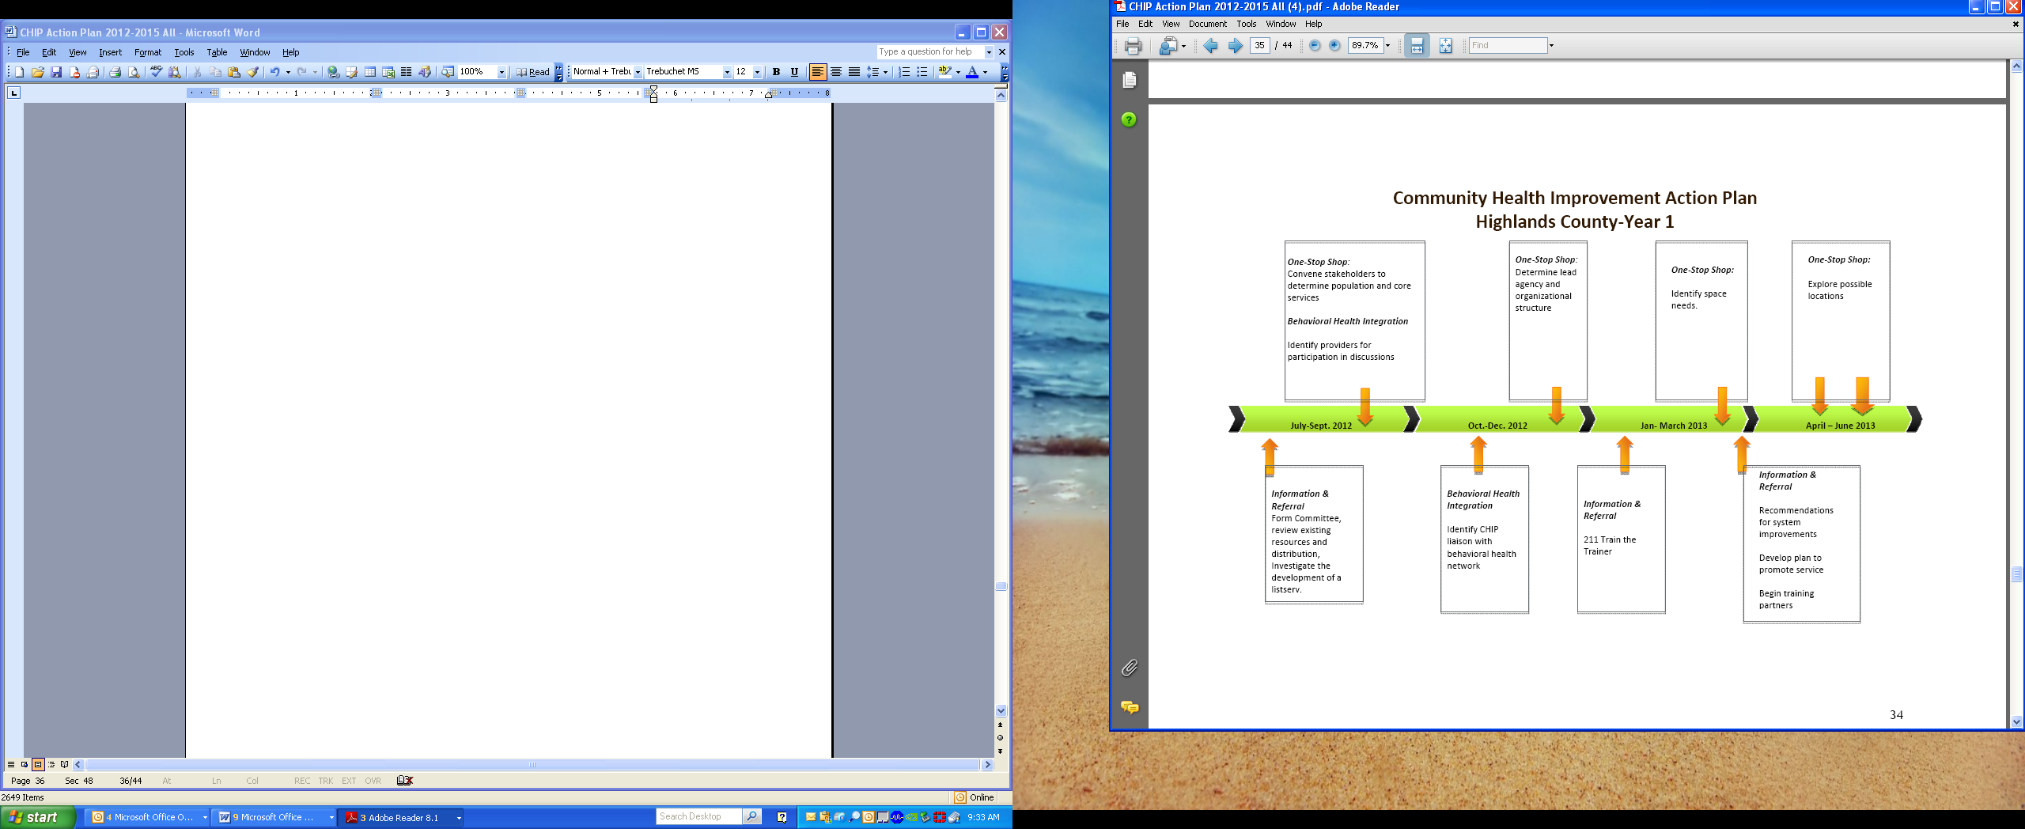

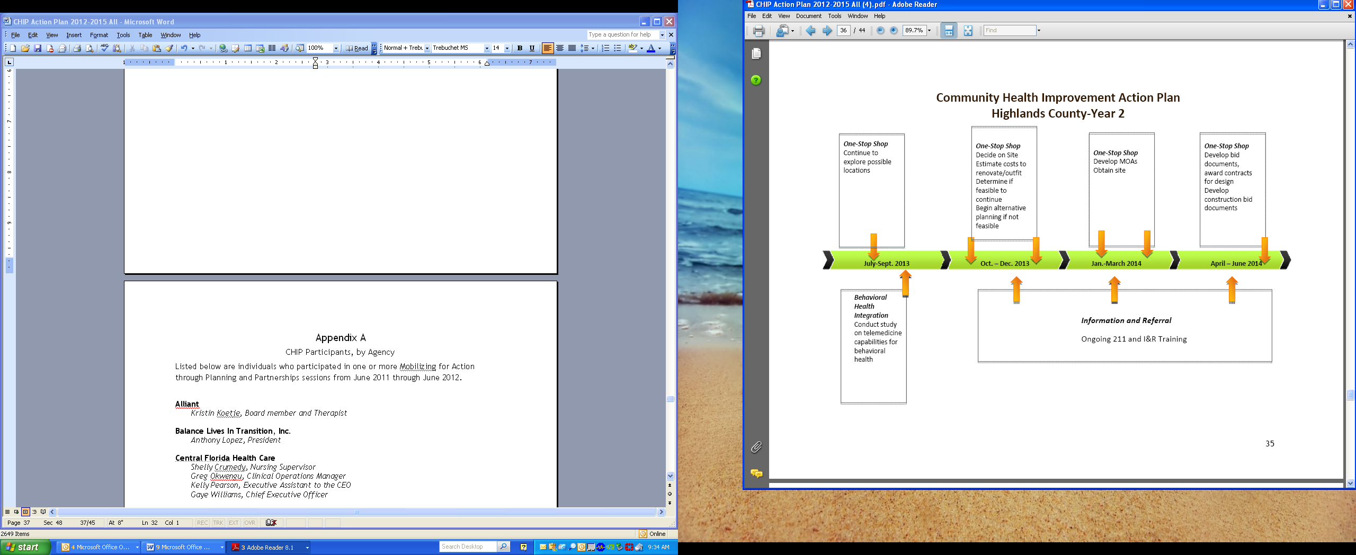

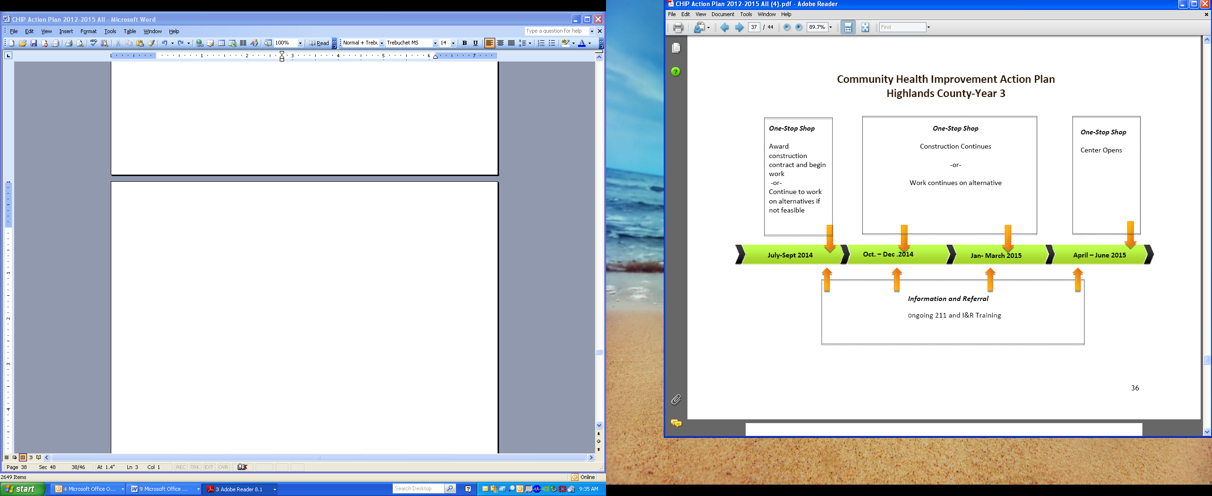

Appendix A

CHIP Participants, by Agency

Listed below are individuals who participated in one or more Mobilizing for Action through Planning and Partnerships sessions from June 2011 through June 2012.

Alliant

Kristin Koetje, Board member and Therapist

Balance Lives In Transition, Inc.

Anthony Lopez, President

Central Florida Health Care

Shelly Crumedy, Nursing Supervisor

Greg Okwengu, Clinical Operations Manager
Kelly Pearson, Executive Assistant to the CEO

Gaye Williams, Chief Executive Officer

Children’s Services Council
Jeff Roth, Executive Director

Tealy Williams, Principal, Avon Park High School

Drug Free Highlands

Aisha Alayande, Assistant Project Coordinator

Florida Department of Children and Families

Julia Hermelbracht, Circuit 10 Community Development Administrator, Hardee, Highlands & Polk Counties

Florida Hospital Heartland

Meredith Lutz, Performance Improvement, Patient Safety, Infection Control Officer Sara Rosenbaum, Community Health Educational Coordinator

Florida Hospital Heartland, Faith-Based Community Nursing
Suzanne Crews, Director

Peggy Pierce, Faith-Based Community Nurse

Healthy Families Highlands

Jeannie DuBenion, Program Manager

Healthy Start Coalition for Hardee, Highlands, and Polk Counties

Holly Parker, Provider & Community Awareness Coordinator Mary Jo Plews, Executive Director

Heartland Rural Health Network
Kelly Johnson, Executive Director

- Rudy Reinhardt, formerly Executive Director (retired)

Highlands County Board of County Commissioners

Ron Handley, County Commissioner, District 3

Highlands County Health Department

Debra Caruso, formerly Healthy Start Director and Diabetes Coordinator Barbara Moore, Community Health Nursing Director

Robert Palussek, formerly Administrator Ingrid Utech, Community Outreach Coordinator

Highlands County Homeowners Association

Rick Ingler, Active Member and former President

Highlands County School Board

Marcia Davis, Coordinator of Student Services

Highlands County Sheriff’s Office

Dorothy Reed, Behavioral Health Coordinator, Highlands County Jail Linda Travers, Nursing Director, Highlands County Jail

Highlands County Veteran Services Office

Denise Williams, County Veteran Service Officer

Highlands Regional Medical Center

Kristin Kopinsky, formerly Chief Operating Officer

Redlands Christian Migrant Association

Nancy Zachary, Health Specialist

Samaritan’s Touch Care Center
Susan Elam, formerly Lake Placid Clinical Director

Rachel Nawrocki, Director

South Florida State College

Kevin Brown, Dean, Division of Applied Sciences and Technologies Tonya Chancey, Professor, Nursing

Sylvia Lauchman, former Nursing student Becky Sroda, Associate Dean, Allied Health

Teenage Pregnancy Prevention Alliance

Greg Smith, former Coordinator

Tri-County Human Services

Bill John, formerly Targeted Case Manager for Adolescents Kitty Slark, Licensed Program Coordinator

Becky Razaire, Licensed Program Manager

United Health Care

Sharon Weatherhead, Account Manager

Appendix B

Ten Essential Public Health Services

Public health serves communities and individuals with ten basic essential services. They are:

- Monitor health status to identify and solve community health problems: This service includes accurate diagnosis of the community’s health status; identification of threats to health and assessment of health service needs; timely collection, analysis, and publication of information on access, utilization, costs, and outcomes of personal health services; attention to the vital statistics and health status of specific-groups that are at higher risk than the total population; and collaboration to manage integrated information systems with private providers and health benefit plans.

- Diagnose and investigate health problems and health hazards in the community: This service includes epidemiologic identification of emerging health threats; public health laboratory capability using modern technology to conduct rapid screening and high volume testing; active infectious disease epidemiology programs; and technical capacity for epidemiologic investigation of disease outbreaks and patterns of chronic disease and injury.

- Inform, educate, and empower people about health issues: This service involves social marketing and targeted media public communication; providing accessible health information resources at community levels; active collaboration with personal health care providers to reinforce health promotion messages and programs; and joint health education programs with schools, churches, and worksites.

- Mobilize community partnerships and action to identify and solve health

problems: This service involves convening and facilitating community groups and associations, including those not typically considered to be health -related, in undertaking defined preventive, screening, rehabilitation, and support programs; and skilled coalition-building ability in order to draw upon the full range of potential human and material resources in the cause of community health.

- Develop policies and plans that support individual and community health efforts: This service requires leadership development at all levels of public health; systematic community-level and state-level planning for health improvement in all jurisdictions; development and tracking of measurable health objectives as a part of continuous quality improvement strategies; joint evaluation with the medical health care system to define consistent policy regarding prevention and treatment services; and development of codes, regulations and legislation to guide the practice of public health.

- Enforce laws and regulations that protect health and ensure safety: This service involves full enforcement of sanitary codes, especially in the food industry; full protection of drinking water supplies; enforcement of clean air standards; timely follow-up of hazards, preventable injuries, and exposure-related diseases identified in occupational and community settings; monitoring quality of medical services (e.g. laboratory, nursing homes, and home health care); and timely review of new drug, biologic, and medical device applications.

- Link people to needed personal health services and assure the provision of health care when otherwise unavailable: This service (often referred to as "outreach" or "enabling" services) includes assuring effective entry for socially disadvantaged people into a coordinated system of clinical care; culturally and linguistically appropriate materials and staff to assure linkage to services for special population groups; ongoing "care management"; transportation services; targeted health information to high risk population groups; and technical assistance for effective worksite health promotion/disease prevention programs.

- Assure a competent public and personal health care workforce: This service includes education and training for personnel to meet the needs for public and personal health service; efficient processes for licensure of professionals and certification of facilities with regular verification and inspection follow-up; adoption of continuous quality improvement and life-long learning within all licensure and certification programs; active partnerships with professional training programs to assure community-relevant learning experiences for all students; and continuing education in management and leadership development programs for those charged with administrative/executive roles.

- Evaluate effectiveness, accessibility, and quality of personal and population-based health services: This service calls for ongoing evaluation of health programs, based on analysis of health status and service utilization data, to assess program effectiveness and to provide information necessary for allocating resources and reshaping programs.

- Research for new insights and innovative solutions to health problems: This service includes continuous linkage with appropriate institutions of higher learning and research and an internal capacity to mount timely epidemiologic and economic analyses needed health services research.

Appendix C
Highlands County Participants
Local Public Health System Assessment
October 20, 2011
Adela Abela | Eleanor Davis
Volunteer | Family Psychiatric Nurse Practitioner
Manna Ministries & | Peace River Center
Samaritan's Touch Care Center | Jeannie DuBenion
Tim Banks | Program Manager
Community Transportation Coordinator | Healthy Families of Highlands County
Community Transportation of Highlands | June Fisher
County | June Fisher
 | Assistant County Administrator
Rhonda Beckman | Highlands County
Executive Director | Jennifer Forde
Ridge Area ARC | Jennifer Forde
 | Clinical Manager, Inpatient Unit
Pat Binns | Good Shepherd Hospice
Clinical Social Worker | Ingra Gardner
Kevin Brown | Executive Director
Dean, Applied Sciences and | Nu-Hope Elder Care Services, Inc.
Technologies | Jackie Graham
South Florida State College | Jackie Graham
 | Assistant Veterans Service Officer
Debra Caruso | Highlands County Veterans Services
Healthy Start and Wellness Director | Office
Highlands County Health Department | David Greenslade
Eva Cooper | Executive Director
Executive Assistant | Avon Park Chamber of Commerce
Highlands County IDA/EDC | Jeanne Griffith
Suzanne Crews | Manager, Grant Development
Director | Early Learning Coalition of Florida's
Florida Hospital Parish Nursing Program | Heartland
Dick Daggett | R. Greg Harris
Director | Highlands County Commissioner
Highlands County Coalition for the | Board of County Commissioners
Homeless | Erin Hess
Marcia Davis | Administrator
Coordinator of Student Services | Okeechobee County Health Department
School Board of Highlands County

Tom Higginbotham | Sherry Maiel
Environmental Health Director | Infection Control/Employee Health
Highlands County Health Department | Director
John Holbrook | Highlands Regional Medical Center
Mayor | Marlen Martinez
Town of Lake Placid | Marlen Martinez
 | Coordinator
Lucille Huber | Early Steps
Administrator | Teedy McNeil
Florida Hospital Home Care Services | Teedy McNeil
 | Director of Nursing
Lorie Jackson | Central Florida Health Care
WIC & Nutrition | Marcene Miller
Highlands County Health Department | Marcene Miller
 | Director of Respiratory & Laboratory
Kelly Johnson | Services
Health Planning Director | Florida Hospital Heartland Division
Heartland Rural Health Network | Barbara Moore
Sharmin Jones | Director of Nursing
Director of Nursing | Highlands County Health Department
The Palms of Sebring | Thomas Moran
Kelly Kirk | Emergency Preparedness Director
Office Manager | Highlands County Health Department
Community Transportation of Highlands | Laurie Murphy
County | Laurie Murphy
 | Resource Director
Kristen Kopinsky | NuHope Elder Care Services
Chief Operating Officer | Michelle Myers
Highlands Regional Medical Center | Michelle Myers
 | Director, Human Resources
Lynn Ledford | Florida Hospital Heartland Division
Human Resource Liaison | Sue Nardy
Highlands County Health Department | Sue Nardy
 | Parish Nurse
Keith Loweke | Florida Hospital Parish Nursing Program
Director of Safety and Security | Rachel Nawrocki
South Florida State College | Rachel Nawrocki
 | Executive Director
Meredith Lutz | Samaritan’s Touch Care Center
Performance Improvement/Infection | Judy Neuwirth
Control | Judy Neuwirth
Florida Hospital Heartland Division | Volunteer
Kathy MacNeill | Manna Ministries
Kathy MacNeill | Robert Palussek
Associate Director, Diabetes Master | Robert Palussek
Clinician Program | Administrator
Heartland Rural Health Network | Highlands County Health Department

Holly Parker | Becky Sroda
Provider & Community Awareness | Associate Dean, Allied Health and
Coordinator | Director, Dental Education
Healthy Start Coalition, Hardee, | South Florida State College
Highlands, Polk Counties | Anthony Stahl
Linda Paul | VP, Support & Ancillary Services
Executive Director | Florida Hospital Heartland Medical
Heartland Horses & Handicapped, Inc. | Center
Cheryal Phillips | Ginger Svendsen
Parish Nurse | Public Works Specialist
Florida Hospital Parish Nursing Program | Highlands Co. Parks and Natural
J. Rudy Reinhardt | Resources
J. Rudy Reinhardt | Linda Travers
Executive Director | Linda Travers
Heartland Rural Health Network | Nursing Administrator
Bob Rihn | Highlands County Sheriff's Office
Bob Rihn | Donald Wilhelm
Executive Director | Donald Wilhelm
Tri-County Human Services | Dental Director
Rob Roy | Highlands County Health Department
Rob Roy | Gaye Williams
Chief of Nursing Operations | Gaye Williams
Highlands Regional Medical Center | Chief Executive Officer
John Ruggiero | Central Florida Health Care
John Ruggiero | Nancy Zachary
President | Nancy Zachary
Highlands County Lakes Association | Health Specialist
Lynda Schock | Redlands Christian Migrant Association
Training Officer & Acting Shift
Supervisor
Emergency Medical Service of Highlands
County
Kitty Slark
Clinical Coordinator
Tri-County Human Services
Connie Snyder
Caseworker
Salvation Arrmy
Deanna Sparks
National Alliance on Mental Illness
Heather Sparks
National Alliance on Mental Illness

